

CAPSTONE PROJECT REPORT
Report 3 – Software Requirement Specification
Version: 1.3

– Hanoi, Oct 2026 –

Table of Contents
Change Log 6
Definition and Acronyms 9
I. Overall Requirements 9
1. Context Diagram 9
2. Main Business Flow 10
2.1 Location Setup and Configuration (BF-01) 10
2.2 Staff Scheduling and Task Operations (BF-02) 11
2.3 Tenant and Co-occupant Onboarding, Holding Contract and Main Tenancy Contract (BF-03) 13
2.4 Temporary Residence and Contract Lifecycle (BF-04) 17
2.5 Meter Reading and Invoice Cycle (BF-05) 20
2.6 Bank Payment, Debt and Invoice Adjustment (BF-06) 21
2.7 Incident and Maintenance Handling (BF-07) 24
3. Conceptual Data Model 25
3.1 Entity Relationship Diagram 25
3.2 Entity Descriptions 26
3.3 Data Business Rules 33
4. User Requirements 34
4.1 Actors 34
4.2 Use Cases (UC) 34
4.3 Use Case Diagrams 38
4.4 Permission Matrix 41
5. System Functionalities 42
5.1 Screen Inventory 43
5.2 External API Inventory 45
5.3 Background Job Inventory 45
II. Use Case Specifications 46
1. Chain, Location and Staff Operations 46
1.1 UC-04 - Manage Locations, Room Types and Rooms 46
1.2 UC-05 – Manage Assets and Facilities 47
1.3 UC-06 – Manage Rental Rates and Fees 48
1.4 UC-07 – View Occupancy and Room History 48
1.5 UC-08 – Manage Staff Accounts, Employment and Location Assignments 49
1.6 UC-09 – Manage Staff Shifts 49
1.7 UC-10 – Create and Assign Operational Tasks 50
1.8 UC-11 – Execute and Update Operational Tasks 51
1.9 UC-12 – Monitor and Coordinate Operational Tasks 52
2. Tenant, Contract and Residence 53
2.1 UC-14 - Prepare and Sign Holding Contract 53
2.2 UC-15 - Prepare, Sign and Activate Main Tenancy Contract 54
2.3 UC-17 - Perform Move-in Room Handover 55
2.4 UC-18 - Track Temporary Residence Registration 55
2.5 UC-19 - Handle Contract Expiry, Renewal and Termination 56
3. Utility, Billing and Payment 58
3.1 UC-20 - Capture and Confirm Meter Readings 58
3.2 UC-21 - Generate, Finalize and View Invoice 58
3.3 UC-22 - Reconcile Bank Payment 59
3.4 UC-23 - Track Outstanding Debt and Send Payment Reminders 60
3.5 UC-24 - Request and Approve Invoice Adjustment 60
3.6 UC-25 - View Payment History 61
4. Incident and Maintenance 62
4.1 UC-26 - Submit Incident or Maintenance Report 62
4.2 UC-27 - Respond to Emergency Incident 62
4.3 UC-28 - Review and Assign Incident Handling 63
4.4 UC-29 - Inspect, Propose and Execute Repair 64
4.5 UC-30 - Verify Completion and Update Maintenance History 65
5. Finance and Public Information 66
5.1 UC-31 - Manage Initial Investment and Operating Expenses 66
5.2 UC-34 - Analyze Financial What-if Scenario 66
5.3 UC-37 - Publish Public Location and Room Information 67
III. Functional Requirements 68
1. FE-01 – Chain, Location, Staff Scheduling & Task Operations 68
1.1 Location and Room Management 68
1.2 Staff Administration 76
1.3 Staff Shift and Operational Tasks 78
2. FE-02 – Identity, Fixed-Role Access Control & Audit 84
2.1 Authentication 84
2.2 Personal Profile 86
2.3 Access Control and Audit 88
3. FE-03 – Tenant Onboarding, Contract, Room Handover & Residence Tracking 88
3.1 Tenant and Occupant Management 88
3.2 Contract Management 90
3.3 Room Handover and Residence 94
4. FE-04 – Utility, Fee, Invoice & Controlled Adjustment 98
4.1 Rental, Utility and Fee Policy 98
4.2 Meter Reading 99
4.3 Invoice 101
4.4 Invoice Adjustment 103
5. FE-05 – Bank Payment, Outstanding Debt & Financial Exceptions 105
5.1 Payment Reconciliation 105
5.2 Outstanding Debt 107
5.3 Payment History 109
6. FE-06 – Incident & Maintenance Management 111
6.1 Incident Management 111
6.2 Maintenance Execution 117
6.3 Maintenance Verification 121
6.4 Maintenance & Operational History 123
7.FE-07–TenantSelf-Service, Living Environment & Notifications 125
7.1 Tenant Home 125
7.2 My Contract 127
7.3 My Billing & Payment 129
7.4 Notifications 131
8. FE-08 – Owner Finance, Business Dashboard & Decision Support 133
8.1 Investment and Operating Expenses 133
8.2 Business Reporting 135
8.3 What-if Analysis 137
9. FE-09 – Public Website 139
9.1 Public Content Management 139
9.2 Public Website 141
10. Background Job Inventory 143
10.1 Overdue Invoice Reminder (JOB-01) 143
10.2 Contract Expiry Reminder (JOB-02) 143
10.3 Payment Reconciliation Retry (JOB-03) 144
10.4 Notification Delivery Retry (JOB-04) 144
10.5 Holding Contract Expiry (JOB-05) 144
10.6 Recurring Operational Task Generation (JOB-06) 145
10.7 Operational Task Deadline Reminder (JOB-07) 145
10.8 Temporary Residence Reminder (JOB-08) 145
10.9 Periodic Meter-Reading Task Generation (JOB-09) 146
10.10Draft and Final Invoice Generation (JOB-10) 146
11. External API Specifications 146
11.1 Payment Gateway Integration (API-01) 146
11.2 Notification Service Integration (API-02) 147
11.3 Electronic Contract Provider Integration (API-03) 147
IV. Non-Functional Requirements 148
1. External Interfaces 148
2. Quality Attributes 148
2.1 Usability 148
2.2 Performance 149
2.3 Security 149
2.4 Reliability and Recoverability 150
2.5 Privacy and Test Data 150
V. Requirement Appendix 151
1. Business Rules 151
2. System Messages 152
3. Other Requirements 154
3.1 Open Questions Register 154
3.2 Traceability Summary 155
3.3 Explicit MVP Exclusions 155

Change Log
Date | A*  M, D | In charge | Change Description
27/09/2026 | A | Nguyen Quoc Huy | Created Report 3 - SRS v0.9 as the overall-requirements baseline. Aligned roles, scope, workflows, business rules, Smart Operations, payment policy, public website boundary, and Open Questions with the current BHOME baseline.
27/09/2026 | M | Dinh Thien Huy | Aligned SRS v0.9 with Report 1 v1.1 and Project Plan v1.0: added Guest room reservation and bank-transfer holding deposit to FE-09 and updated related flow, UC, data, rules, jobs and exclusions.
01/10/2026 | M | Nguyen Quoc Huy | Started the SRS v1.0 revision from the v0.9 overall-requirements baseline. Updated SRS to align with the revised Report 1 and Report 2 baseline: added AI-assisted Staff scheduling, Staff employment and Salary Calculation, task deadlines and overdue accountability, Owner business decision support, individual occupant contact/notification requirements, stronger personal-data protection, and standardized refund/deposit terminology.
02/10/2026 | M | Vu Xuan Truong | Revised BF-01 and related requirements to replace AI-assisted scheduling with internal OR-Tools task allocation. Clarified Staff task execution, shift changes and manual shift-handover confirmation by both outgoing and incoming Staff.
04/10/2026 | M | Nguyen Quoc Huy | Reclassified meter/CCCD OCR from an external service to an internal BHOME component; removed OCR from external actors/APIs, updated UC-06/UC-08 and NFR wording, and aligned the Context Diagram with internal OCR and internal OR-Tools.
05/10/2026 | M | Nguyen Quoc Huy | Started the SRS v1.1 revision to consolidate substantive requirement corrections. Addressed SRS review feedback: aligned business rules, entity states, permissions, inventories, use cases and NFRs; refined unresolved dashboard and maintenance scope; and updated the Open Questions Register and traceability mapping to match Project Tracking and Sprint dependencies.
05/10/2026 | M | Dinh Thien Huy | Added automatic invoice issuance as UC-13 and renumbered it as UC-13; merged underpayment/overpayment handling into UC-12; corrected UC-08, UC-09, UC-11 and UC-15; clarified Guest deposit refunds in UC-24; added GBR-51–54 and JOB-08/10 specifications; corrected job IDs, references and traceability; aligned financial screens with Staff permissions and removed duplicate content and editing artifacts.
05/10/2026 | M | Vu Xuan Truong | Replaced OR-Tools proposals with Owner-managed scheduling and task assignment while preserving shift-change and handover rules. Updated UC-22, What-if UI requirements and related rules for baseline-versus-scenario financial analysis.
05/10/2026 | M | Nguyen Quang Huy | Addressed review feedback on FE-06 and FE-07: unified the work-order lifecycle, replaced Tenant repair verification with the Staff result check, defined rule-based emergency-keyword screening (GBR-22, OQ-08 closed), and corrected UC-16 to UC-19, related screens, business rules, messages and cross-references.
06/10/2026 | M | Dinh Thien Huy | Updated all five use case diagrams for Owner, Staff, Tenant, Guest and External Service Interactions; refined use case names, corrected actor participation and relationships, and aligned access scopes and traceability with the master UC list.
07/10/2026 | M | Dinh Thien Huy | Reformatted the entire report, standardized heading and text styles, removed incorrect labels, and fixed formatting inconsistencies to improve overall readability and consistency. Consolidated SRS v1.1 requirements for scheduling, automatic billing, payment/refund, Staff permissions and maintenance, with related rules, jobs and references.
08/10/2026 | M | Nguyen Quang Huy | Removed AI report drafting and classification (JOB-06, API-02). Reports are submitted manually with reporter-selected type,keyword screening assigns Urgent severity surfaced first to Staff,Staff verifies Urgent reports on site and records emergency actions.
08/10/2026 | M | Vu Xuan Truong | Split Location configuration and Staff operations into BF-01 and BF-02 and separate UC specification groups; renumbered subsequent sections and updated related references.
08/10/2026 | M | Nguyen Quoc Huy | Started the SRS v1.2 revision to align the rental scope, contract lifecycle and operational workflows with the revised Reports 1–2 baseline. Aligned Report 3 with the revised Reports 1–2 baseline: corrected business flows and contract lifecycle; limited the Public Website to information only; removed remaining external AI and Guest enquiry/reservation content; aligned business visibility and financial analysis; revised CCCD image handling; and corrected related UCs, APIs, jobs, rules, NFRs and traceability.
08/10/2026 | M | Nguyen Quang Huy | Restructured BF-07 to Owner-driven handling: removed AI report analysis (JOB-06, API-02), keyword screening, Urgent severity and Staff classification. Owner reviews, classifies and assigns tasks; Staff records progress and evidence in append-only entries; Owner verifies results and closes reports. Rewrote §2.7, the Incident Report entity, UC-17/18/19, FE-06/07 screens, JOB-06 scope, GBR-13/19/22 and related traceability.
08/10/2026 | M | Dinh Thien Huy | Updated the overall and five actor-specific use case diagrams to align with the current UC list and Owner/Staff permissions; clarified shared onboarding, CCCD capture and contract creation; corrected external service interactions; and standardized fonts, headings, tables and formatting throughout Report 3.
08/10/2026 | M | Nguyen Quoc Huy | Consolidated SRS v1.2 by aligning business flows, use cases, permissions, business rules, entities, external APIs and traceability with the finalized BHOME scope. Corrected outdated workflows, terminology and document inconsistencies.
08/10/2026 | M | Bui Bao Long | Split BF-03 into BF-03A and BF-03B, updated UC-07 workflows and conditions, and aligned Contract and Room lifecycle states with Holding Deposit verification, contract creation/conversion, Security Deposit handling, and contract activation.
09/10/2026 | M | Nguyen Quoc Huy | Aligned contract deposits, payment reconciliation, Invoice Adjustments, refunds and Tenant Credit; corrected permissions and business-rule references, added JOB-11, clarified initial meter readings, and updated related BF/UC specifications and traceability.
09/10/2026 | M | Vu Xuan Truong | Restructured BF-02 into three swimlane diagrams: (a) Scheduling and Task Assignment, (b) Task Execution and Task Handover, and (c) Shift Changes and Shift Handover.
09/10/2026 | M | Nguyen Quang Huy | Fixed BF-07 diagram and entity lifecycles (Incident Report, MaintenanceWorkOrder, OperationalTask)corrected 6.2.1 purpose and Report Detail inventory description
09/10/2026 | M | Dinh Thien Huy | Split BF-05 into meter reading confirmation and automatic invoice issuance, and BF-06 into bank payment reconciliation, excess refund/credit handling and overdue debt follow-up. Redrew use case diagrams to align actor participation, permissions and relationships with the UC list; replaced notification-specific use cases with external service participation and notification event tables.
17/10/2026 | M | Vu Xuan Truong | Revised Staff scheduling and task-operation requirements. Staff permissions are predefined, Owner assigns Staff to Locations, and tasks are routed based on Location responsibility. Removed Staff availability, shift-change and Staff-to-Staff handover workflows. Added Staff task execution and Owner completion verification flow.
18/10/2026 | M | Bui Bao Long | Revised contract-related Use Case Specifications to align with the finalized BHOME contract model. Standardized terminology for the Holding Contract and Room Rental Contract, refined contract signing and activation conditions, and updated the Room handover, renewal, and termination flows.
18/10/2026 | M | Nguyen Quang Huy | Aligned BF-07 and UC-26–30 with the finalized requirements: standardized Work Order terminology and lifecycle; added Duplicate status, Asset state updates, cost linkage, postconditions, and notifications; and corrected DBR mappings, FE-06 headings, and screen references.
18/10/2026 | M | Nguyen Quoc Huy | Rebuilt BF-05 and BF-06 to align with the finalized Actor–Feature–Use Case specification. Removed outdated flows and UCs, rebuilt related use cases and diagrams, and updated dependent requirements and traceability.
19/10/2026 | M | Dinh Thien Huy | Reworked BF-05 and BF-06 to align with the updated Actor–Feature–Use Case specification. Replaced the previous billing/payment use cases with UC-20 to UC-25; revised meter reading, invoice generation/finalization, bank payment reconciliation, debt follow-up and invoice adjustment flows; updated related actors and use case specifications.
21/10/2026 | M | Nguyen Quoc Huy | Updated SRS to add the Owner Web Portal as the primary administration interface and reposition the Owner Mobile App for monitoring, notifications, and quick-response actions.
21/10/2026 | M | Bui Bao Long | Revised BF-03A/BF-03B and BF-04A/BF-04B; aligned UC-14–19 and JOB-08 with Holding and Main Tenancy Contract creation, renewal, early termination, payment-based contract activation, move-out settlement, and Tenant-led temporary residence registration through VNeID.
21/10/2026 | M | Nguyen Quang Huy | Aligned UC-26–30 and FE-06 with GBR-11: added Operational Emergency and life-safety hotline handling, emergency notification and escalation, Owner direct handling with actual cost and OperatingExpense, Work Order In Progress trigger, report closure when Work Orders are cancelled; removed Draft from IncidentReport lifecycle; fixed 6.1.2 and 6.2.2 field descriptions.
*A - Added M - Modified D - Deleted

Definition and Acronyms
Acronym | Definition
BHOME | BHome - Smart Boarding House Chain Management and Operations Platform
SRS | Software Requirement Specification
MVP | Minimum Viable Product
FE | Functional Epic
UC | Use Case
BR | Business Rule
OQ | Open Question
RBAC | Role-Based Access Control
API | Application Programming Interface
REST | Representational State Transfer
OCR | Optical Character Recognition
AI | Artificial Intelligence
CCCD | Citizen Identity Card used for onboarding
JWT | JSON Web Token
FCM | Firebase Cloud Messaging or equivalent push-notification service
UAT | User Acceptance Testing
QR | Quick Response Code used to initiate a bank-transfer payment
Holding Deposit | A deposit associated with an internally created Holding Contract to temporarily reserve an eligible Room under the approved holding policy.
Security Deposit | Deposit associated with a Tenant's rental contract.
Refund Request | A request to return money previously received.
Refund Decision | Owner's approval or rejection of a Refund Request.
External Refund Execution | Actual transfer of refunded money outside BHOME after an approved Refund Decision.
Refund Evidence | Transaction reference or proof recorded in BHOME after External Refund Execution.
Staff Salary Calculation | Internal calculation of Staff labor cost from configured employment terms and approved work schedules; it is not Statutory Payroll.
Electronic Contract Provider | External provider supporting electronic contract signing and returning signing status/evidence to BHOME.
Initial Investment | Initial capital invested in a Location before or during operation.
Operating Expense | Expense incurred during normal Location operation.
Payback Period | Estimated time required to recover the initial investment.
What-if Scenario | A financial simulation using changed assumptions without modifying actual operational data.
Temporary Residence Task | An internal BHOME record used to track a Tenant's temporary-residence registration deadline, status, evidence and Owner confirmation. Official registration is performed by the Tenant outside BHOME.

I. Overall Requirements

1. Context Diagram
BHOME is a multi-channel boarding-house chain management and operations platform. Owner primarily performs administration and management through the Owner Web Portal, while the Mobile Application supports Owner monitoring and quick-response actions and serves as the primary operational interface for Staff and Tenant.
BHOME integrates with a Payment Gateway for bank-transfer reconciliation and an Electronic Contract Provider for supported electronic contract signing. Notification delivery may use an external notification service as a technical integration.
BHOME tracks temporary-residence tasks but does not submit residence-registration records to government systems. Scheduled reminders, invoice generation and operational tasks are handled internally by BHOME.
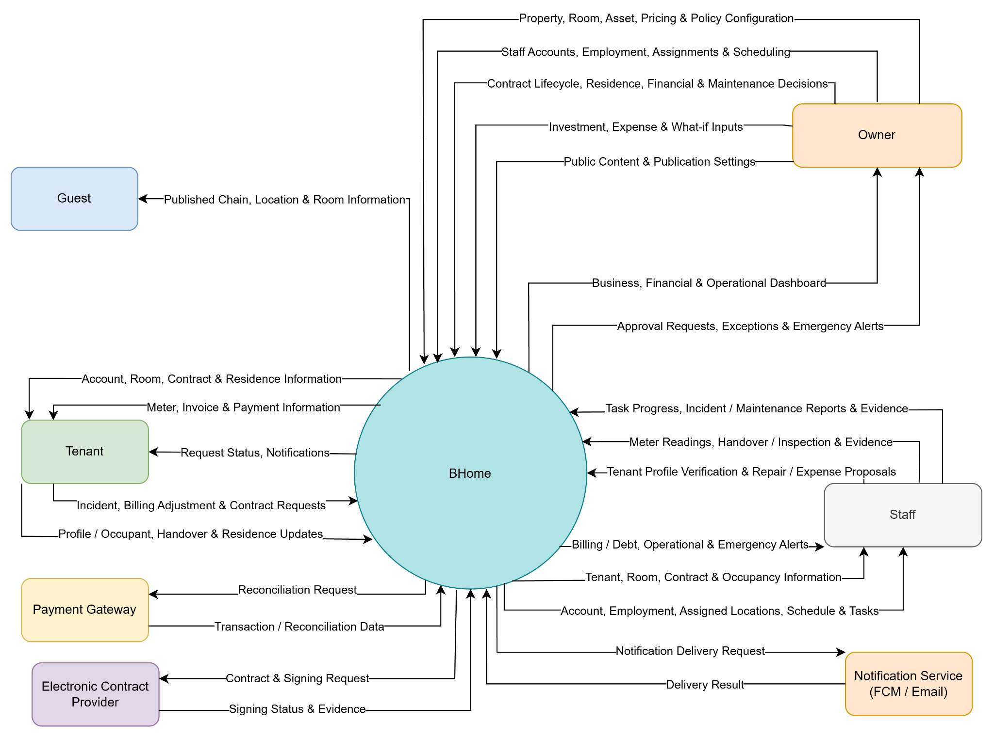

Scope boundary: BHOME includes Contract and room-handover management, basic temporary-residence task tracking, billing and payment exception handling, incident and maintenance management, Owner investment/expense tracking, payback and What-if analysis, Tenant self-service and an information-only Public Website. Full accounting, official tax filing, certified digital signature, government residence submission and online reservation/payment through the Public Website are outside the MVP.

2. Main Business Flow

2.1 Location Setup and Configuration (BF-01)
Trigger: Owner creates or updates a Location, Room Type, Room, managed Asset/Facility, rental rate or applicable fee configuration.
End condition: Valid Location, Room, Asset/Facility and pricing/fee configuration is saved. Room status and effective-dated rate information remain consistent and traceable.
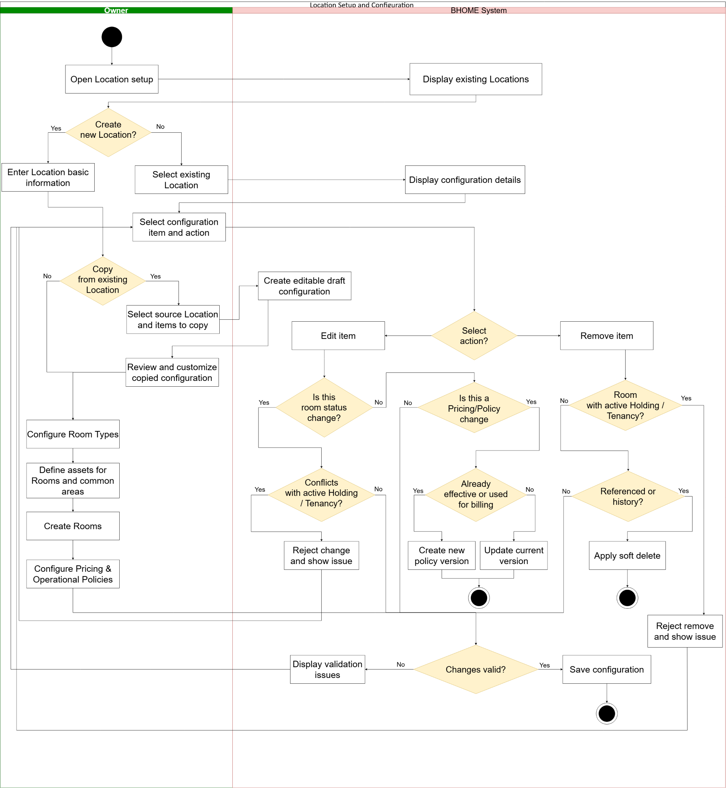

2.2 Staff Scheduling and Task Operations (BF-02)
Trigger: Owner creates or updates Staff schedules or operational tasks; BHOME may generate recurring tasks according to configured schedules; Staff performs assigned work.
End condition: Valid Staff schedules and Location responsibilities are active. Tasks are assigned according to Location responsibility. Staff progress, blockers, evidence and completion submissions are retained, and Owner verifies completion or requests rework. Staff-to-Staff task transfer, shift swap and shift handover are not supported.

2.2.1 : Staff Scheduling and Location-based Task Assignment — BF-02(a)
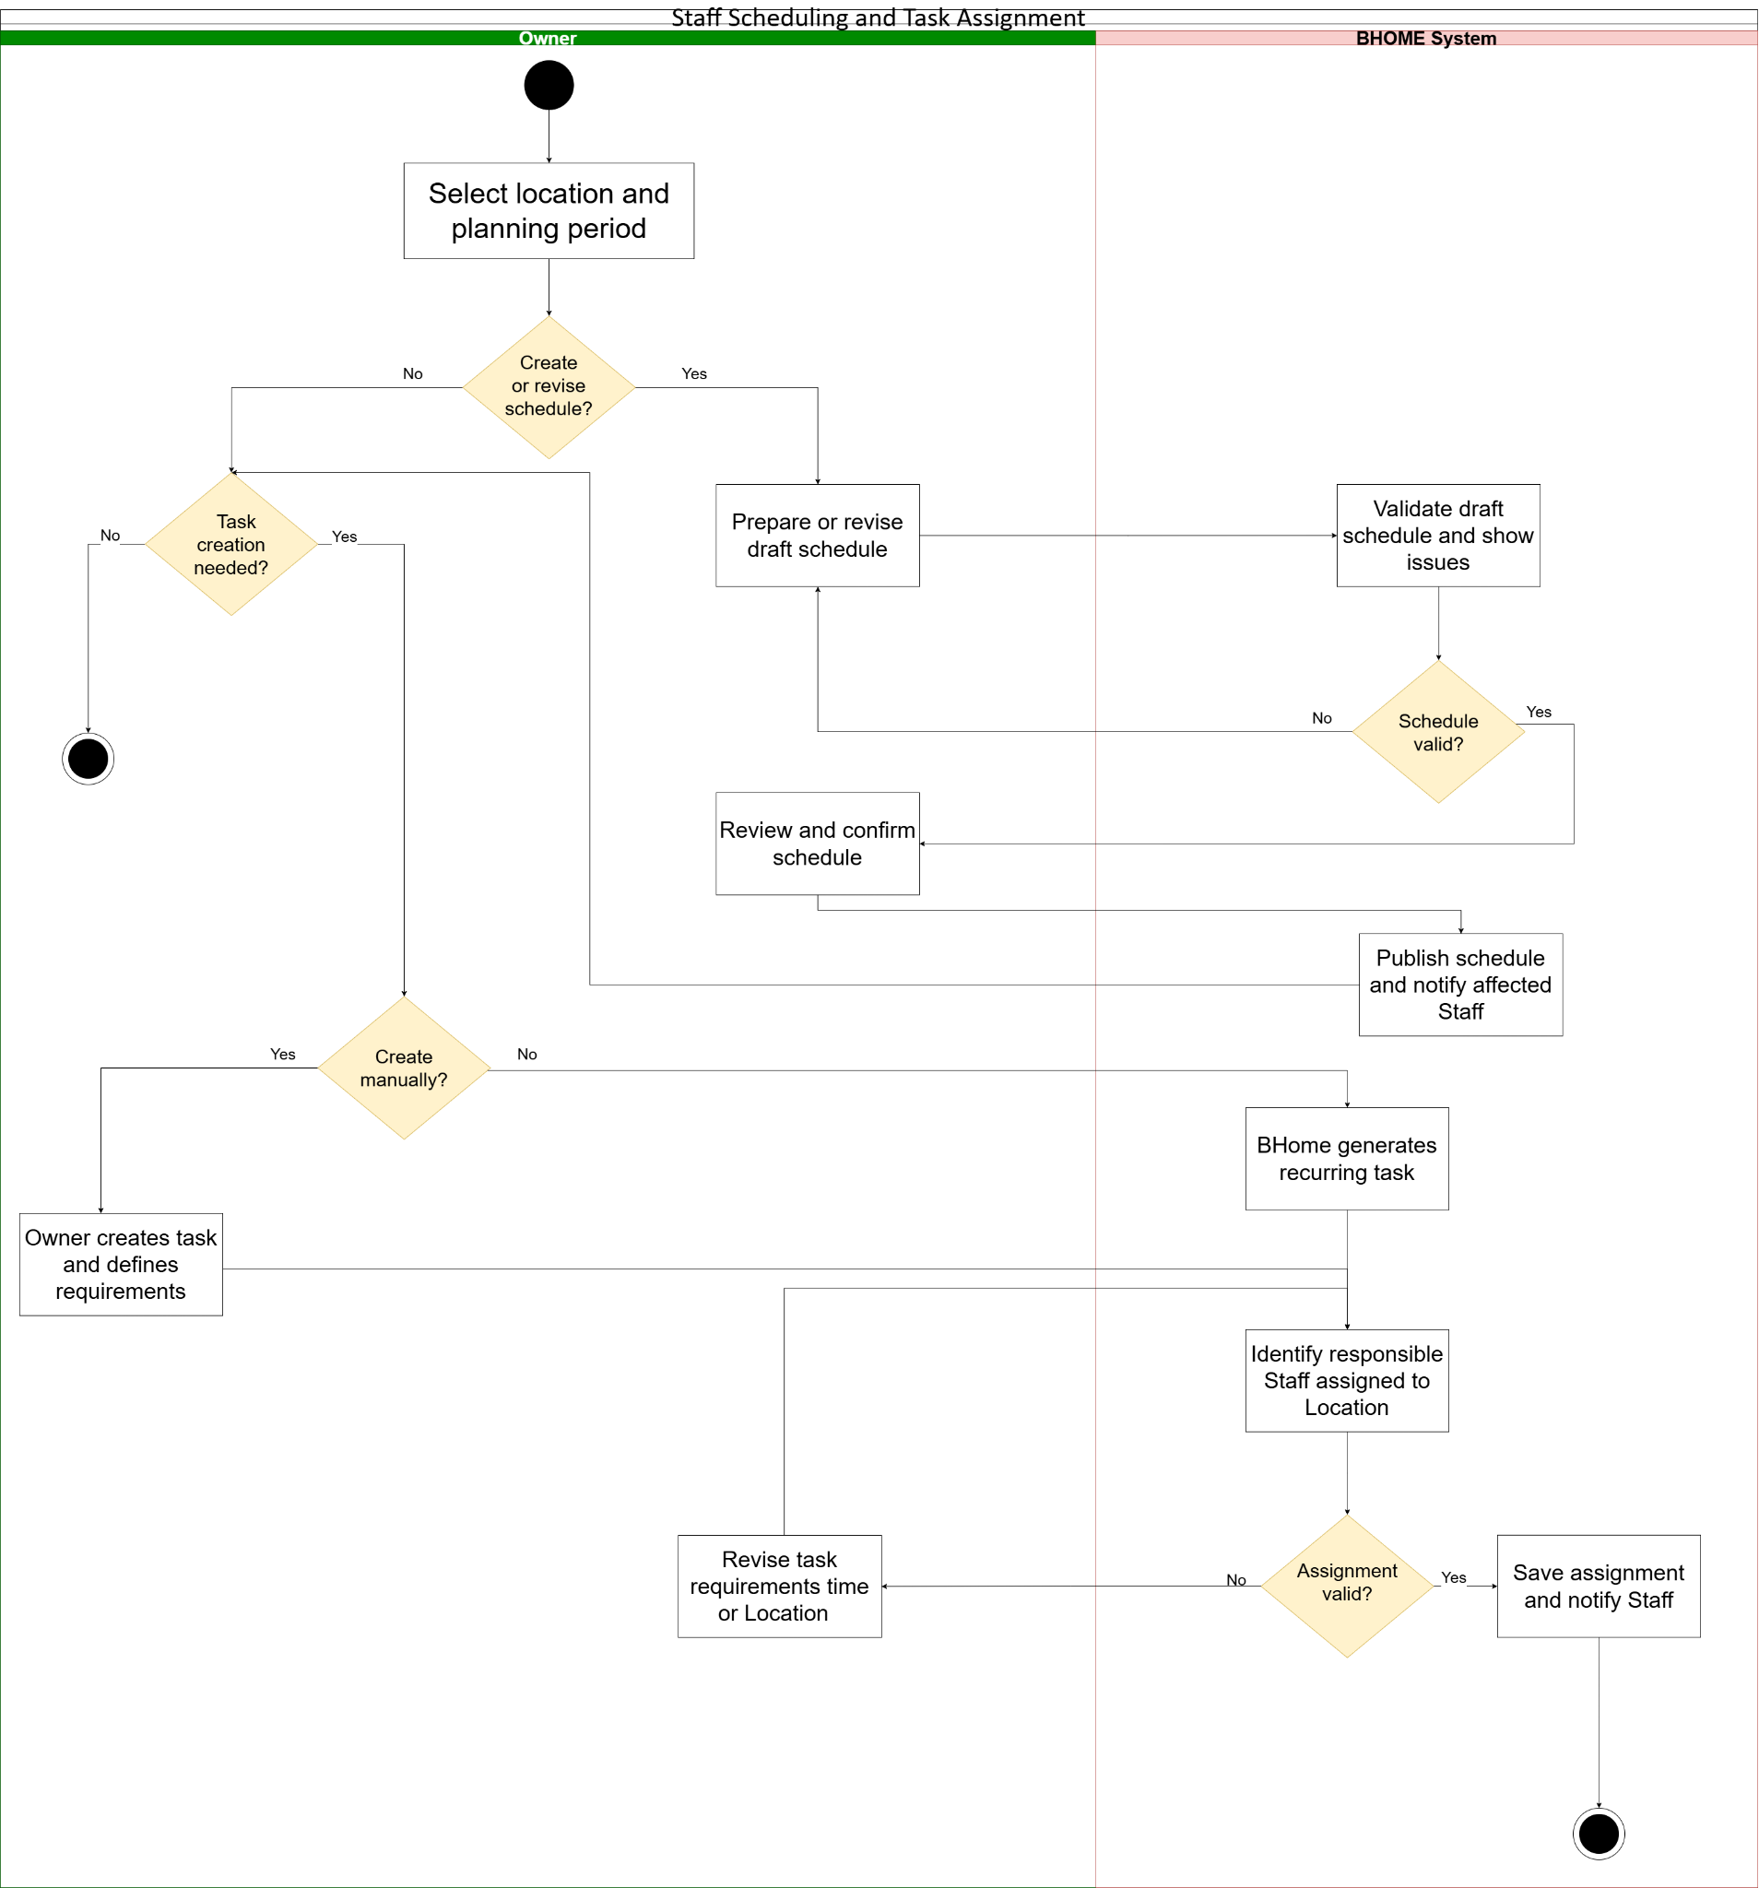

2.2.2 : Task Execution and Completion Verification — BF-02(b)
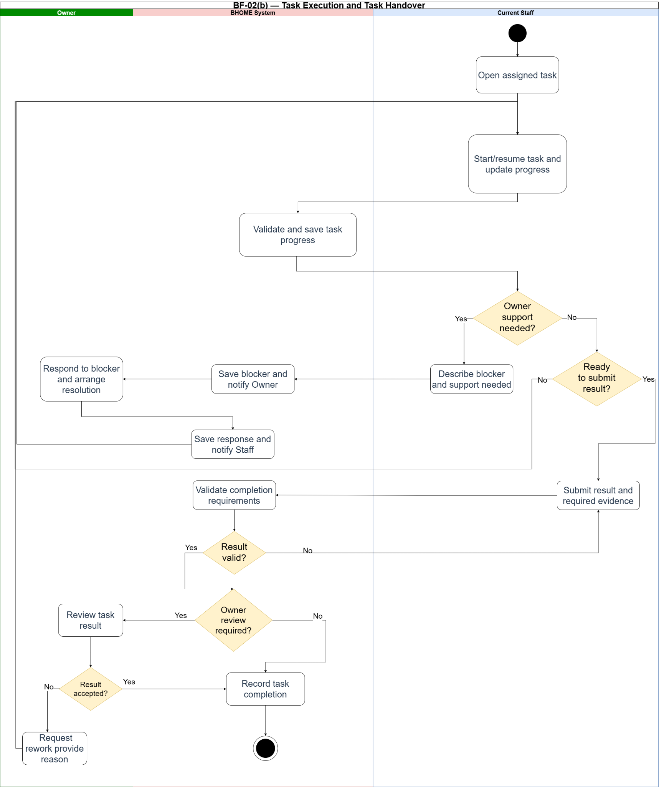

2.3 Tenant and Co-occupant Onboarding, Holding Contract and Main Tenancy Contract (BF-03)

2.3.1 : BF-03A – Holding Contract and Holding Deposit
Trigger: After direct contact with a prospective Tenant, authorized Owner/Staff initiates a Holding Contract for an eligible Room.
End Condition: The Holding Contract is activated and the Room is set to On Hold after successful Holding Deposit verification, with confirmation notification initiated; or the Holding Contract remains Pending Deposit for unresolved payment, or becomes Expired/Cancelled according to the applicable policy, without an active Room hold.
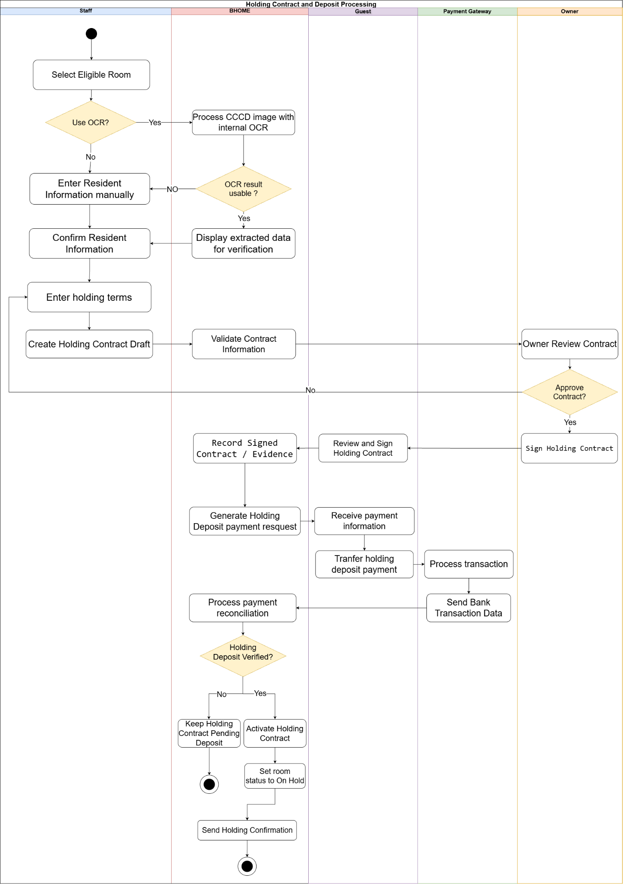

2.3.2 : BF-03B - Tenant Onboarding and Main Tenancy Contact
Trigger: An authorized Owner or Staff initiates Tenant onboarding and Main Tenancy Contract creation for an eligible Room, either directly or from an existing valid Holding Contract .
End Condition: The Main Tenancy Contract is activated after Tenant information is verified and all required initial payment conditions are satisfied. Any verified Holding Deposit is applied to the Security Deposit, the Tenant account is created or linked, and the Room status is updated to Occupied. If payment is not fully verified, the contract remains pending and occupancy is not activated.
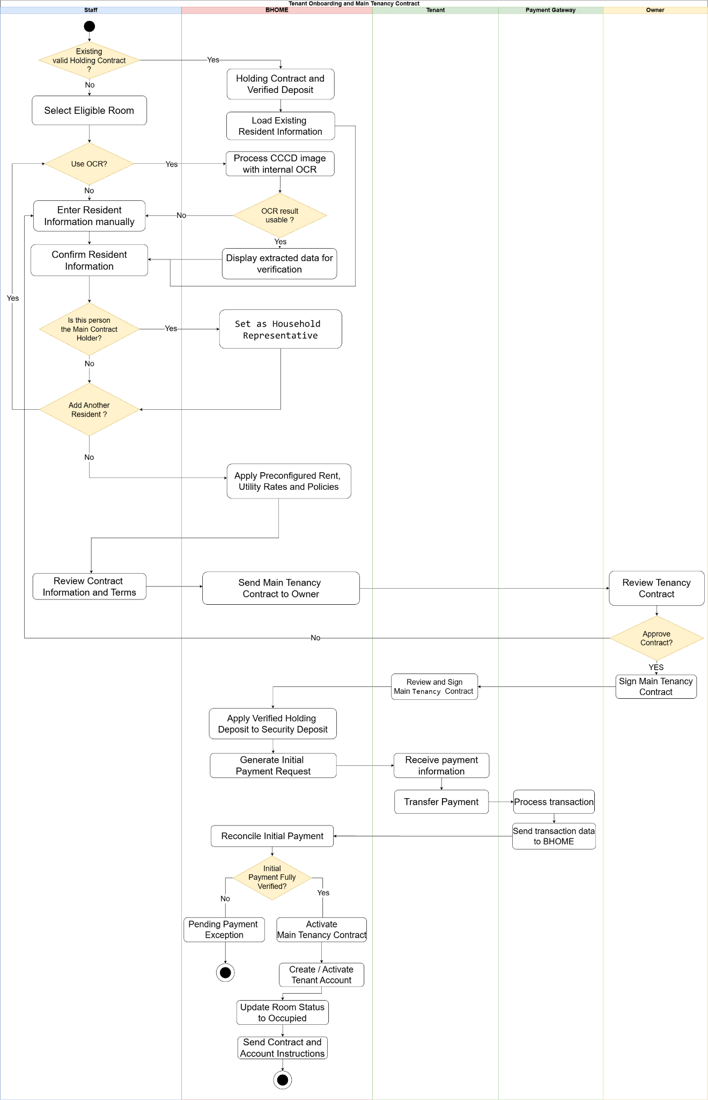

2.4 Temporary Residence and Contract Lifecycle (BF-04)
2.4.1 : BF-04A – Holding Contract and Holding Deposit
Trigger: BHOME detects that a Main Tenancy Contract will expire within 30 days through JOB-02, or the Tenant submits an early termination request.
End condition: The contract is either renewed and remains active, or the termination and move-out process is completed with the final inspection, final charges, Security Deposit settlement, payment/refund status, and contract records updated. Any outstanding amount remains tracked until fully settled.
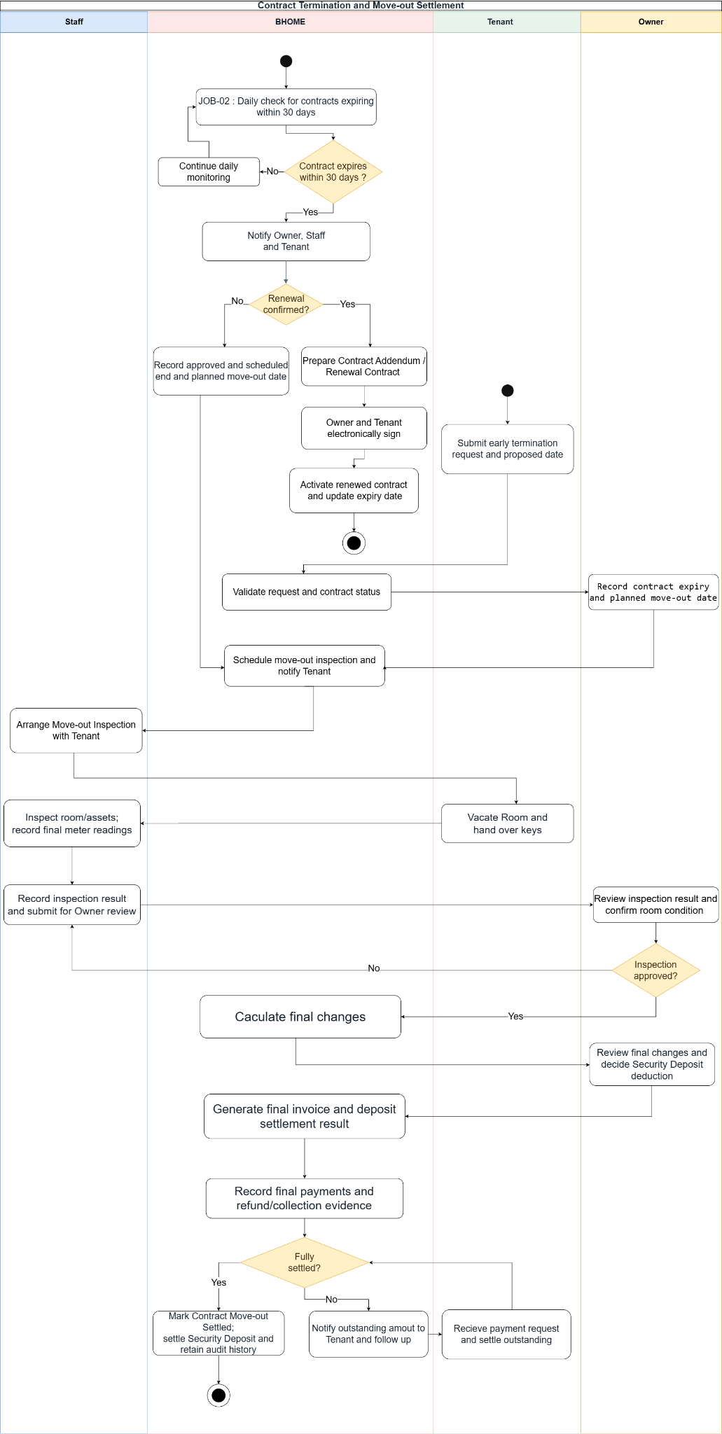
2.4.2 : BF-04B – Temporary Residence Registration
Trigger: Main tenancy contract is activated and the tenant starts actual residence .
End condition: The temporary residence registration result and related evidence are recorded in BHOME, and the Owner and Tenant are notified .
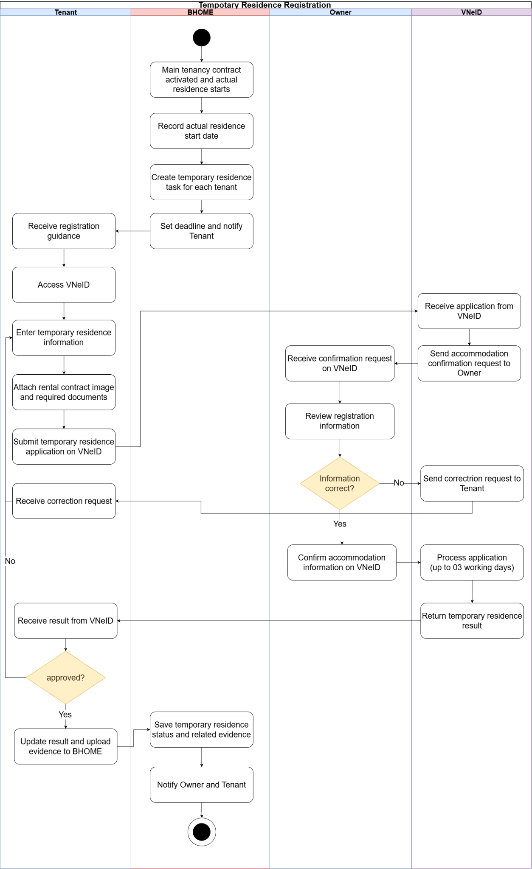

2.5 Meter Reading and Invoice Cycle (BF-05)
2.5.1 Meter Reading and Confirmation (BF-05A)
Trigger: Staff opens an assigned meter-reading task for a Room and begins recording the current electricity or water meter reading.
End condition: The Staff-confirmed meter reading and supporting image evidence are validated and stored by BHOME, and the meter-reading task is marked Completed. The confirmed reading becomes available as billing input.
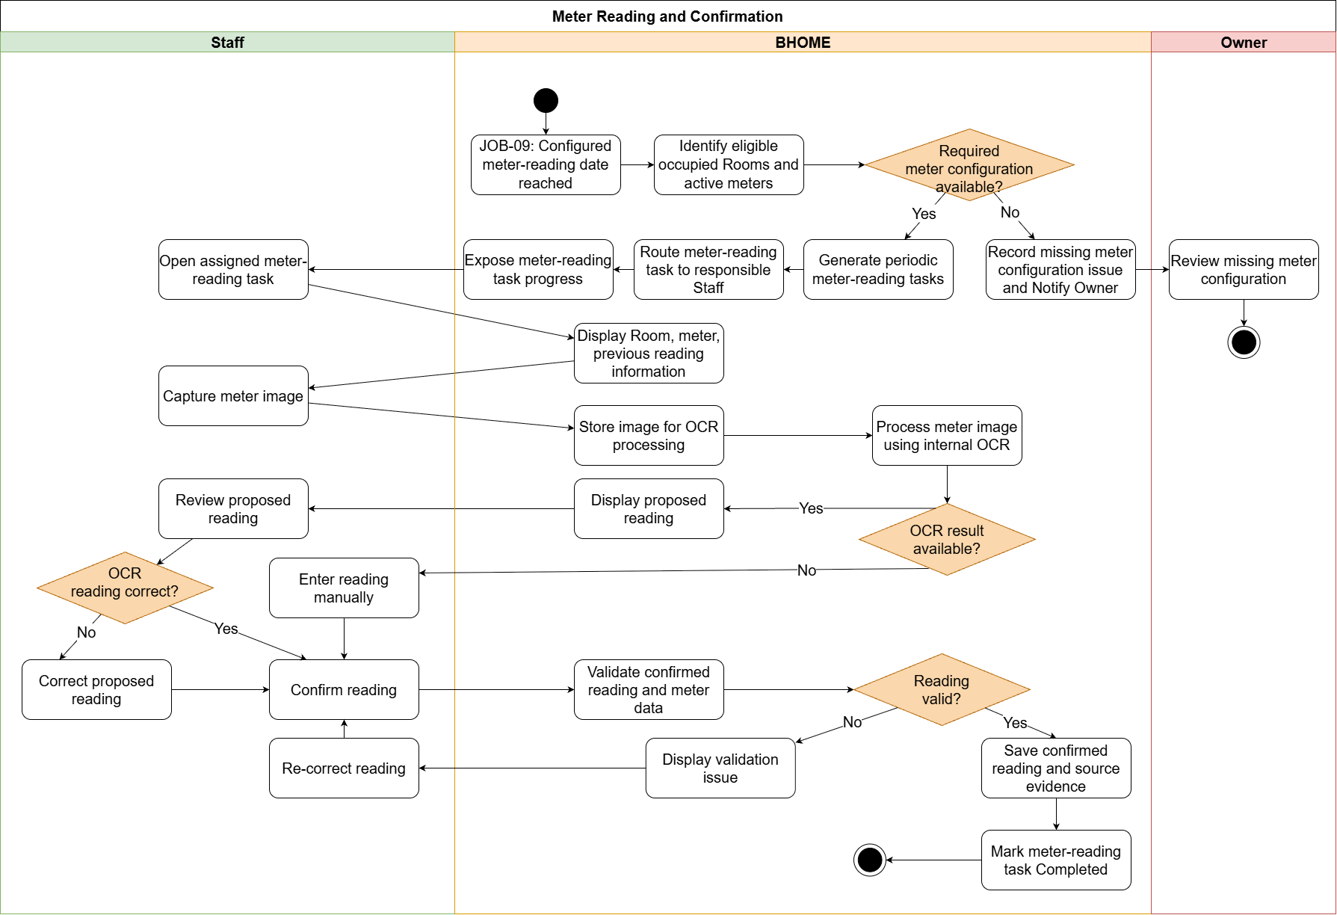
2.5.2 Invoice Cycle (BF-05B)
Trigger: The configured Draft Invoice generation date is reached for a Location, and BHOME starts processing eligible Contracts for the billing period.
End condition: A Draft Invoice is generated and made available to the Tenant for review. On the configured Finalization Date, BHOME finalizes the Invoice using confirmed billing data, assigns the configured Due Date, retains the charge details, and notifies the Tenant. Any correction after finalization must be handled through an Invoice Adjustment record without directly modifying the finalized Invoice.
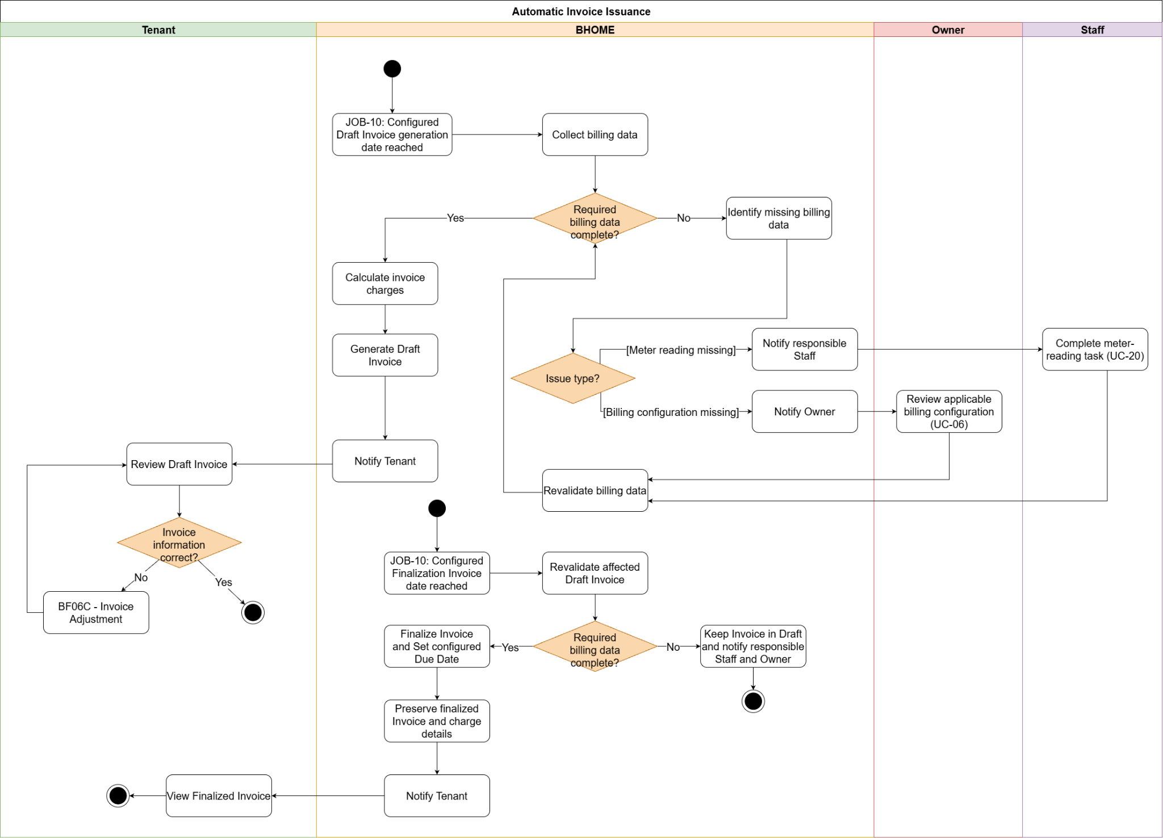

2.6 Bank Payment, Debt and Invoice Adjustment (BF-06)
2.6.1 Bank Payment Reconciliation (BF-06A)
Trigger: Bank transaction data is received from the Payment Gateway, or the Owner performs manual verification when automatic reconciliation cannot identify the related payment obligation.
End condition: A successfully matched or manually verified transaction is recorded once as a verified payment, and the related Invoice or deposit payment state is updated with reconciliation evidence retained. Transactions that cannot be identified or verified remain recorded as unmatched or under manual review with the applicable reason and history.
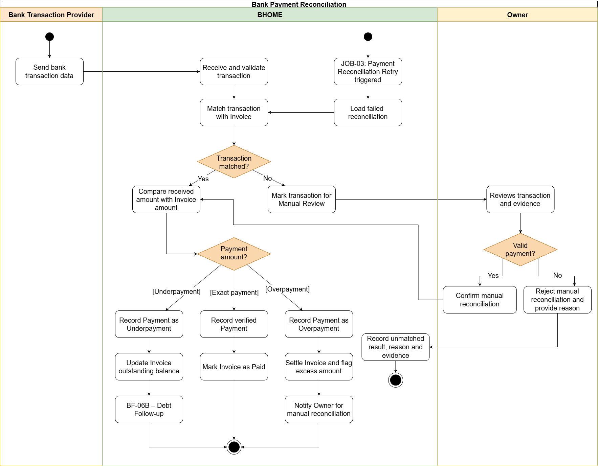
2.6.2 Overdue Debt and Reminder (BF-06B)
Trigger: BHOME evaluates issued Invoices and their verified payment status against the configured Due Date, or an authorized Owner or Staff member opens the outstanding debt list for follow-up.
End condition: Outstanding and overdue amounts are updated with the applicable overdue status and number of overdue days. Eligible payment reminders are recorded and sent to the Tenant. Owner can review detailed debt information, while Staff can access only the debt information required for follow-up within assigned Locations.
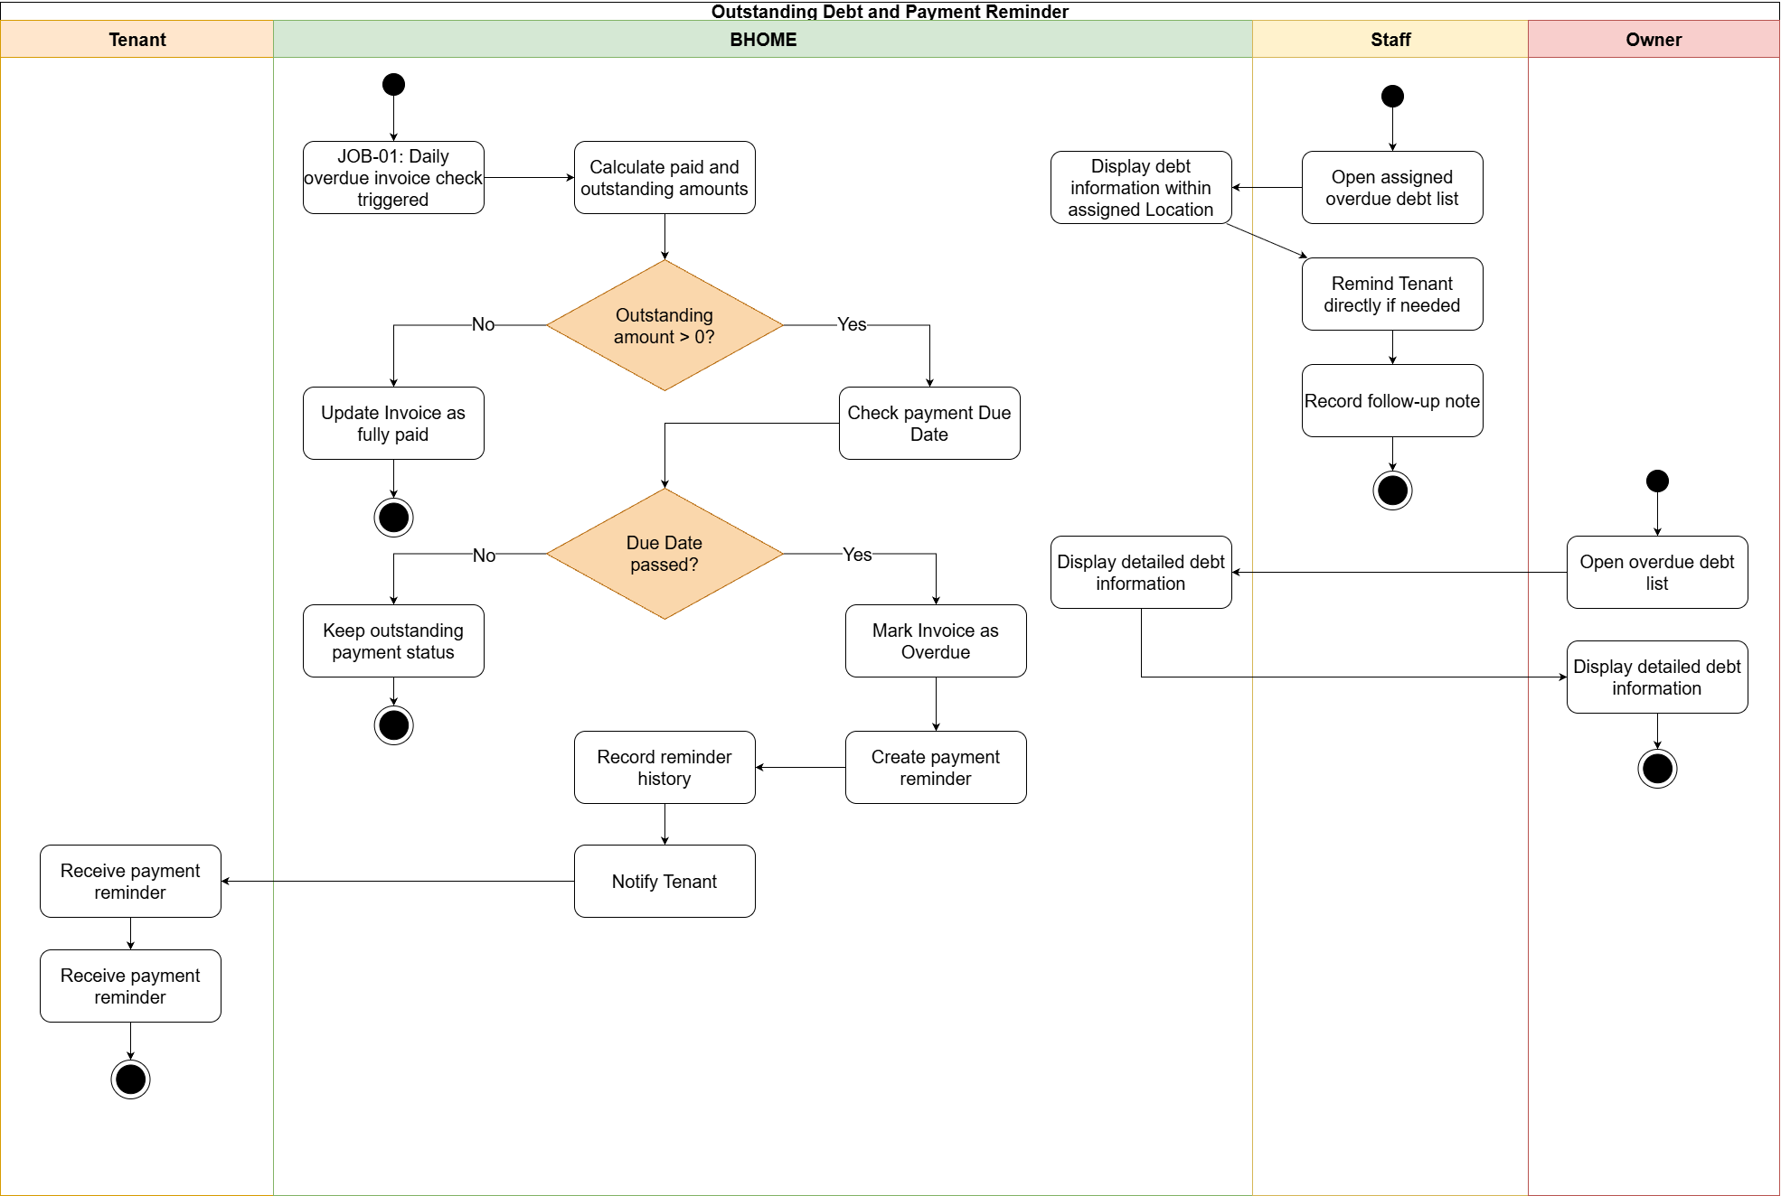
2.6.3 Invoice Adjustment (BF-06C)
Trigger: A Tenant identifies a possible billing error and submits an Invoice Adjustment request with the reason and available supporting evidence.
End condition: The Owner approves or rejects the Invoice Adjustment request and BHOME retains the decision and history. An approved request before finalization updates the Draft Invoice; an approved request after finalization creates a separate Invoice Adjustment record and recalculates the applicable balance without modifying the original finalized Invoice. The Tenant is notified of the result.
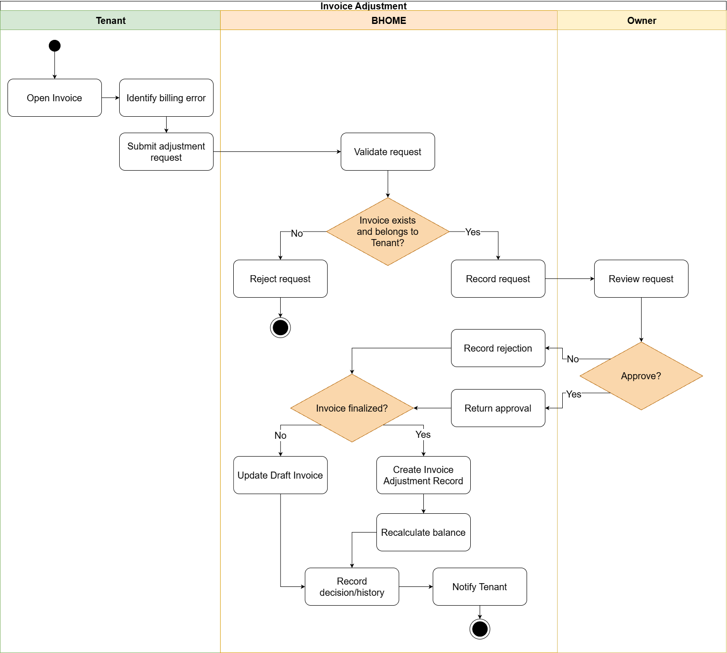

2.7 Incident and Maintenance Handling (BF-07)
Trigger: Tenant or Staff reports a technical malfunction/breakdown or a living-environment issue.
End condition: BHOME records the report and its severity. Emergency reports immediately notify the Owner and responsible Staff for immediate safety actions. The Owner reviews each report, rejects invalid cases, and either handles valid reports directly or assigns a Work Order. Staff inspects, proposes, executes, and submits evidence; the Owner verifies or requests rework. The report is resolved after all required work is verified, with actual cost and maintenance history retained.

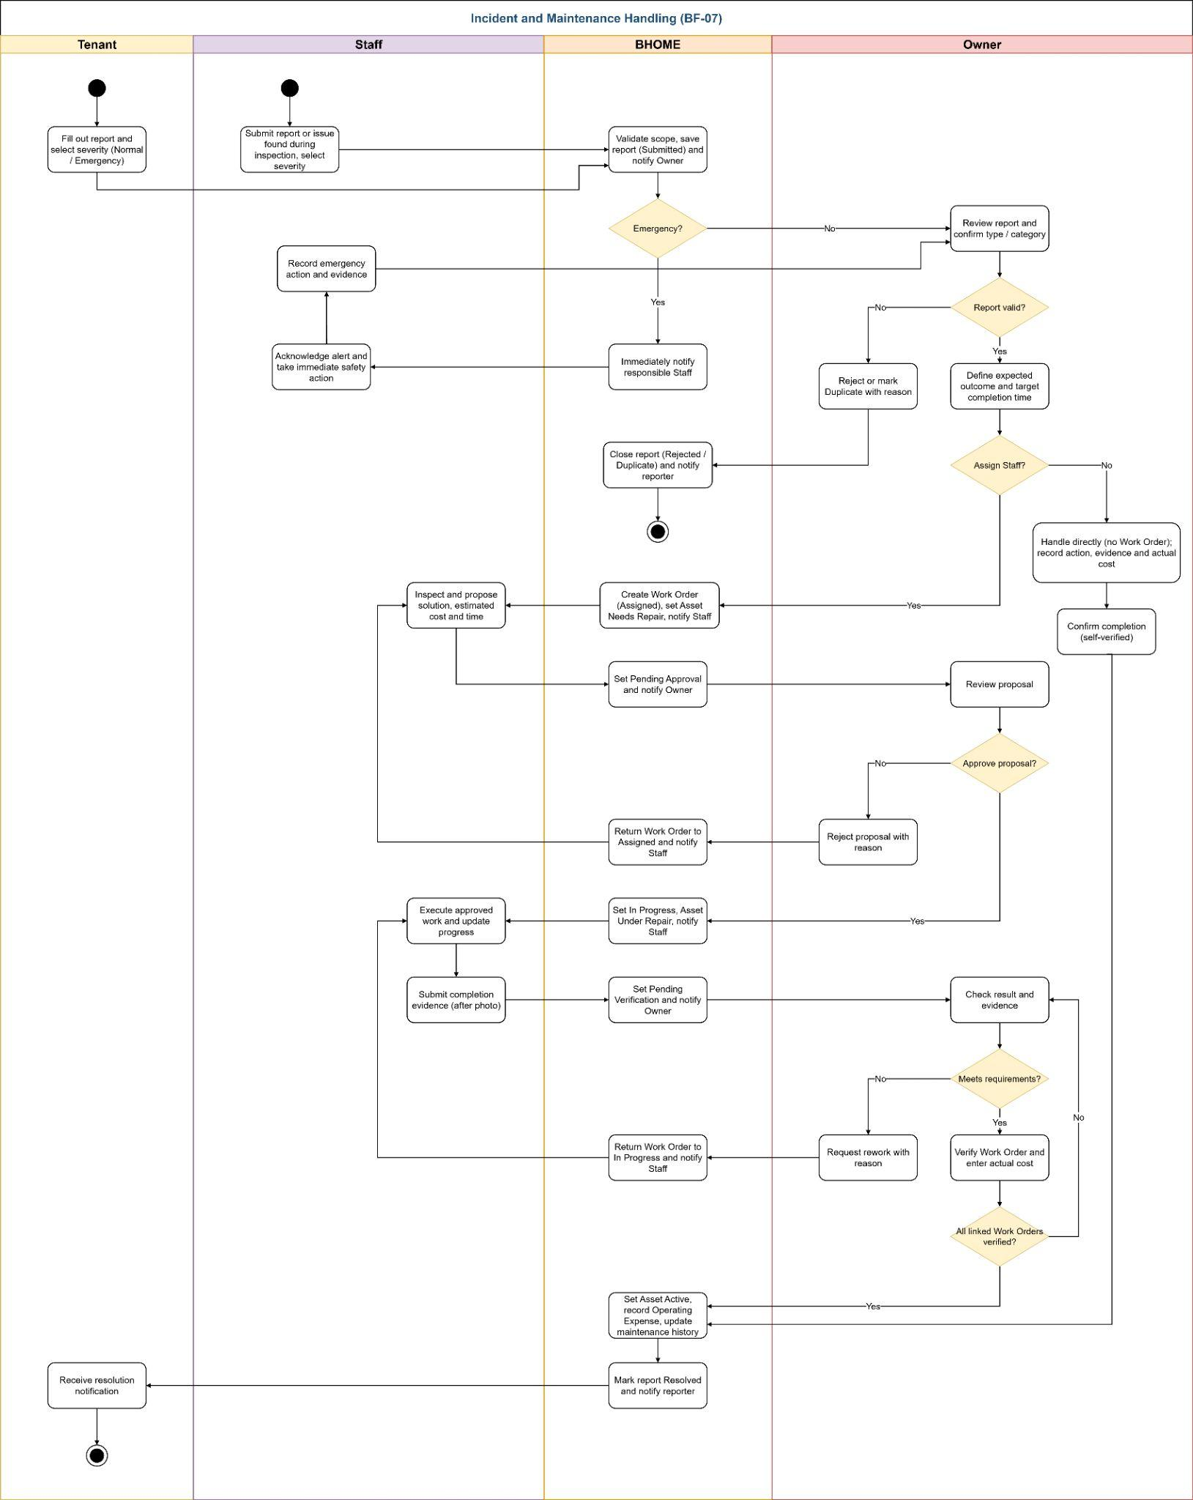

3. Conceptual Data Model

3.1 Entity Relationship Diagram
The conceptual model below shows the business entities required to support the current v1.3 scope. It is not the physical database design; technical tables and implementation details belong to Report 4 - SDD.
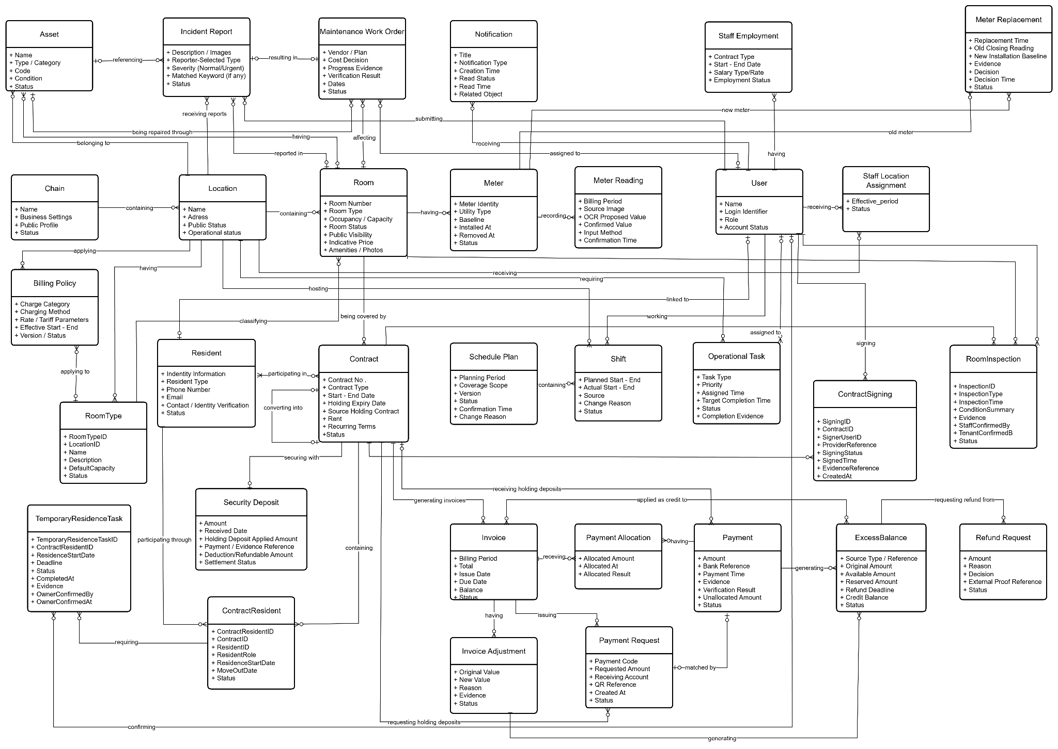

3.2 Entity Descriptions
Entity: Chain
Field | Value
Purpose | Represents the managed boarding-house business boundary of BHOME.
Key business attributes | Name, business settings, public profile, status
Business identity | System-generated identifier; no natural business key is assumed in the current SRS.
Status / lifecycle | Active / Inactive
Entity: Location
Field | Value
Purpose | Represents a physical boarding-house location belonging to the managed Chain.
Key business attributes | Name, address, public status
Business identity | System-generated identifier within the managed Chain; no global natural key is assumed.
Status / lifecycle | Active / Inactive
Entity: Room
Field | Value
Purpose | Represents a rentable room within a Location.
Key business attributes | Room number, location, occupancy/availability data
Business identity | System-generated identifier; room number is interpreted within its Location.
Status / lifecycle | Available / On Hold / Occupied / Unavailable.
Entity: RoomType
Field | Value
Purpose | Represents a configurable type/category of Rooms within a Location and provides reusable Room configuration for Rooms of the same type.
Key business attributes | Location, name, description, default capacity, area/configuration where applicable, amenities/configuration, status
Business identity | System-generated RoomType identifier within one Location. RoomType name should be unique within the applicable Location where required.
Status / lifecycle | Active / Inactive

Entity: RoomInspection
Field | Value
Purpose | Records the Room, Asset and condition evidence used during move-in handover or move-out inspection for a tenancy.
Key business attributes | Contract, Room, inspection type, inspection time, condition summary, Asset conditions, evidence/photos, meter readings where applicable, Staff confirmation and Tenant confirmation
Business identity | System-generated RoomInspection identifier linked to one Contract and one Room.
Status / lifecycle | Recommended: Draft / Pending Confirmation / Confirmed

Entity: User
Field | Value
Purpose | Represents an authenticated Owner, Staff or Tenant account in BHOME.
Key business attributes | Name, login identifier, role, account status
Business identity | System-generated identifier; the configured login identifier must uniquely resolve one account.
Status / lifecycle | Active / Inactive / Temporarily Locked where the security policy applies
Entity: StaffLocationAssignment
Field | Value
Purpose | Defines the Locations in which a Staff member is responsible and authorized to perform predefined Staff operations.
Key business attributes | Staff, Location, effective period, status
Business identity | System-generated identifier linking one Staff member and one Location for an effective period.
Status / lifecycle | Active / Ended
Entity: StaffEmployment
Field | Value
Purpose | Stores Owner-managed Staff employment, base salary, compensation terms and approved bonus/penalty adjustments required for internal Staff-cost calculation. It is not statutory payroll.
Key business attributes | Staff, contract number/type, start date, end date, salary type, salary rate, employment status
Business identity | System-generated employment record identifier linked to one Staff account.
Status / lifecycle | Active / Ended
Entity: Shift
Field | Value
Purpose | Represents a scheduled operating period assigned by the Owner to one Staff member at one Location.
Key business attributes | Schedule Plan, Location, assigned Staff, planned start/end time, actual start/end time where applicable, source, change reason, status
Business identity | System-generated Shift identifier linked to one SchedulePlan, one Staff member and one Location.
Status / lifecycle | Planned / Confirmed / Ongoing / Ended / Cancelled
Entity: OperationalTask
Field | Value
Purpose | Tracks Location-based operational work assigned to responsible Staff, including priority, deadline, progress, evidence, completion submission and Owner verification.
Key business attributes | Location, assigned Staff, task type, priority, assigned time, target completion time, completion evidence, completed time, status
Business identity | System-generated OperationalTask identifier retained through assignment, execution, overdue monitoring and completion verification.
Status / lifecycle | Assigned / In Progress / Pending Verification / Completed / Overdue / Cancelled
Entity: Resident
Field | Value
Purpose | Represents a Tenant or co-occupant identity and contact record associated with a Room tenancy.
Key business attributes | Linked User account, representative/co-occupant role, permitted contact information, verification status, Room/Contract context and residence status.
Business identity | System-generated Resident identifier. Identity-document information is not used as a public business key.
Status / lifecycle | Active / Moved Out
Entity: Contract
Field | Value
Purpose | Represents a Holding Contract, Main Tenancy Contract or supported Addendum governing the Room holding or tenancy relationship between Owner and Tenant.
Key business attributes | Contract number, contract type, Room, representative Tenant, start/end date, Holding expiry date where applicable, rent and recurring terms, source Holding/parent Contract, deposit information and status
Business identity | System-generated Contract identifier. A converted Main Tenancy Contract retains a reference to its source Holding Contract; an Addendum retains a reference to the related Contract.
Status / lifecycle | Draft / Pending Signing / Pending Activation / Active / Converted / Expired / Terminated / Settled / Cancelled, according to Contract type
Entity: ContractSigning
Field | Value
Purpose | Stores the electronic-signing state and evidence returned by the Electronic Contract Provider for each required signer of a Contract.
Key business attributes | Contract, signer User, signer role, provider reference, signing status, signed time, evidence/reference, created time
Business identity | System-generated ContractSigning identifier linked to one Contract and one required signer. A Contract may contain multiple signing records.
Status / lifecycle | Pending / Signed / Failed / Cancelled

Entity: SecurityDeposit
Field | Value
Purpose | Records the Security Deposit associated with a Main Tenancy Contract and its move-out settlement result.
Key business attributes | Main Tenancy Contract reference, required deposit amount, applied Holding Deposit amount, remaining required amount, verified bank-transfer amount, payment/evidence reference, verification actor and time, deduction amount and reason, refundable or remaining amount, settlement notes, settlement actor and time.
Business identity | System-generated Security Deposit identifier linked to the related Contract.
Status / lifecycle | Pending / Received / Settled ,subject to the final deduction and approval rules defined by OQ-01.
Entity: ContractResident
Field | Value
Purpose | Links a Resident to a tenancy Contract and records that person's occupancy role and residence period under the Contract.
Key business attributes | Contract, Resident, resident role, actual move-in/residence start date, move-out date, residence status
Business identity | System-generated ContractResident identifier linking one Resident to one Contract for a residence period.
Status / lifecycle | Planned / Active / Moved Out
Entity: TemporaryResidenceTask
Field | Value
Purpose | Tracks the temporary-residence registration status, deadline, result and evidence for an applicable Resident without submitting records to government systems.
Key business attributes | Contract Resident, actual residence start date, deadline, registration status, registration/completion time, result/evidence, Owner confirmation, confirmation time
Business identity | System-generated TemporaryResidenceTask identifier linked to one ContractResident and one residence-registration tracking cycle.
Status / lifecycle | Pending / In Progress / Completed / Overdue / Cancelled

Entity: MeterReading
Field | Value
Purpose | Records an electricity/water reading, evidence and Staff-confirmed value used for Tenant review and subsequent billing.
Key business attributes | Meter, Room, related Main Tenancy Contract where applicable, reading purpose (initial or periodic), billing period where applicable, reading time, source image, OCR-proposed value, confirmed value, confirming Staff and confirmation time.
Business identity | System-generated MeterReading identifier linked to the Room, meter type and billing period.
Status / lifecycle | Proposed → Confirmed / Corrected
Entity: Invoice
Field | Value
Purpose | Represents a periodic billing obligation for a Main Tenancy Contract, generated first as a Draft and later finalized for payment.
Key business attributes | Contract, billing period, charge breakdown, total, draft/final issue date, due date, paid amount, outstanding balance
Business identity | System-generated Invoice identifier; only one finalized periodic Invoice may exist for the same Contract and billing period.
Status / lifecycle | Draft → Finalized → Partially Paid / Overdue → Paid
Entity: InvoiceAdjustment
Field | Value
Purpose | Records a traceable correction to an Invoice after the Invoice has been issued.
Key business attributes | Invoice, original value, new value, reason, evidence, approval result
Business identity | System-generated InvoiceAdjustment identifier linked to one issued Invoice.
Status / lifecycle | Requested / Approved / Rejected / Applied, as permitted by the applicable policy
Entity: Payment
Field | Value
Purpose | Records the actual bank-transfer amount received and matched to an Invoice or a Holding Deposit obligation associated with a Holding Contract.
Key business attributes | Amount, bank transaction reference, payment time, source, matched PaymentRequest, verification evidence and match result.
Business identity | System-generated Payment identifier together with the retained external bank transaction reference or evidence.
Status / lifecycle | Matched / Underpayment / Overpayment / Manual Review

Entity: RefundRequest
Field | Value
Purpose | Tracks Tenant refund requests against available excess balances, Owner decisions and evidence of external refund execution.
Key business attributes | ExcessBalance reference, requesting Tenant, requested amount, reason, receiving bank account, request time, Owner decision/reason, reserved amount, completion time and external transfer evidence.
Business identity | System-generated RefundRequest identifier linked to the related ExcessBalance and requesting Tenant.
Status / lifecycle | Requested → Approved → Completed, or Requested → Rejected. Requested and Approved amounts remain reserved until rejection or completed external refund.
Entity: Asset
Field | Value
Purpose | Represents equipment or managed assets declared for a Room or common operational area and used in incident and maintenance workflows.
Key business attributes | Name/type, equipment category, asset code where used, Location or Room scope, purchase information where applicable, condition, photos, repair history
Business identity | System-generated Asset identifier; an operator-facing asset code may be retained within the managed BHOME scope where configured.
Status / lifecycle | Active → Needs Repair → Under Repair → Active / Retired
Entity: IncidentReport
Field | Value
Purpose | Represents a Tenant- or Staff-submitted incident, maintenance or living-environment issue requiring BHOME handling. Normal incidents follow Owner review and assignment; Emergency incidents immediately notify the Owner and responsible Staff.
Key business attributes | Report code, reporter, Location, Room/common area, related Asset where applicable, description, images/evidence, severity (Normal/Emergency), acknowledgement time, handling method (Work Order / Direct), direct-handling actual cost. Owner classification, rejection/cancellation reason, duplicate-of reference, resolution note
Business identity | System-generated IncidentReport identifier; each submitted report remains independently traceable.
Status / lifecycle | Submitted → In Progress → Resolved / Rejected / Duplicate / Cancelled
Entity: MaintenanceWorkOrder
Field | Value
Purpose | Represents repair or maintenance work created from an IncidentReport or identified operational issue and tracked through Staff execution until Owner verification.
Key business attributes | Source IncidentReport, Location, Room/Asset where applicable, work plan, expected outcome, target completion time, assigned Staff, progress evidence, vendor where applicable, estimated/actual cost, verifier, verification time, rework reason
Business identity | System-generated MaintenanceWorkOrder identifier. One IncidentReport may result in one or more Work Orders.
Status / lifecycle | Assigned → Pending Approval → In Progress → Pending Verification → Verified / Cancelled. A rejected proposal returns the Work Order to Assigned; a rework request returns it to In Progress.
Entity: BillingPolicy
Field | Value
Purpose | Represents effective-dated utility-rate, charging-method and recurring-charge parameters used by BHOME for billing calculations within an applicable business scope.
Key business attributes | Applicable scope, charge category, charging method, rate or tariff parameters, effective start/end dates, version, Owner change actor/time.
Business identity | System-generated BillingPolicy identifier. Policy versions are distinguished by business scope, charge category and effective period.
Status / lifecycle | Effective-dated policy versions are retained historically. A policy may become active according to its effective period and later be retired or superseded without changing calculation data already used by issued invoices.

Entity: Meter
Field | Value
Purpose | Represents an electricity or water meter installed for a Room and provides the authoritative meter identity and baseline used to validate Meter Readings.
Key business attributes | Room, meter identity/code, utility type, baseline, installation time, removal time, operating status.
Business identity | System-generated Meter identifier together with the retained operator-visible meter identity where applicable.
Status / lifecycle | Active / Removed or equivalent operating states. Installation and removal history is retained.

Entity: Meter Replacement
Field | Value
Purpose | Records the controlled replacement of an existing Room meter with a new meter while preserving billing continuity and evidence.
Key business attributes | Room, utility type, old Meter, new Meter, replacement time, old closing reading, new installation baseline, evidence, requested/recorded Staff, Owner decision, decision reason, decision time.
Business identity | System-generated MeterReplacement identifier linking exactly one old Meter and one new Meter.
Status / lifecycle | Pending Approval / Approved / Rejected

Entity: PaymentRequest
Field | Value
Purpose | Represents bank-transfer payment instructions for either an issued Invoice or a Holding Deposit associated with a Holding Contract.
Key business attributes | Payment purpose (INVOICE / HOLDING_DEPOSIT), Invoice or Holding Contract reference, Payment Code, requested amount, receiving account, QR reference, creation time and status.
Business identity | System-generated identifier with a unique Payment Code. Each request references exactly one Invoice or one Holding Contract, according to its payment purpose.
Status / lifecycle | Current / Replaced / Settled / Expired / Cancelled. Historical requests remain traceable.
Entity: PaymentAllocation
Field | Value
Purpose | Represents the financial effect of applying part or all of a verified bank Payment to an Invoice outstanding balance.
Key business attributes | Payment, Invoice, allocated amount, allocation time, resulting allocation outcome.
Business identity | System-generated PaymentAllocation identifier linking one Payment to one Invoice allocation event.
Status / lifecycle | Applied and retained as financial history. Duplicate provider or reconciliation events must not create duplicate allocation effects.

Entity: SchedulePlan
Field | Value
Purpose | Represents an Owner-managed, versioned Staff schedule for a defined Location and planning period.
Key business attributes | Location/coverage scope, planning period, version, status, confirmation actor/time, change reason.
Business identity | System-generated SchedulePlan identifier; versions are retained for the same planning context.
Status / lifecycle | Draft → Confirmed → Superseded / Cancelled
Entity: ExcessBalance
Field | Value
Purpose | Records excess funds from verified overpayments or approved Invoice Adjustments and tracks refund eligibility, Tenant Credit conversion, usage and settlement.
Key business attributes | Tenant, related Contract, source Payment or Invoice Adjustment, original excess amount, available amount, reserved refund amount, refund deadline, converted credit, remaining credit, settlement references.
Business identity | System-generated ExcessBalance identifier linked to the originating Payment or Invoice Adjustment and relevant Tenant.
Status / lifecycle | Refund-eligible excess may be reserved for Requested or Approved refunds. Expired unreserved amounts convert once into Tenant Credit, which is applied to future Invoices or settled externally at move-out. Partial balances and settlement history are retained.
Entity: Notification
Field | Value
Purpose | Represents a persistent in-app notification delivered to an authenticated BHOME user for a relevant business event.
Key business attributes | Recipient User, title, notification type, creation time, read status, read time, related business object where applicable.
Business identity | System-generated Notification identifier linked to one recipient User.
Status / lifecycle | Unread / Read

3.3 Data Business Rules

Rule | Description | Enforced On
DBR-01 | Staff may access operational data only for Locations currently assigned to them. | StaffLocationAssignment (StaffID, LocationID, EffectiveFrom, EffectiveTo)
DBR-02 | A Room cannot have conflicting active Holding or Main Tenancy Contracts for the same period. | Contract (RoomID, PrimaryTenantID) and SecurityDeposit (ContractID)
DBR-03 | Contract signing status and evidence returned by the Electronic Contract Provider must remain traceable. | Meter (RoomID, UtilityType, Status, effective period)
DBR-04 | Temporary-residence tasks are tracked per applicable Tenant and actual residence start date. | Invoice (ContractID, BillingPeriod, Status) and InvoiceAdjustment (InvoiceID)
DBR-05 | Only one active Meter of each utility type may exist for a Room at the same time. | Payment reconciliation event identifier and PaymentAllocation
DBR-06 | Only one finalized periodic Invoice may exist for the same Contract and billing period. | Contract (RoomID, ContractType, effective period, Status)
DBR-07 | A finalized Invoice cannot be edited directly; corrections use InvoiceAdjustment. | AuditLog records — INSERT only; no UPDATE or DELETE
DBR-08 | Duplicate bank transactions or reconciliation retries must not create duplicate payment effects. | Notification (RecipientUserID, ReadStatus)
DBR-09 | Every incident report must identify its severity as Normal or Emergency. | PaymentRequest, Payment, Contract
DBR-10 | Maintenance cost must be linked to the related Location, Room, Asset or work item. | MaintenanceWorkOrder, OperatingExpense,IncidentReport
DBR-11 | FinancialScenario data must remain separate from actual investment, revenue and expense data. | FinancialScenario
DBR-12 | Public Website data must contain only approved non-sensitive information. | PublicContent
DBR-13 | Audit records are append-only and cannot be modified or deleted through normal business functions. | AuditLog
Workflow and authorization rules are defined once in the GBR catalogue in Section V.1.

4. User Requirements

4.1 Actors
# | Actor | Description
1 | Owner | Authenticated chain-wide decision maker. Manages property configuration, Staff accounts and employment, Contracts, residence confirmations, financial information, maintenance decisions and business performance.
2 | Staff | Authenticated operator limited to assigned Locations. Performs operational tasks, Tenant onboarding verification, Room handover, meter capture, inspection, incident reporting, maintenance work and debt follow-up. Staff does not perform temporary-residence registration and has limited access to Tenant personal data.
3 | Tenant | Authenticated resident who manages permitted profile information and accesses their Room, Contract, confirmed meter readings, Invoice, payment, residence status, requests and notifications. Tenant performs temporary-residence registration outside BHOME and may record the result/evidence.
4 | Guest | Non-RBAC user who views approved public Location, Room, amenity, indicative-pricing, vacancy and contact information.
5 | Payment Gateway | External service providing bank-transfer transaction or reconciliation data. Owner manual verification remains available when automatic reconciliation is unavailable.
6 | Notification Service | External service used for supported push/email delivery. Delivery failure does not change the committed business transaction or persistent in-app notification.
7 | Time | Logical actor representing scheduled time triggers for internal BHOME background jobs. It initiates automatic invoice issuance when the configured billing date is reached.
8 | Electronic Contract Provider | External service supporting electronic signing and returning contract signing status and evidence to BHOME.

4.2 Use Cases (UC)

ID | Use Case | Feature | Use Case Description
UC-01 | Sign In | FE-02 | Owner, Staff and Tenant sign in and access functions allowed for their role.
UC-02 | Sign Out | FE-02 | Authenticated users securely end their current session.
UC-03 | View / Update Personal Profile | FE-02 | Users view/update permitted profile information. On first login, Tenant completes required profile information; identity-related changes may require Staff verification.
UC-04 | Manage Locations, Room Types and Rooms | FE-01 | Owner creates and updates Locations, Room Types, Rooms and Room status.
UC-05 | Manage Assets and Facilities | FE-06 | Owner manages Room/common assets; Staff updates asset condition within assigned Locations.
UC-06 | Manage Rental Rates and Fees | FE-04 | Owner configures rental prices, utility rates and applicable service fees.
UC-07 | View Occupancy and Room History | FE-01 | Owner views occupancy and Room history; Staff views data within assigned Locations.
UC-08 | Manage Staff Accounts, Employment and Location Assignments | FE-01 / FE-02 | Owner creates, activates/deactivates Staff accounts and manages Staff employment, compensation information and Location assignments.
UC-09 | Manage Staff Shifts | FE-01 | Owner manages Staff schedules; Staff views their assigned shifts and changes.
UC-10 | Create and Assign Operational Tasks | FE-01 | Owner creates recurring or ad-hoc tasks and assigns responsible Staff and deadlines.
UC-11 | Execute and Update Operational Tasks | FE-01 | Staff performs assigned tasks and records progress, blockers and evidence.
UC-12 | Monitor and Coordinate Operational Tasks | FE-01 | Owner monitors task progress, requests changes or rework and confirms completion.
UC-13 | Manage Tenant and Occupant Information | FE-03 | Owner manages Tenant/co-occupant records; Staff performs authorized onboarding verification and can access only operational information required within assigned Locations.
UC-14 | Prepare and Sign Holding Contract | FE-03 | Staff prepares the Holding Contract; Owner and Tenant review and sign it through the supported signing process.
UC-15 | Prepare, Sign and Activate Main Tenancy Contract | FE-03 | Staff prepares the Main Tenancy Contract; Owner and Tenant sign it; Owner activates it. BHOME then creates or links the Tenant account and sends activation information.
UC-16 | Manage Contract Addendum and Renewal | FE-03 | Owner and Staff prepare Addendums for renewal or supported Contract changes and retain change history.
UC-17 | Perform Move-in Room Handover | FE-03 | Staff and Tenant confirm Room condition, assets and initial meter readings at move-in.
UC-18 | Track Temporary Residence Registration | FE-03 | Tenant performs temporary-residence registration outside BHOME; BHOME tracks status/evidence and Owner confirmation without Staff processing or government submission.
UC-19 | Handle Contract Expiry, Renewal and Termination | FE-03 | Owner, Staff and Tenant handle renewal or termination; Staff records move-out inspection and final readings, Owner decides settlement, and BHOME closes the Contract after required conditions are resolved.
UC-20 | Capture and Confirm Meter Readings | FE-04 | Staff captures and confirms meter readings; BHOME makes confirmed readings and usage visible to Tenant before billing.
UC-21 | Generate, Finalize and View Invoice | FE-04 | BHOME generates Draft/Final Invoices using confirmed Tenant-visible billing data and allows authorized users to view them.
UC-22 | Reconcile Bank Payment | FE-05 | BHOME matches bank transactions with invoices or deposits; Owner handles unmatched transactions.
UC-23 | Track Outstanding Debt and Send Reminders | FE-05 | BHOME tracks outstanding and overdue amounts and sends payment reminders.
UC-24 | Request and Approve Invoice Adjustment | FE-04 | Tenant requests an invoice correction; Owner approves or rejects it while preserving the original invoice.
UC-25 | View Payment History | FE-05 | Tenant views their payment history; Owner views payment records by Room or Location.
UC-26 | Submit Incident or Maintenance Report | FE-06 / FE-07 | Tenant or Staff reports Normal or Operational Emergency incidents with description and evidence.
UC-27 | Respond to Emergency Incident | FE-06 | BHOME notifies Owner and responsible Staff for Operational Emergency containment; life-safety emergencies are directed to public emergency services first.
UC-28 | Review and Assign Incident Handling | FE-06 | Owner reviews an incident and assigns Staff to inspect or handle it.
UC-29 | Inspect, Propose and Execute Repair | FE-06 | Staff inspects the issue, proposes solution/cost/time and performs approved repair work.
UC-30 | Verify Completion and Update Maintenance History | FE-06 | Owner verifies the result; BHOME records actual cost, result and related operational history.
UC-31 | Manage Initial Investment and Operating Expenses | FE-08 | Owner records initial investment and operating expenses by Location and category.
UC-32 | View Business Reports | FE-08 | Owner views occupancy, revenue, expenses, debt and operating profit by Room, Location or chain.
UC-33 | Track Capital Recovery and Payback | FE-08 | BHOME calculates capital recovery and estimated payback using available actual business data.
UC-34 | Analyze Financial What-if Scenario | FE-08 | Owner changes hypothetical inputs and compares projected financial results without changing actual data.
UC-35 | Send Tenant Notifications | FE-07 | Owner or Staff sends operational notices; Staff is limited to assigned Locations.
UC-36 | View Notifications | FE-07 | Owner, Staff and Tenant receive and view relevant system and operational notifications.
UC-37 | Publish Public Location and Room Information | FE-09 | Owner selects and publishes approved non-sensitive Location and Room information.
UC-38 | View Public Location and Room Information | FE-09 | Guest views published Locations, Rooms, amenities, indicative prices, vacancy and contact information.

4.3 Use Case Diagrams

4.3.1 Overall Use Case Diagram
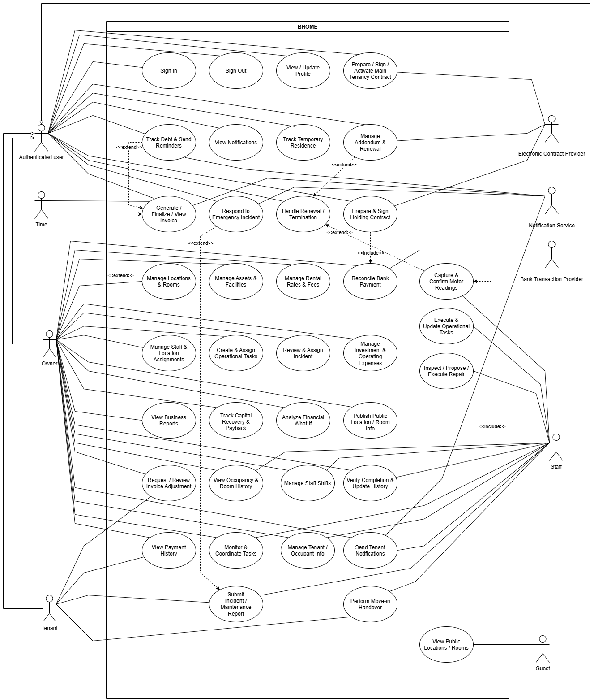

4.3.2 UCs for Owner
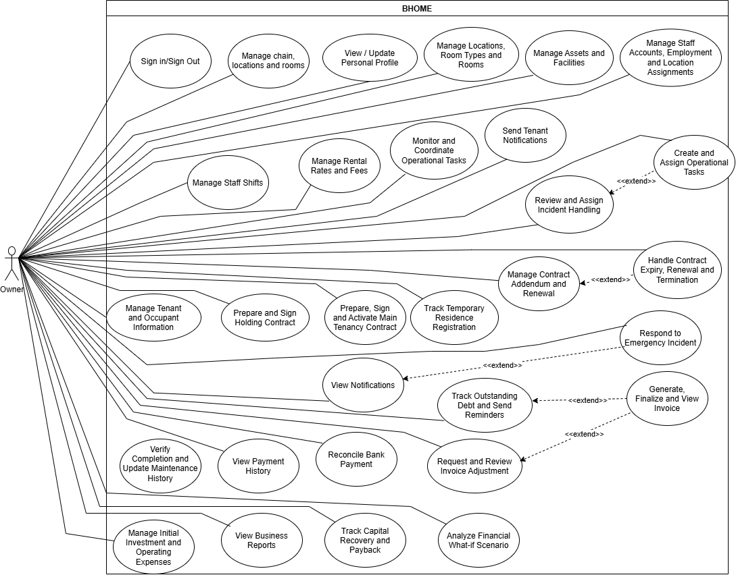

4.3.3 UCs for Staff
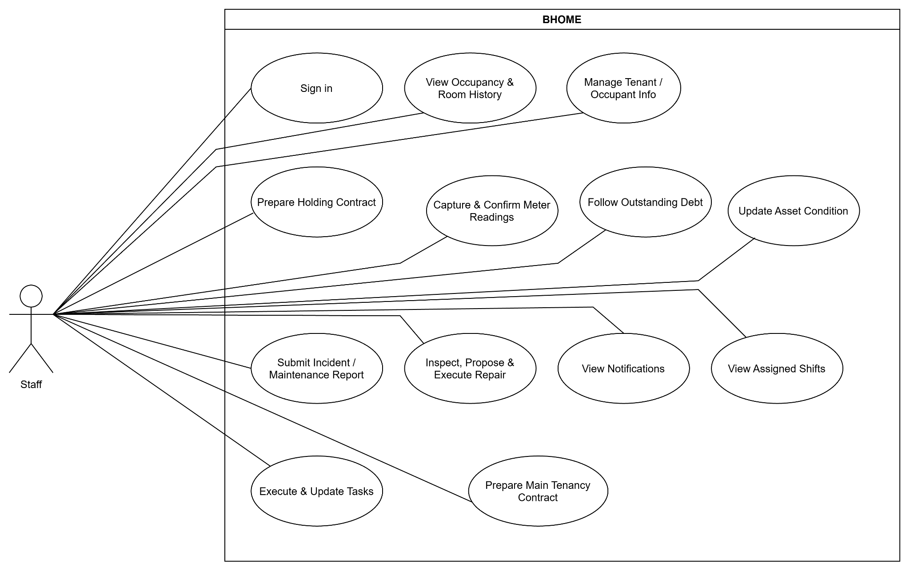

4.3.4 UCs for Tenant
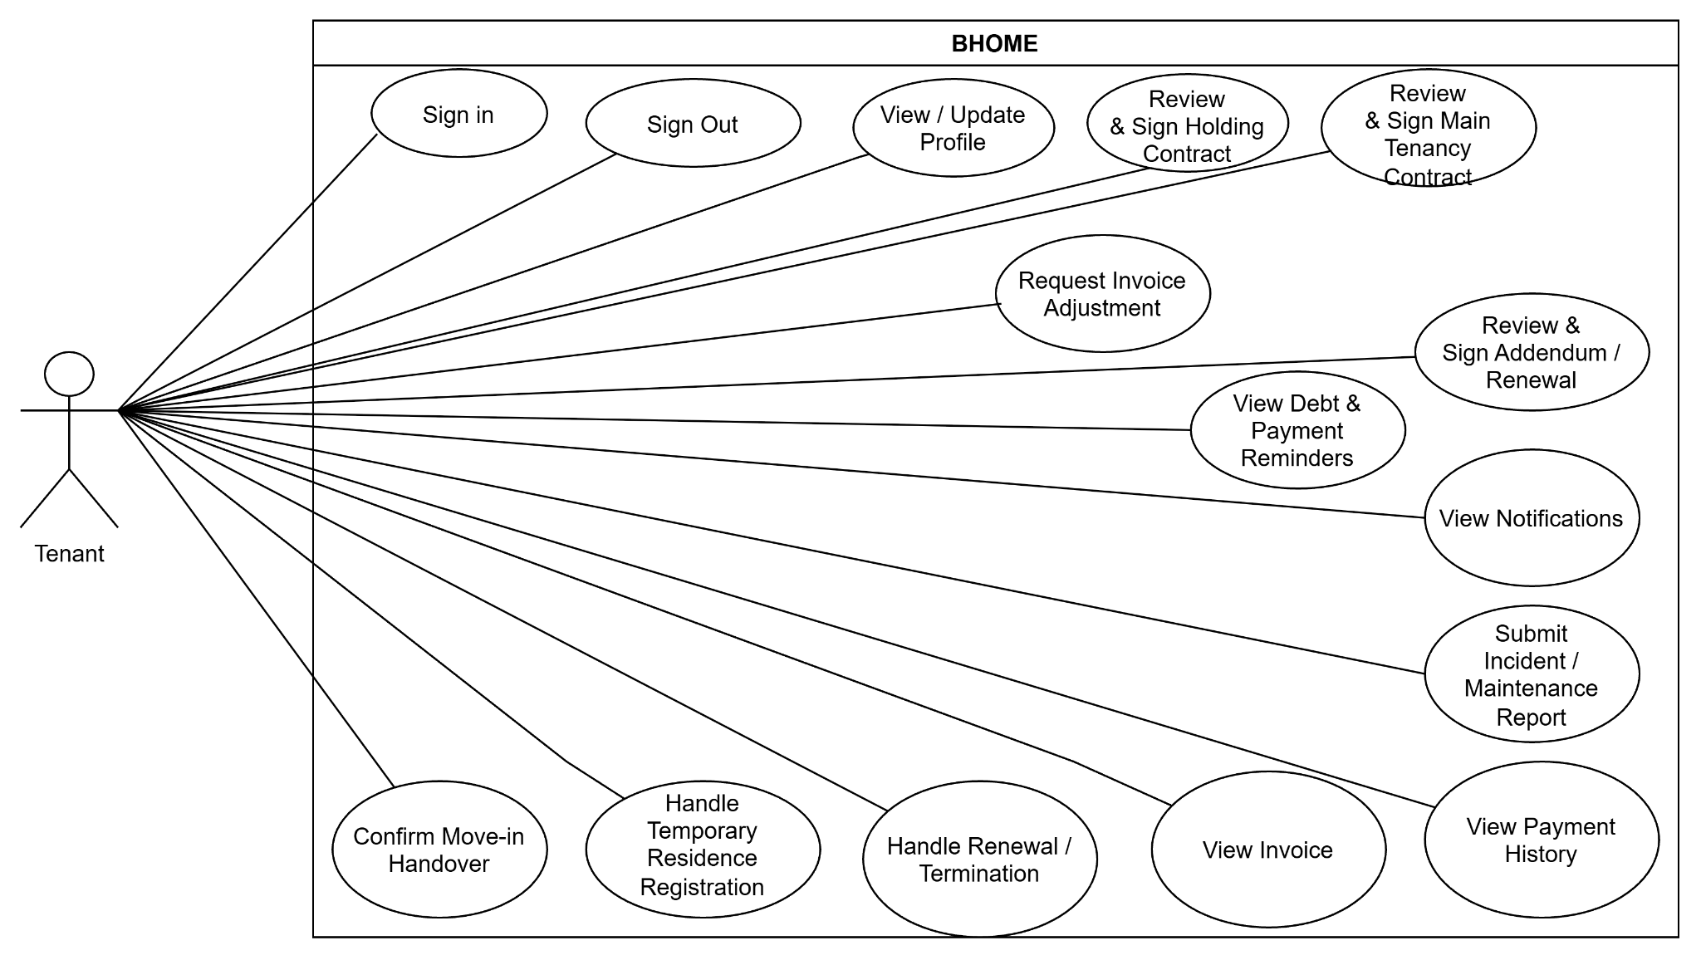

4.3.5 UCs for Guest
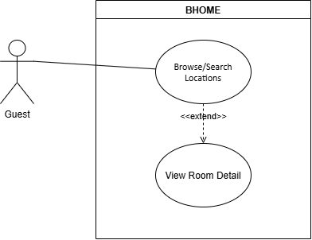

4.4 Permission Matrix
Full = chain-wide or unrestricted for the role. Restricted = own data or assigned-location scope, or action requires an Owner decision. No = denied. Guest is public and non-RBAC.

Entity / Area | Owner | Staff | Tenant | Guest
Account / Profile | Own account; manage Staff accounts | Own account | Own account; update permitted profile | No
Location / Room | Full | View assigned Locations | View own Room | Published only
Assets | Full | Update condition in assigned Locations | View own-Room information where allowed | No
Staff / Employment | Full | Own employment/compensation information | No | No
Shift | Manage | View own shifts | No | No
Operational Task | Create, assign, monitor, verify | Execute assigned tasks | No | No
Tenant / Occupant | Full | Limited operational data in assigned Locations; verification data only during authorized task | Own information | No
Contract | Final decision, activate, renew, terminate | Prepare/support within assigned Location | View/sign/request renewal or termination | No
Room Handover | Monitor | Create/confirm | Confirm own handover | No
Temporary Residence | Monitor / confirm required accommodation information | No | Manage own status/evidence | No
Meter Reading | View | Capture and confirm | View confirmed reading and usage before billing | No
Invoice | Full | Operational view where required | Own invoices | No
Invoice Adjustment | Approve/reject | No | Request/view own | No
Payment / Debt | Full | Restricted debt follow-up | Own payment/debt | No
Incident / Maintenance | Final decision / cost approval / verification | Report, inspect and execute assigned work | Report/view own | No
Emergency Incident | Full monitoring | Operational containment in assigned Location | Submit/track; life-safety guidance | No
Finance / What-if | Full | No | No | No
Notifications | Full | Assigned Location scope | Receive own | No
Public Information | Publish/manage | View | View | View

5. System Functionalities
The Owner Web Portal is the primary administration interface for Owner. The Mobile Application is the primary operational client for Staff and Tenant and provides Owner with monitoring, notifications and quick-response functions. The Public Website is limited to approved Guest-facing information.

5.1 Screen Inventory

a. Screen Flow
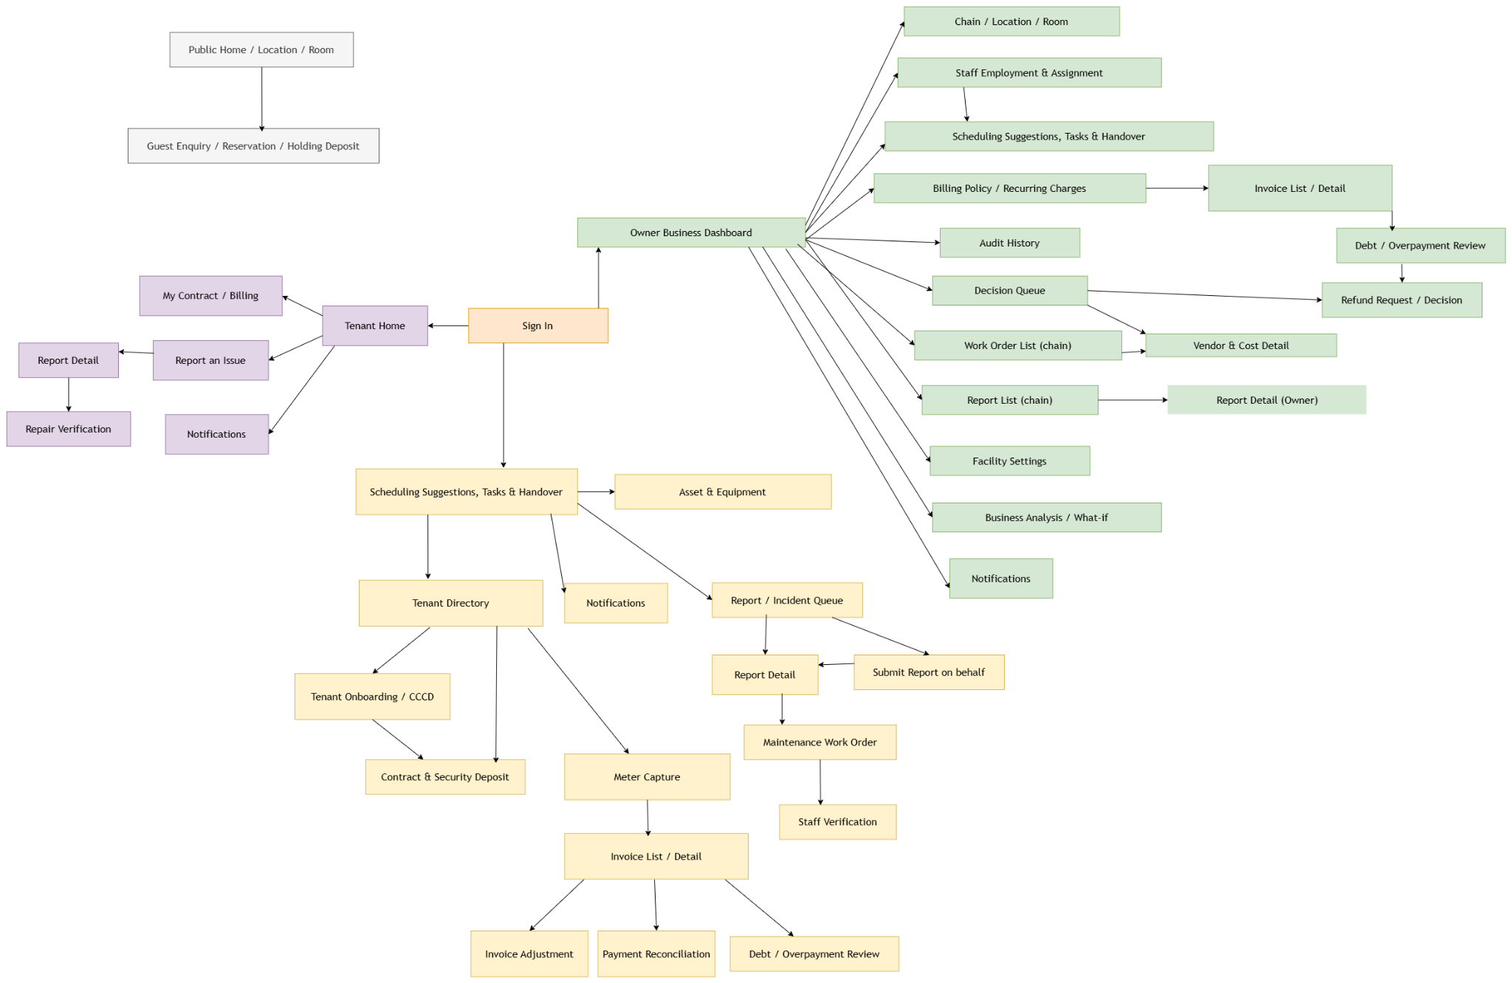

b. Screen List

# | Screen Name | Feature | Description
1 | Sign In | FE-02 | Authenticates Owner, Staff and Tenant.
2 | Profile | FE-02 | Displays and updates permitted personal information.
3 | Owner Dashboard | FE-08 | Displays key business and operational indicators.
4 | Location / Room Management | FE-01 | Manages Locations, Room Types, Rooms and status.
5 | Occupancy / Room History | FE-01 | Displays occupancy and Room history.
6 | Asset Management | FE-06 | Manages Room/common assets and condition history.
7 | Staff Management | FE-01 / FE-02 | Manages Staff account, employment and Location assignment.
8 | Staff Shift Management | FE-01 | Manages Staff schedules and shifts.
9 | Operational Task Management | FE-01 | Creates, assigns and monitors operational tasks.
10 | Tenant / Occupant Management | FE-03 | Manages Tenant, co-occupant and Room assignment information.
11 | Contract Management | FE-03 | Manages Holding and Main Tenancy Contracts.
12 | Contract Signing Status | FE-03 | Displays electronic signing status and evidence.
13 | Room Handover | FE-03 | Records Room/assets and initial meter condition.
14 | Temporary Residence Tasks | FE-03 | Tracks residence deadlines, status and evidence.
15 | Meter Reading | FE-04 | Captures and confirms electricity/water readings.
16 | Billing Policy | FE-04 | Configures rental, utility and recurring fee rules.
17 | Invoice Management | FE-04 | Displays draft/final invoices and billing status.
18 | Invoice Adjustment | FE-04 / FE-07 | Creates/reviews invoice correction requests.
19 | Payment Reconciliation | FE-05 | Reviews automatic and manual bank reconciliation.
20 | Debt Management | FE-05 | Displays outstanding and overdue debt.
21 | Incident / Maintenance Management | FE-06 | Displays Normal and Emergency reports and handling status.
22 | Incident Detail | FE-06 | Displays report, evidence, severity and handling history.
23 | Repair Task / Proposal | FE-06 | Records inspection, proposed solution, cost/time and progress.
24 | Maintenance Verification | FE-06 | Allows Owner to verify completion or request rework.
25 | Investment & Expense Management | FE-08 | Records initial investment and operating expenses.
26 | Business Reports | FE-08 | Displays revenue, costs, debt, occupancy and profit.
27 | Financial What-if | FE-08 | Creates and compares financial scenarios.
28 | Public Content Management | FE-09 | Allows Owner to manage published information.
29 | Staff Home | FE-01 | Displays Staff shifts, tasks and operational shortcuts.
30 | My Tasks | FE-01 | Displays and updates Staff assigned tasks.
31 | Tenant Home | FE-07 | Displays Tenant tenancy, billing, reports and notifications.
32 | My Contract | FE-03 / FE-07 | Displays Tenant Contract information.
33 | My Billing & Payment | FE-04 / FE-05 / FE-07 | Displays Tenant invoices, debt and payment history.
34 | Submit Incident | FE-06 / FE-07 | Allows Tenant/Staff to submit Normal or Emergency reports.
35 | Notifications | FE-07 | Displays relevant notifications for authenticated users.
36 | Public Home / Location / Room | FE-09 | Displays approved public BHOME information to Guest.

5.2 External API Inventory
# | API Name | Calling Path | Description
API-01 | Payment Gateway Integration | Payment Gateway ↔ BHOME | Receives bank transaction data for reconciliation. Owner manual verification remains available.
API-02 | Notification Service Integration | BHOME → Notification Service | Sends supported notifications; delivery failure does not roll back business transactions.
API-03 | Electronic Contract Provider Integration | BHOME ↔ Electronic Contract Provider | Sends Contract/signing information and receives signing status and evidence.

5.3 Background Job Inventory
# | Job Name | Group | Description
JOB-01 | Overdue Invoice Reminder | Detects overdue invoices and sends payment reminders without duplicate notifications. | JOB-01
JOB-02 | Contract Expiry Reminder | Notifies Owner, Staff and Tenant before applicable Contract expiry. | JOB-02
JOB-03 | Payment Reconciliation Retry | Retries failed automatic bank reconciliation safely. | JOB-03
JOB-04 | Notification Delivery Retry | Retries failed push/email delivery. | JOB-04
JOB-05 | Holding Contract Expiry | Detects expired Holding Contracts and updates Room-hold status according to policy. | JOB-05
JOB-06 | Recurring Operational Task Generation | Creates configured recurring operational tasks. | JOB-06
JOB-07 | Operational Task Deadline Reminder | Detects approaching or overdue operational tasks and sends reminders. | JOB-07
JOB-08 | Temporary Residence Reminder | Reminds responsible users about incomplete residence-registration tasks. | JOB-08
JOB-09 | Periodic Meter-Reading Task Generation | Creates meter-reading tasks for eligible Rooms according to schedule. | JOB-09

II. Use Case Specifications
All fully specified use cases follow the same specification template below. Simple CRUD/read-only use cases may remain summarized in the master UC list.

1. Chain, Location and Staff Operations

1.1 UC-04 - Manage Locations, Room Types and Rooms
Primary Actors | Owner | Secondary Actors | None
Description | Allows the Owner to create and maintain Locations, Room Types and Rooms, including their configuration and operational availability.
Preconditions | 1. The Owner is authenticated.  2. The managed Chain exists.
Normal Flow | 1. The Owner opens Location / Room Management.  2. BHOME displays existing Locations, Room Types and Rooms.  3. The Owner creates a new Location or selects an existing Location to update.  4. For a new Location, the Owner chooses to configure it manually or copy selected configuration from an existing Location.  5. If copying, the Owner selects the source Location and the configuration items to copy. BHOME creates independent draft configuration for the new Location.  6. The Owner reviews and modifies the copied configuration before continuing.  7. The Owner records or updates the Location information such as name, address and operational status.  8. The Owner creates or updates Room Types and their basic configuration.  9. The Owner creates or updates Rooms under the selected Location and assigns the applicable Room Type.  10. The Owner records Room information such as room number/name and supported capacity.  11. BHOME validates the entered information and dependencies.  12. The Owner confirms the changes.  13. BHOME saves the configuration and retains the applicable history.
Alternative Flows | A1. Invalid or duplicate data: BHOME rejects the change and identifies the fields requiring correction.  A2. Room status is controlled by an active business obligation: If an active Holding Contract or tenancy requires the Room to remain On Hold or Occupied, BHOME does not allow a conflicting manual status change.  A3. Room or Location is no longer operational: The Owner may mark it Unavailable/Inactive where permitted instead of deleting business history.  A4. Referenced record cannot be deleted: If a Location, Room Type or Room is referenced by contracts, occupancy, invoices, assets or operational history, BHOME preserves the record and uses an inactive/unavailable state instead of destructive deletion.  A5. Copy existing Location configuration: BHOME copies only supported configuration such as Room Types, Asset defaults and Pricing/Policies. Contracts, Tenants, Invoices, Payments, occupancy history, maintenance history and actual operational records are not copied. Copied configuration becomes independent from the source Location.
Postconditions | 1. Valid Location, Room Type and Room configuration is stored.  2. Room operational status remains consistent with active holding/tenancy conditions.  3. The configuration is available to downstream rental, billing, asset and operational workflows.

1.2 UC-05 – Manage Assets and Facilities
Primary Actors | Owner | Secondary Actors | None
Description | Allows the Owner to declare and maintain managed assets and facilities for Rooms and common areas, including their assignment, condition and retained repair/replacement history.
Preconditions | 1. The Owner is authenticated.  2. The target Location, Room or Room Type exists.
Normal Flow | 1. The Owner opens Asset Management.  2. The Owner selects the applicable Location and asset scope.  3. The Owner creates a new asset/facility record or selects an existing record.  4. The Owner enters asset information such as name/type, category, asset code where applicable and supporting information/photos.  5. The Owner assigns the asset to a specific Room/common area or configures it according to a Room Type where applicable.  6. The Owner records the current or initial condition of the asset.  7. BHOME validates the asset information and assignment scope.  8. The Owner confirms the change.  9. BHOME saves the asset and retains its condition and maintenance history.
Alternative Flows | A1. Invalid Location/Room/Room Type: BHOME rejects the assignment and requires a valid scope.  A2. Invalid or incomplete asset information: BHOME identifies the information requiring correction.  A3. Asset has historical maintenance records: BHOME prevents destructive deletion; the Owner may retire or replace the asset while preserving history.  A4. Asset is being handled by a maintenance workflow: Its maintenance-controlled condition remains traceable and is not silently overwritten.
Postconditions | 1. The asset/facility is linked to the appropriate Location, Room, common area or Room Type configuration.  2. Current condition and historical maintenance information remain traceable.  3. The asset is available to room handover and incident/maintenance workflows.

1.3 UC-06 – Manage Rental Rates and Fees
Primary Actors | Owner | Secondary Actors | None
Description | Allows the Owner to configure effective-dated rental prices, electricity/water rates and recurring service fees for the applicable business scope.
Preconditions | 1. The Owner is authenticated.  2. The applicable Location, Room Type or Room exists.
Normal Flow | 1. The Owner opens Rental Rate / Billing Policy Management.  2. The Owner selects the applicable scope such as Location, Room Type or individual Room.  3. The Owner selects the charge category: rent, electricity, water or supported service fee.  4. The Owner selects the applicable charging method, such as fixed amount, metered rate or another supported method.  5. The Owner enters the applicable rate or amount.  6. The Owner defines the effective start date and optional end date.  7. BHOME validates the scope, charging method, values and effective period.  8. The Owner confirms the policy.  9. BHOME stores the policy as an effective-dated version.
Alternative Flows | A1. Invalid amount/rate: BHOME rejects negative, missing or otherwise invalid values.  A2. Invalid effective period: BHOME requires the Owner to correct the dates.  A3. Conflicting policy period: BHOME does not allow ambiguous active policies for the same applicable scope and charge category.  A4. Existing policy was already used for billing: BHOME preserves the historical version and requires a new effective-dated policy instead of modifying historical billing data.
Postconditions | 1. A valid current or future rental/fee policy is available for billing.  2. Previous policy versions remain traceable.  3. Issued historical billing data is not changed by later policy updates.

1.4 UC-07 – View Occupancy and Room History
Primary Actors | Owner | Secondary Actors | Staff
Description | Allows authorized users to view current Room occupancy, Room status and historical occupancy information. The Owner has chain-wide visibility while Staff is restricted to assigned Locations.
Preconditions | 1. The user is authenticated.  2. For Staff, an active assignment to the requested Location exists.
Normal Flow | 1. The user opens Occupancy / Room History.  2. The user selects or filters by Location.  3. BHOME displays Rooms and their current operational/occupancy status.  4. The user selects a Room.  5. BHOME displays current Tenant/co-occupant information where authorized.  6. BHOME displays occupancy periods, move-in/move-out history and previous Room occupancy records.  7. The user may filter the history by the supported time period.
Alternative Flows | A1. Staff requests an unassigned Location: BHOME denies access to the Location data.  A2. No occupancy history exists: BHOME displays the current Room information with an empty historical result.  A3. Referenced historical resident data is restricted: BHOME displays only information allowed for the actor's role and scope.
Postconditions | 1. No business data is modified.  2. Authorized occupancy and Room history has been displayed to the user.

1.5 UC-08 – Manage Staff Accounts, Employment and Location Assignments
Primary Actors | Owner | Secondary Actors | None
Description | Allows the Owner to manage Staff accounts, employment information and responsibility for one or more Locations.
Preconditions | 1. The Owner is authenticated.  2. Any Location selected for assignment already exists.
Normal Flow | 1. The Owner opens Staff Management.  2. The Owner creates a new Staff account or selects an existing Staff member.  3. The Owner records or updates the Staff member's account information.  4. The Owner records supported employment information such as employment/contract type, employment period and salary information.  5. The Owner activates or deactivates the Staff account as required.  6. The Owner selects one or more Locations for which the Staff member is responsible.  7. The Owner defines the applicable assignment effective period.  8. BHOME validates the Staff account and Location assignments.  9. The Owner confirms the changes.  10. BHOME stores the employment and Location-assignment history.
Alternative Flows | A1. Invalid employment or assignment period: BHOME rejects the change and requests correction.  A2. Location already has another active responsible Staff for the same effective period: BHOME prevents conflicting Location responsibility until the previous responsibility is ended or changed.  A3. Staff account is deactivated: BHOME preserves the Staff member's employment, assignment and operational history.  A4. Owner attempts to configure custom Staff permissions: BHOME does not allow custom role permissions; Staff permissions are predefined by role and Location scope.
Postconditions | 1. The Staff account and employment information are stored.  2. Active Location responsibilities are established for the applicable period.  3. The active Location assignment determines Staff operational access and task routing.  4. Historical assignments remain auditable.

1.6 UC-09 – Manage Staff Shifts
Primary Actors | Owner | Secondary Actors | Staff
Description | Allows the Owner to create and adjust Staff work schedules. Staff may view their own assigned shifts and schedule changes.
Preconditions | 1. The Owner or Staff user is authenticated as applicable.  2. The Staff account is active.  3. The Staff member has a valid Location assignment for the scheduled work period.
Normal Flow | 1. The Owner opens Staff Shift Management.  2. The Owner selects the Staff member and assigned Location.  3. The Owner selects the working date or scheduling period.  4. The Owner enters the planned start and end time.  5. BHOME validates the Staff member, Location responsibility and shift information.  6. The Owner saves/publishes the shift.  7. BHOME records the schedule and makes it visible to the Staff member.  8. BHOME notifies the affected Staff member of the schedule or applicable changes.  9. Staff opens their schedule and views the assigned shift information.  10. Where the Owner adjusts or cancels a shift, BHOME retains the applicable change history and displays the updated schedule to Staff.
Alternative Flows | A1. Staff is not assigned to the Location for the selected period: BHOME rejects the shift assignment.  A2. Invalid time range or conflicting schedule: BHOME identifies the scheduling issue for the Owner to correct.  A3. Schedule is changed: BHOME retains the relevant previous information/change history and informs the affected Staff.  A4. Staff attempts to modify or request a shift change: This action is outside the finalized UC-09 scope; Staff has view access only.
Postconditions | 1. A valid Staff schedule is stored and visible to the affected Staff member.  2. Schedule changes remain traceable.  3. No Staff-to-Staff shift handover or Staff shift-request workflow is created by this use case.

1.7 UC-10 – Create and Assign Operational Tasks
Primary Actors | Owner | Secondary Actors | None
Description | Allows the Owner to create ad-hoc operational tasks or review/configure recurring operational tasks. Tasks are routed to the responsible Staff according to the selected Location.
Preconditions | 1. The Owner is authenticated.  2. The target Location is active.  3. An active responsible Staff assignment exists for the Location before the task can be assigned.
Normal Flow | 1. The Owner opens Operational Task Management.  2. The Owner selects the target Location.  3. The Owner creates an ad-hoc task or opens a recurring task generated by BHOME according to its configured schedule.  4. The Owner enters or confirms the task name/type and work requirements.  5. The Owner sets the task priority.  6. The Owner defines the Target Completion Time/deadline.  7. The Owner defines required completion evidence where applicable.  8. BHOME identifies the responsible Staff from the active Staff-to-Location assignment.  9. BHOME validates the Location responsibility, task information and deadline.  10. The Owner confirms the task.  11. BHOME creates/updates the Operational Task in Assigned status and records the responsible Staff.  12. BHOME notifies the assigned Staff.
Alternative Flows | A1. No responsible Staff is assigned to the Location: BHOME cannot activate the task assignment and informs the Owner to resolve the Location responsibility first.  A2. Invalid task information/deadline: BHOME rejects confirmation and requests correction.  A3. Recurring task requires adjustment: The Owner updates the permitted task information before confirming the generated task.  A4. Location responsibility changes before work starts: BHOME requires the task responsibility to be updated consistently with the valid Location assignment while retaining assignment history.
Postconditions | 1. The Operational Task is assigned to the responsible Staff for the selected Location.  2. Priority, deadline and evidence requirements are retained.  3. The assigned Staff is notified.  4. Assignment history remains traceable.

1.8 UC-11 – Execute and Update Operational Tasks
Primary Actors | Staff | Secondary Actors | None
Description | Allows Staff to perform Operational Tasks assigned to them, update progress, report blockers and submit completion evidence for Owner verification.
Preconditions | 1. The Staff member is authenticated.  2. The Operational Task is assigned to the Staff member.  3. The task belongs to a Location within the Staff member's active responsibility scope.
Normal Flow | 1. Staff opens My Tasks.  2. BHOME displays tasks assigned to the authenticated Staff member.  3. Staff opens the selected task and reviews the requirements, priority, deadline and evidence requirements.  4. Staff starts the task.  5. BHOME changes the task to In Progress.  6. Staff performs the assigned work.  7. Staff records progress updates and supporting notes/evidence where applicable.  8. If an operational blocker occurs, Staff records the blocker and supporting information.  9. When work is finished, Staff records the task result.  10. Staff uploads the required completion evidence.  11. Staff submits the result for verification.  12. BHOME validates the required completion information/evidence.  13. BHOME changes the task to Pending Verification.  14. BHOME notifies the Owner.
Alternative Flows | A1. Staff encounters a blocker: Staff records the blocker and the task remains In Progress until it can continue or Owner coordination is provided through UC-12.  A2. Required completion evidence is missing: BHOME blocks completion submission and requests the required evidence.  A3. Target Completion Time is exceeded: The task becomes/remains visible as Overdue while its execution history is retained.  A4. Staff cannot complete the assigned work: Staff records the reason/blocker; the task remains open for Owner coordination.  A5. Staff attempts to mark the task Completed directly: BHOME does not allow final completion because Owner verification is required.
Postconditions | Success: The task is Pending Verification with progress, result and completion evidence retained.  Incomplete: The task remains In Progress/Overdue with its progress, blocker and evidence history retained.

1.9 UC-12 – Monitor and Coordinate Operational Tasks
Primary Actors | Owner | Secondary Actors | Staff
Description | Allows the Owner to monitor Operational Task progress, coordinate blockers or required changes, review submitted results and confirm completion or request rework.
Preconditions | 1. The Owner is authenticated.  2. The Operational Task exists.  3. For Staff participation, the task is assigned to that Staff member.
Normal Flow | 1. The Owner opens Operational Task Management.  2. BHOME displays current tasks, responsible Location/Staff, priority, deadline and status.  3. The Owner opens a task and reviews its progress, notes, evidence and blocker information.  4. If Staff has reported a blocker, the Owner reviews the issue and records the required coordination or instruction.  5. Where an operational adjustment is required, the Owner updates the permitted task information such as priority, deadline or required outcome, with change history retained.  6. Staff receives the update and continues the work through UC-11.  7. When the task reaches Pending Verification, the Owner reviews the submitted result and completion evidence.  8. The Owner determines whether the required outcome has been achieved.  9. If accepted, the Owner confirms completion.  10. BHOME changes the task to Completed and records the verification actor/time.  11. BHOME retains the full assignment, progress, evidence and verification history.
Alternative Flows | A1. Completion result is insufficient: The Owner records a rework reason; BHOME returns the task to In Progress and notifies Staff.  A2. Additional evidence is required: The Owner requests additional evidence; the task does not become Completed.  A3. Staff responds to a blocker/rework request: Staff records the response and continues execution through UC-11 until the task is resubmitted.  A4. Task becomes overdue: BHOME keeps it visible to the Owner for follow-up; overdue history is retained until resolution.  A5. Task is cancelled: The Owner records the applicable reason and BHOME preserves the task history instead of deleting it.
Postconditions | Accepted: The task is Completed only after Owner verification, with verifier and operational history retained.  Not accepted: The task remains active in an applicable In Progress/Overdue state with the rework, blocker or coordination history retained.

2. Tenant, Contract and Residence

2.1 UC-14 - Prepare and Sign Holding Contract
Primary Actors | Staff, Owner, Tenant | Secondary Actors | Electronic Contract Provider, Payment Gateway
Description | Prepares and signs a Holding Contract for an eligible Room and verifies the required Holding Deposit before the Contract becomes active
Preconditions | Staff is authenticated and assigned to the relevant Location.  The Room is eligible for holding.  The prospective Tenant's required identity and contact information is available.  Applicable Holding Contract terms and Holding Deposit policy are available.
Normal Flow | 1. Staff selects an eligible Room and records or confirms the prospective Tenant information.  2. Staff enters the Holding Contract terms, including the holding period, expiry date, Holding Deposit amount and applicable conditions.  3. BHOME validates Room eligibility and the required Contract information.  4. BHOME generates the Holding Contract draft from the configured template and entered terms.  5. Owner reviews and confirms the Holding Contract terms.  6. BHOME sends the Contract for electronic signing.  7. Owner and Tenant review and electronically sign the Holding Contract.  8. BHOME records the signing status and signing evidence.  9. BHOME generates the Holding Deposit payment request.  10. The Tenant transfers the required Holding Deposit.  11. BHOME reconciles and verifies the Holding Deposit through the Payment Gateway or Owner manual verification when necessary.  12. When signing and Holding Deposit requirements are satisfied, BHOME activates the Holding Contract and changes the Room status to On Hold.
Alternative Flows | FlowsA1. Room is no longer eligible: BHOME prevents Contract creation or activation and Staff must select another eligible Room.  A2. Required Tenant or Contract information is incomplete: BHOME displays validation errors and the Contract remains inactive until corrected.  A3. Owner or Tenant has not completed signing: The Holding Contract remains inactive until the required signing is completed.  A4. Signing is rejected or cancelled: BHOME records the signing result and does not activate the Contract.  A5. Electronic Contract Provider is unavailable: The signing request remains unresolved and may be retried.  A6. Holding Deposit cannot be automatically reconciled: BHOME marks the transaction for manual review and Owner verifies the payment evidence.  A7. Holding Deposit is not verified before the holding expiry: The Holding Contract expires or is cancelled according to the applicable policy.  A8. Holding Contract expires or is cancelled: BHOME releases the Room from On Hold when no other valid holding obligation exists.
Postconditions | The Holding Contract is Active only after the required signatures and Holding Deposit are verified.  Signing and payment evidence are retained.  The Room status becomes On Hold.  If payment remains unresolved, the Contract remains Pending Deposit and the Room is not actively held.

2.2 UC-15 - Prepare, Sign and Activate Main Tenancy Contract
Primary Actors | Staff, Owner, Tenant | Secondary Actors | Electronic Contract Provider
Description | Prepares, signs and activates a Main Tenancy Contract for an eligible Room, either directly or from an existing valid Holding Contract .
Preconditions | An eligible Room is selected, or a valid Holding Contract exists.  Tenant and applicable occupant information is available.  Applicable rental rates, utility rates, fees and Contract policies are configured.
Normal Flow | 1. Staff starts Main Tenancy Contract creation either from an existing valid Holding Contract or directly for an eligible Room.  2. If a valid Holding Contract exists, BHOME loads its Tenant information and verified Holding Deposit.  3. Otherwise, Staff records or confirms the Tenant information.  4. Staff records applicable co-occupants and identifies the Household Representative where required.  5. BHOME applies the configured rent, utility rates, fees and applicable Contract policies.  6. Staff reviews the Contract information and terms.  7. BHOME validates the Contract information and generates the Main Tenancy Contract.  8. Owner reviews and approves the Contract terms.  9. Owner and Tenant electronically sign the Main Tenancy Contract.  10. BHOME stores the signing status and evidence.  11. If a verified Holding Deposit exists, BHOME applies the eligible amount toward the Security Deposit.  12. BHOME generates any remaining initial payment request.  13. Tenant performs the required payment.  14. BHOME reconciles and verifies the initial payment.  15. If all required signing and payment conditions are satisfied, BHOME activates the Main Tenancy Contract.  16. BHOME creates or activates the Tenant account, updates the Room status to Occupied and sends the applicable Contract/account information
Alternative Flows | A1. Required contract information is incomplete or invalid: BHOME displays validation errors and does not allow the signing process to start until the information is corrected.  A2. Owner or Tenant has not completed signing: The Main Tenancy Contract is not activated and remains awaiting completion of the signing process.  A3. Electronic signing is unsuccessful or cancelled: BHOME retains the current contract status and available signing history. The contract cannot be activated until the required signing process is successfully completed.  A4. Required activation conditions are not satisfied: BHOME prevents activation and informs the Owner of the unresolved conditions.  A5. An eligible Holding Deposit exists: The Holding Deposit may be processed or converted toward the Security Deposit according to the configured policy before activation.
Postconditions | The Main Tenancy Contract becomes active only after the required parties have signed, applicable business conditions are satisfied, and the Owner confirms activation.  Contract information, signing status and signing evidence are retained for traceability.

2.3 UC-16 - Prepare and Sign Contract Addendum and Renewal
Primary Actors | Owner, Staff, Tenant | Secondary Actors | Electronic Contract Provider
Description | Prepares and signs a Contract Addendum or Renewal Contract for an active Main Tenancy Contract.
Preconditions | An active Main Tenancy Contract exists.  Renewal or another supported Contract change has been initiated.  Applicable revised terms are available.\
Normal Flow | 1. Owner or authorized Staff initiates the renewal/addendum and records the updated terms.  2. BHOME loads the existing Contract and generates the Addendum or Renewal Contract.  3. Owner reviews the updated terms.  4. BHOME sends the document for electronic signing.  5. Owner and Tenant electronically sign.  6. BHOME records the signing evidence.  7. BHOME activates the renewed Contract/Addendum and updates the applicable Contract expiry date and terms.  8. Previous Contract versions and change history are retained
Alternative Flows | A1. Required revised terms are incomplete or invalid: BHOME displays validation issues and the Addendum/Renewal Contract remains in Draft until corrected.  A2. Owner or Tenant has not completed electronic signing: The Addendum/Renewal Contract remains Pending Signing and is not activated.  A3. Electronic signing fails or is cancelled: BHOME records the signing result and retains the current Contract status until signing is successfully completed.  A4. Renewal terms are not accepted: The Addendum/Renewal Contract is not activated and the current Main Tenancy Contract continues under its existing terms until expiry or another valid Contract action occurs.
Postconditions | 1. The Addendum/Renewal Contract becomes effective only after the required terms are confirmed and all required signatures are completed.  2. BHOME updates the applicable Contract terms and expiry date while retaining the previous Contract version, signing evidence and change history for traceability.

2.3 UC-17 - Perform Move-in Room Handover
Primary Actors | Staff, Tenant | Secondary Actors | None
Description | Records and mutually confirms Room condition, assets, keys and initial meter readings at move-in.
Preconditions | The Room Rental Contract is active.  The Staff member is assigned to the relevant Location.  The Tenant is assigned to the Room covered by the Room Rental Contract.
Normal Flow | 1. Staff opens the move-in handover for the Contract.  2. BHOME loads Room, asset inventory and required handover checklist.  3. Staff and Tenant inspect Room condition and assets.  4. Staff records condition, notes, photos and key/access information.  5. Staff captures initial electricity/water readings and evidence or links confirmed initial readings.  6. BHOME validates required checklist items.  7. Staff reviews the handover summary with Tenant.  8. Tenant confirms the recorded handover information.  9. Staff confirms completion.  10. BHOME stores the handover record, confirmation actors/times and evidence.
Alternative Flows | A1. Tenant disputes an item: Staff records discrepancy; handover remains pending until corrected and acknowledged.  A2. Missing asset or damage is found: evidence is recorded and Owner is notified where a decision is required.  A3. Initial meter evidence is invalid: Staff must correct it before final confirmation.
Postconditions | 1. A confirmed move-in handover baseline exists for Room condition, assets and initial readings.  2. Evidence is available for later maintenance/move-out settlement.

2.4 UC-18 - Track Temporary Residence Registration
Primary Actors | Staff, Tenant | Secondary Actors | Owner
Description | Tracks the temporary residence registration process for each Tenant, including responsibility, deadline, status, reminders, and completion evidence. BHOME does not submit registration records to government systems.
Preconditions | The Main Tenancy Contract is active.  The Tenant is assigned to the Room.  The Tenant's actual residence start date is recorded.
Normal Flow | 1. BHOME records the Tenant's actual residence start date.  2. BHOME creates a Temporary Residence Task for the Tenant.  3. BHOME determines the applicable deadline and provides registration guidance to the Tenant.  4. Tenant accesses VNeID and enters the required temporary-residence information.  5. Tenant attaches the required Contract/document evidence and submits the application through VNeID.  6. VNeID sends an accommodation confirmation request to the Owner.  7. Owner reviews the registration information.  8. If the information is correct, Owner confirms the accommodation information on VNeID.  9. VNeID processes the registration and returns the result to the Tenant.  10. Tenant records the registration result and uploads the related evidence to BHOME.  11. BHOME saves the temporary-residence status and evidence.  12. BHOME notifies the Owner and Tenant.
Alternative Flows | A1. Owner requests correction through VNeID.  A2. VNeID notifies the Tenant.  A3. Tenant corrects the registration information and resubmits the application.  A4. The Owner confirmation flow is repeated.
Postconditions | 1. The temporary-residence result and related evidence are stored in BHOME.  2. Owner and Tenant are notified.  3. BHOME does not submit registration records to VNeID or another government system.

2.5 UC-19 - Handle Contract Expiry, Renewal and Termination
Primary Actors | Owner, Staff, Tenant | Secondary Actors | None
Description | Handles Main Tenancy Contract expiry, renewal, early termination and move-out settlement.
Preconditions | 1. An active Main Tenancy Contract exists.  2. Tenant and Room information is available.  3. The Contract is within 30 days of expiry or the Tenant submits an early-termination request.
Normal Flow | 1. JOB-02 runs daily and detects an active Main Tenancy Contract expiring within 30 days.  2. BHOME notifies Owner, Staff and Tenant of the upcoming expiry.  3. Tenant confirms whether the Contract will be renewed.  4. If renewal is confirmed, BHOME initiates UC-16 – Prepare and Sign Contract Addendum / Renewal.  5. After successful signing, BHOME activates the renewed Contract and updates its expiry date.  6. If the Tenant does not renew, BHOME records the Contract expiry and planned move-out date.  7. BHOME schedules the move-out inspection and notifies the Tenant.  8. Staff arranges the inspection with the Tenant.  9. Tenant vacates the Room and hands over the keys.  10. Staff inspects the Room/assets and records final meter readings and supporting evidence.  11. Owner reviews the inspection result and confirms the Room condition.  12. If re-inspection is required, Staff updates the inspection result and resubmits it.  13. After the inspection is confirmed, BHOME calculates the final charges.  14. Owner reviews the final charges and decides the applicable Security Deposit deduction.  15. BHOME generates the final invoice and deposit settlement result.  16. BHOME records payment, refund or collection evidence.  17. If any outstanding amount remains, BHOME notifies the Tenant and continues tracking the settlement.  18. When fully settled, BHOME marks the Contract move-out as Settled, settles the Security Deposit and retains the audit history.
Alternative Flows | Tenant submits an early-termination request and proposed date.  A1. BHOME records the request and Contract status.  A2. Owner reviews and confirms the early-termination details and applicable Contract obligations.  A3. BHOME records the termination date and planned move-out date.  A4. The process continues with the common move-out inspection and settlement flow.
Postconditions | 1. If renewed, the tenancy remains active with the renewed Contract/Addendum and updated terms retained.  2. If terminated, move-out information, final meter readings, charges and deposit settlement are retained.  3. The Contract is closed only after the required settlement is completed.  4. The Room status is updated according to the completed move-out result.

3. Utility, Billing and Payment

3.1 UC-20 - Capture and Confirm Meter Readings

Primary Actors | Staff | Secondary Actors | None
Description | Staff performs an assigned electricity or water meter-reading task and captures the meter image. BHOME may assist by proposing a reading from the captured image, but Staff must review and confirm the value before it is used for billing.
Preconditions | 1. Staff is authenticated.  2. Staff operates within an assigned Location.  3. A meter-reading task for the relevant Room is available to Staff.
Normal Flow | 1. Staff opens the assigned meter-reading task.  2. BHOME displays the relevant Room and meter information.  3. Staff captures the meter image.  4. BHOME may process the image and propose a meter reading.  5. Staff reviews the proposed reading.  6. Staff corrects the proposed value or enters the reading manually when necessary.  7. Staff confirms the final reading.  8. BHOME validates and stores the Staff-confirmed reading together with the supporting meter image and confirmation metadata.  9. BHOME marks the meter-reading task as Completed.  10. The confirmed reading becomes available as billing input for the applicable billing period.
Alternative Flows | A1. Image-reading assistance is unavailable: Staff enters the meter reading manually and continues with confirmation.  A2. Proposed reading is incorrect: Staff corrects the proposed value before confirming it.
Postconditions | 1. The electricity or water meter reading has been reviewed and confirmed by Staff.  2. The confirmed reading, supporting meter image and confirmation information are retained by BHOME.  3. The related meter-reading task is marked Completed.  4. The confirmed reading is available as input for Invoice calculation

3.2 UC-21 - Generate, Finalize and View Invoice

Primary Actors | Owner, Staff, Tenant | Secondary Actors | None
Description | BHOME automatically generates a Draft Invoice on the configured monthly Draft Invoice generation date using rent, confirmed electricity and water usage, service fees and applicable additional charges. Tenant can review the Draft Invoice before the configured Finalization Date. On the Finalization Date, BHOME creates the official Invoice from confirmed billing data.
Preconditions | 1. Owner has configured the Draft Invoice generation date, Invoice Finalization Date and payment Due Date for the Location.  2. Applicable pricing and fee configuration exists for the billing period. Required meter readings or other billing inputs may still be incomplete on the Draft Invoice generation date; however, all required billing data must be confirmed before Invoice finalization.
Normal Flow | 1. The configured Draft Invoice generation date is reached.  2. BHOME collects the applicable rent, electricity, water, service fees and additional charges.  3. BHOME calculates the billing amount.  4. BHOME creates the Draft Invoice.  5. BHOME checks whether all required billing inputs are available.  6. If some required billing inputs are incomplete, BHOME keeps the Invoice in Draft status and identifies the missing information.  7. Tenant can review the available Draft Invoice information.  8. On the configured Finalization Date, BHOME revalidates all required billing data.  9. If all required data is confirmed, BHOME calculates the final amount and finalizes the Invoice.  10. BHOME assigns the configured payment Due Date and notifies the Tenant.
Alternative Flows | A1. Tenant identifies an error before finalization: Tenant submits an Invoice Adjustment request through UC-24. An approved correction is handled on the Draft Invoice before finalization.  A2. A correction is required after finalization: The correction is handled through UC-24 using a separate Invoice Adjustment record; the original finalized Invoice is not directly modified.  A3. Required billing data remains incomplete on the Finalization Date: BHOME does not finalize the Invoice. The Invoice remains Draft/Pending, the missing billing information is identified for follow-up, and finalization occurs only after the required data has been confirmed.
Postconditions | 1. A Draft Invoice is generated for Tenant review on the configured date.  2. On the configured Finalization Date, an official Invoice is generated from confirmed billing data.  3. The applicable payment Due Date is recorded.  4. The Tenant is notified of the Invoice.  5. A finalized Invoice cannot be directly changed; later corrections must use the Invoice Adjustment process.

3.3 UC-22 - Reconcile Bank Payment

Primary Actors | Owner, Payment Gateway | Secondary Actors | None
Description | BHOME reconciles bank-transfer transaction data with the related Invoice or deposit. When automatic reconciliation cannot determine the related obligation, Owner performs manual verification using the available transaction evidence.
Preconditions | 1. Bank-transfer transaction data is available from the Payment Gateway, or transaction evidence is available for Owner verification.  2. The transaction may relate to an Invoice or deposit managed by BHOME.
Normal Flow | 1. Payment Gateway provides bank-transfer transaction data to BHOME.  2. BHOME receives and validates the transaction data.  3. BHOME attempts to match the transaction with the related Invoice or deposit.  4. If the transaction is successfully matched, BHOME records the reconciliation result against the related obligation.  5. BHOME retains the reconciliation information for payment tracking.
Alternative Flows | A1. Automatic reconciliation is unsuccessful: BHOME presents the transaction for manual review. Owner checks the transaction and available evidence, determines the related Invoice or deposit where possible, and records the manual reconciliation evidence.
Postconditions | 1. A successfully reconciled transaction is associated with the applicable Invoice or deposit.  2. The reconciliation result and supporting transaction evidence are retained by BHOME.

3.4 UC-23 - Track Outstanding Debt and Send Payment Reminders

Primary Actors | Owner, Staff, Tenant | Secondary Actors | None
Description | BHOME tracks amounts due, amounts paid, outstanding amounts and overdue days. BHOME sends payment reminders to Tenant, while Staff may directly remind Tenants within assigned Locations when necessary.
Preconditions | 1. An Invoice or payment obligation exists in BHOME.  2. Payment information required to determine the paid and outstanding amounts is available.  3. Staff access, where applicable, is limited to assigned Locations.
Normal Flow | 1. BHOME reviews the payable amount and recorded payment information.  2. BHOME determines the amount due, amount paid and outstanding amount.  3. BHOME compares the payment obligation with the applicable Due Date.  4. When payment is overdue, BHOME determines the number of overdue days.  5. BHOME sends a payment reminder to the Tenant.  6. Tenant can view their own outstanding debt information.  7. Owner can review debt information for management purposes.  8. Staff can view debt information required for follow-up within assigned Locations.  9. Staff may remind the Tenant directly when necessary.
Alternative Flows | A1. No outstanding amount remains: The obligation is not treated as outstanding debt for reminder purposes.  A2. Payment is outstanding but has not yet passed the Due Date: BHOME continues tracking the outstanding amount without treating it as overdue.
Postconditions | 1. Current due, paid and outstanding amounts are available in BHOME.  2. Overdue days are available when applicable.  3. Payment reminders are sent for applicable overdue debt.  4. Owner, Staff and Tenant can access debt information only within their permitted scope.

3.5 UC-24 - Request and Approve Invoice Adjustment

Primary Actors | Tenant, Owner | Secondary Actors | None
Description | Tenant submits an Invoice Adjustment request when a billing error is identified. Owner reviews and makes the final decision. Before Invoice finalization, an approved correction is handled on the Draft Invoice. After the official Invoice has been issued, an approved correction is recorded through a separate Invoice Adjustment record without directly modifying the original Invoice.
Preconditions | 1. Tenant has access to the relevant Invoice.  2. Tenant has identified a possible billing error.
Normal Flow | 1. Tenant opens the relevant Invoice.  2. Tenant identifies the billing information considered incorrect.  3. Tenant submits an Invoice Adjustment request describing the issue.  4. BHOME records the request and makes it available to Owner.  5. Owner reviews the request.  6. Owner approves or rejects the adjustment request.  7. If the request is approved before Invoice finalization, the correction is applied to the Draft Invoice.  8. BHOME records the Owner's decision and adjustment result.
Alternative Flows | A1. Owner rejects the request: BHOME records the rejection and the Invoice remains unchanged.  A2. The Invoice has already been finalized: An approved correction is recorded as a separate Invoice Adjustment record; the original finalized Invoice is not directly modified.
Postconditions | 1. Owner's decision on the adjustment request is recorded.  2. An approved pre-finalization correction is reflected in the Draft Invoice.  3. An approved post-finalization correction is retained as a separate Invoice Adjustment record.  4. Original finalized Invoice data remains unchanged and traceable.

3.6 UC-25 - View Payment History

Primary Actors | Tenant, Owner | Secondary Actors | None
Description | Tenant views their own paid and outstanding payment information. Owner reviews payment history by Room or Location.
Preconditions | 1. The actor is authenticated.  2. The actor has permission to access the requested payment information.
Normal Flow | 1. Tenant or Owner opens Payment History.  2. If the actor is Tenant, BHOME retrieves only the Tenant's own payment information.  3. BHOME displays the Tenant's paid amounts and outstanding amounts.  4. If the actor is Owner, Owner selects or filters the payment history by Room or Location.  5. BHOME displays the applicable payment history to Owner.
Alternative Flows | No additional business exception is defined for UC-25 in the current Actor–Feature–Use Case baseline.
Postconditions | 1. The authorized payment history is displayed.  2. Tenant sees only their own payment information.  3. Owner can review payment history by Room or Location.  4. Viewing payment history does not modify payment records.

4. Incident and Maintenance

4.1 UC-26 - Submit Incident or Maintenance Report
Primary Actors | Tenant, Staff | Secondary Actors | Owner
Description | A Tenant or Staff member submits a report about a technical malfunction, damaged equipment, facility issue, or living-environment problem. The reporter provides the affected scope, description, optional evidence, and selects Normal or Operational Emergency severity. Life-safety emergencies (fire, electric shock, serious injury, gas leak) are not handled as reports: BHOME directs the user to public emergency services first (GBR-11).
Preconditions | 1.The reporter is authenticated.  2.A Tenant may submit reports only within their active tenancy.  3.Staff may submit reports only within actively assigned Locations.  4.For a Room-scoped report, the Room belongs to the Tenant's tenancy or the Staff member's assigned Location.
Normal Flow | 1. The reporter opens the issue-reporting function.  2. BHOME displays the emergency-hotline banner (114 Fire, 115 Ambulance, 113 Police, Location manager hotline).  3. BHOME determines the authorized Location/Room scope.  4. The reporter selects the affected Location, Room or common area.  5. The reporter may select the related Asset where applicable.  6. The reporter selects Severity: Normal or Operational Emergency.  7. The reporter enters the issue description (at least 10 characters).  8. The reporter may attach up to 5 photos, each at most 5 MB.  9. BHOME validates required information and authorization scope.  10. BHOME creates the report in Submitted status and stores reporter, source (Tenant/Staff), submission time, severity and evidence.  11. For Normal severity, BHOME notifies the Owner.  12. For Operational Emergency severity, BHOME immediately initiates UC-27.
Alternative Flows | A1. Invalid or incomplete data: BHOME identifies fields requiring correction.  A2. Unauthorized Location/Room: BHOME rejects the submission.  A3. Reporter cancels before submission: no confirmed report is created.  A4. Cancellation before the Owner handling decision: BHOME marks the report Cancelled and retains history.  A5. After the Owner handling decision, the reporter cannot cancel the report. Only the Owner may cancel it with a mandatory reason; BHOME notifies the reporter.  A6. Life-safety emergency: if the reporter indicates that a person is in immediate danger, BHOME shows the emergency-hotline screen with one-tap call and does not require the report form. After the situation is safe, the reporter or the Owner may create a post-incident record for history and repair cost.  A7. Staff reports an Operational Emergency found on site: the report is recorded as acknowledged by that Staff member, and UC-27 continues from immediate action.
Postconditions | Success: the report exists in Submitted status with reporter, scope, severity, description and evidence; the Owner is notified, and Emergency reports have started UC-27.  Unsuccessful: no report is created, or the report is Cancelled with history retained.

4.2 UC-27 - Respond to Emergency Incident
Primary Actors | Staff | Secondary Actors | Owner, Tenant
Description | When a report is marked Operational Emergency, BHOME immediately notifies the Owner and eligible Staff at the affected Location. Staff may perform immediate safety, containment, or damage-prevention actions. The Owner retains authority over the official repair plan, vendor, and applicable cost decisions.
Preconditions | 1.A report exists in Submitted status with Severity = Operational Emergency.  2.The affected Location exists.  3.BHOME can identify eligible Staff from active Staff-to-Location assignments where available.
Normal Flow | 1. BHOME detects that the report has Emergency severity.  2. BHOME identifies eligible Staff responsible for the affected Location.  3. BHOME immediately creates high-priority in-app and push notifications for the Owner and eligible Staff (Staff on the current shift at the Location; if none, all Staff assigned to the Location).  4. An eligible Staff member acknowledges the notification; BHOME records the acknowledgement time and notifies the reporter and the Owner.  5. Staff performs a quick assessment of the situation.  6. Staff performs necessary safety, containment or damage-prevention actions within operational authority.  7. Staff records the action taken, notes and available evidence.  8. BHOME stores each emergency-action entry as append-only with actor and timestamp.  9. The report remains open for formal Owner review. The flow continues to UC-28.
Alternative Flows | A1. No Staff acknowledges within 15 minutes: BHOME re-sends the alert to the Owner and all Staff assigned to the Location; after 30 minutes the report is flagged "Acknowledgement overdue". The Owner may handle or arrange immediate handling directly and record the action.  A2. Staff cannot safely perform immediate handling: Staff records the reason and any safe containment already performed.  A3. The situation becomes life-threatening: Staff or the Owner contacts public emergency services first (GBR-11), then records the call, time and evidence as an emergency-action entry.  A4. External notification delivery fails: the in-app notification remains and delivery is retried according to notification policy.  A5. Immediate action incurs a cost (e.g. temporary parts): Staff records the amount with a receipt photo; the Owner confirms it during UC-28 or UC-30 and it is included in the incident's maintenance cost.
Postconditions | Success: the Emergency report remains open for Owner review under UC-28, with Staff acknowledgement and all emergency-action entries retained as append-only records. Unsuccessful: the reason why immediate handling could not be performed is recorded.

4.3 UC-28 - Review and Assign Incident Handling
Primary Actors | Owner | Secondary Actors | Staff, Tenant
Description | The Owner reviews a submitted report, validates it, confirms its official classification, and determines how it will be handled. The Owner may assign Staff of the owning Location or handle the matter directly.
Preconditions | 1. A report exists in Submitted or In Progress status.  2. The Owner is authenticated.  3. An eligible Staff member is required only when the Owner creates a Work Order.
Normal Flow | 1. The Owner opens the report.  2. BHOME displays reporter, Location/Room, reported severity, description, photos and emergency-action history where applicable.  3. The Owner determines whether the report is valid.  4. The Owner confirms the official report type and category.  5. The Owner determines whether operational handling is required.  6. The Owner defines the expected handling outcome and Target Completion Time.  7. If Staff handling is required, the Owner selects eligible Staff for the affected Location.  8. BHOME validates Staff eligibility and Location scope.  9. BHOME creates a Work Order in Assigned status and links it to the source report.  10. If a related Asset is linked, BHOME sets the Asset to Needs Repair.  11. BHOME updates the report to In Progress.  12. BHOME notifies the assigned Staff.
Alternative Flows | A1. Invalid report: the Owner records a mandatory reason; BHOME marks the report Rejected and notifies the reporter.  A2. Duplicate report: the Owner links the original report; BHOME marks the report Duplicate and notifies the reporter.  A3. Emergency report: the Owner reviews immediate Staff actions and determines the official handling plan.  A4. Owner handles directly: the Owner records the handling action, completion evidence (at least one photo), Actual Cost and the resulting Asset condition, then confirms completion. No Work Order is created. BHOME sets the related Asset to Active (or Needs Repair if further work is needed), creates an OperatingExpense of category Maintenance linked to the report, Location, Room and Asset (DBR-10), updates maintenance history, marks the report Resolved and notifies the reporter.  A5. Additional scope: the Owner creates another Work Order linked to the same report.  A6. Reassignment: the Owner selects another eligible Staff member; previous assignment history is retained.  A7. No operational handling is required: the Owner records a resolution note; BHOME marks the report Resolved and notifies the reporter.
Postconditions | Success: the report is classified and either has one or more linked Work Orders in Assigned status with the report In Progress, or is Resolved by the Owner with a resolution note, and, when handled directly, with completion evidence, Actual Cost and the linked OperatingExpense recorded.  Unsuccessful: the report is Rejected or Duplicate with a recorded reason, and the reporter is notified.

4.4 UC-29 - Inspect, Propose and Execute Repair
Primary Actors | Staff | Secondary Actors | Owner
Description | Staff inspects the actual issue, records findings and evidence, proposes the handling or repair approach, expected time, and estimated cost where applicable. After Owner approval, Staff performs the approved work and records progress and results.
Preconditions | 1. A Work Order has been assigned by the Owner.  2. Staff is actively assigned to the Location that owns the Work Order.  3. The Work Order is linked to a valid report and applicable Location, Room or Asset.
Normal Flow | 1. Staff opens the assigned Work Order.  2. Staff reviews the report, expected outcome and Target Completion Time.  3. Staff inspects the actual situation.  4. Staff records the Inspection Result and supporting evidence.  5. Staff proposes the handling or repair approach.  6. Staff records Estimated Time.  7. Staff records Estimated Cost where applicable.  8. Staff submits the proposal; BHOME changes the Work Order to Pending Approval and notifies the Owner.  9. The Owner reviews the proposal.  10. The Owner approves the handling plan and applicable cost.  11. BHOME records the approval and decision history.  12. Staff starts the approved work.  13. BHOME changes the Work Order to In Progress and, if a related Asset is linked, sets the Asset to Under Repair.  14. Staff adds progress notes and evidence during execution.  15. BHOME stores progress entries as append-only with actor and timestamp.  16. When finished, Staff records the result.  17. Staff uploads at least one after-handling photo or required completion evidence.  18. Staff submits the Work Order for verification.  19. BHOME changes the Work Order to Pending Verification.  20. BHOME notifies the Owner.
Alternative Flows | A1. Owner rejects the proposal: the Owner records a reason; BHOME returns the Work Order to Assigned; Staff revises and resubmits.  A2. Staff encounters a blocker: Staff records the blocker, reason and evidence; the Work Order remains open.  A3. Additional work is required: the Owner updates the scope or creates an additional linked Work Order.  A4. External vendor is required: Staff records inspection findings; the Owner selects the vendor and controls cost approval.  A5. Asset cannot be repaired: Staff proposes replacement or retirement; if the Owner approves retirement, BHOME sets the Asset to Retired.  A6. Work cannot be completed by the target time: Staff records the reason; deadline and overdue history remain.  A7. Required completion evidence is missing: BHOME blocks submission for verification.
Postconditions | Success: the Work Order is in Pending Verification with inspection result, approved proposal, progress entries and completion evidence retained, and the Owner is notified.  Unsuccessful: the Work Order remains Assigned or In Progress with the recorded reason or blocker.

4.5 UC-30 - Verify Completion and Update Maintenance History
Primary Actors | Owner | Secondary Actors | Staff
Description | The Owner verifies completed handling results and evidence, confirms completion or returns the Work Order for rework, and BHOME updates the related maintenance and operational history.
Preconditions | 1. A linked Work Order exists in Pending Verification.  2. The Owner is authenticated.  3. Completion evidence is available.
Normal Flow | 1. The Owner opens the Work Order awaiting verification.  2. BHOME displays the source report, inspection result, approved proposal, progress history and before/after evidence.  3. The Owner checks whether the expected outcome has been satisfied.  4. The Owner confirms the result.  5. BHOME changes the Work Order to Verified and, if a related Asset is linked, sets the Asset to Active.  6. The Owner records Actual Cost where applicable; BHOME creates an OperatingExpense record of category Maintenance linked to the Location, Room, Asset and Work Order (DBR-10, GBR-12).  7. BHOME records the verifier and verification time.  8. BHOME updates maintenance history for the related Location, Room and Asset where applicable.  9. If every Work Order linked to the report is Verified or Cancelled and at least one is Verified, BHOME marks the report Resolved.  10. BHOME notifies the reporter or affected Tenant.
Alternative Flows | A1. Result does not meet requirements: the Owner records a mandatory reason; BHOME returns the Work Order to In Progress and notifies Staff.  A2. Rework is completed: Staff continues through UC-29 and resubmits the Work Order.  A3. Work Order is cancelled: the Owner records a mandatory reason; the report remains open if other linked Work Orders remain unresolved.If all linked Work Orders are Cancelled, the Owner must either create a new Work Order, handle the report directly (UC-28 A4) or resolve it with a resolution note.  A4. Actual Cost differs from Estimated Cost: the Owner records the actual cost and the reason.  A5. More work is required: the Owner creates an additional Work Order linked to the same report.
Postconditions | Success: the Work Order is Verified with verifier, verification time, actual cost and evidence retained; maintenance history and the linked OperatingExpense are updated; the report is Resolved when all linked Work Orders are Verified, and the reporter is notified.  Unsuccessful: the Work Order returns to In Progress with a rework reason, or is Cancelled with a reason.

5. Finance and Public Information

5.1 UC-31 - Manage Initial Investment and Operating Expenses

Primary Actors | Owner | Primary Actors | Staff
Description | Records actual Initial Investment and Operating Expenses by Location for financial analysis.
Preconditions | 1. Owner is authenticated.  2. Target Location exists.
Normal Flow | 1. Owner selects a Location.  2. Selects Initial Investment or Operating Expense.  3. Enters category, amount, date and related Room/Asset/Work Order where applicable.  4. BHOME validates and saves the record.  5. Corrections are retained in audit history.  6. Data becomes available for reports, payback and What-if analysis.
Alternative Flows | A1. Missing or invalid values: BHOME requests correction.  A2. Invalid related object: BHOME rejects the linkage.  A3. Referenced records cannot be destructively deleted.
Postconditions | Investment and expense data is stored and available for financial reporting and analysis.

5.2 UC-34 - Analyze Financial What-if Scenario

Primary Actors | Owner | Secondary Actors | None
Description | Creates hypothetical financial scenarios without changing actual business data.
Preconditions | Baseline financial data and required assumptions are available.
Normal Flow | 1. Owner selects Chain/Location and analysis period.  2. Creates a scenario.  3. Changes assumptions such as rental price, occupancy, utility/service cost, Staff cost, maintenance and other expenses.  4. BHOME calculates projected revenue, OPEX, profit, net cash flow, remaining capital and estimated payback.  5. BHOME compares the scenario with the actual baseline or other scenarios.  6. Owner saves the scenario.
Alternative Flows | A1. Missing assumptions: scenario is marked incomplete or saved as Draft.  A2. Invalid values: BHOME requests correction.  A3. Payback cannot be calculated: BHOME shows it as unavailable.
Postconditions | Scenario assumptions and results are stored separately from actual operational and financial data.

5.3 UC-37 - Publish Public Location and Room Information
Primary Actors | Owner | Secondary Actors | Guest (viewer)
Description | The Public Website is available.  BHOME has public Location and Room information available for display
Preconditions | The Owner is authenticated.  The relevant Location or Room already exists in BHOME.  The information intended for publication is available in the system.
Normal Flow | 1. Guest accesses the BHOME Public Website.  2. BHOME displays public information about Locations and Rooms.  3. Guest selects a Location or Room to view details.  4. BHOME displays available information such as Room details, amenities, indicative price, vacancy status, images, and contact information.  5. Guest selects the contact form when they want to provide their information.  6. Guest enters their name, phone number, and other supported contact information.  7. Guest submits the information.  8. BHOME validates the submitted information.  9. BHOME stores the Guest information and confirms successful submission.
Alternative Flows | A1. Required information is missing: BHOME asks the Guest to complete the required fields.  A2. The contact information has an invalid format: BHOME asks the Guest to correct the information.  A3. Guest cancels before submission: BHOME does not store the entered information.
Postconditions | Guest can view the available public information about BHOME Locations and Rooms.  Submitted Guest contact information is stored in BHOME for follow-up.  No Room reservation, payment, or rental contract is created through the Public Website.

III. Functional Requirements
This section specifies the user-visible functions and supporting system functions of BHOME. Owner primarily uses the Owner Web Portal for administration and management. Staff and Tenant primarily use the Mobile Application. Owner also uses the Mobile Application for monitoring, notifications and quick-response functions. Guest-facing functions are provided through the Public Website. Each screen specification identifies its related use cases, purpose and main data/components. Mockups are requirement-level layouts and do not freeze the final visual design.

1. FE-01 – Chain, Location, Staff Scheduling & Task Operations

1.1 Location and Room Management

1.1.1 Location / Room Management
Related Use Case: UC-04 – Manage Locations, Room Types and Rooms
Purpose: Allows Owner to manage Locations, Room Types, Rooms and Room operational status.
UI Layout:
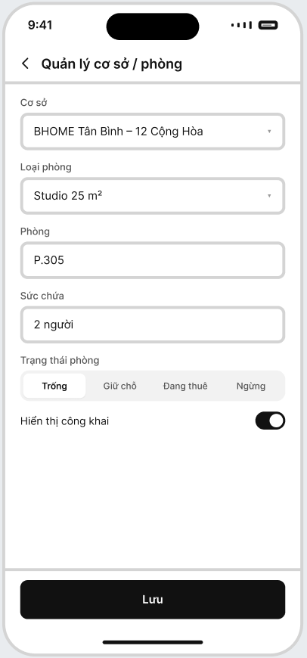
Field Name | Description
Location | Location name and address.
Room Type | Room classification and basic configuration.
Room | Room number/name within the Location.
Capacity | Maximum supported occupants.
Room Status | Available / On Hold / Occupied / Unavailable.
Public Status | Indicates whether Room information may be shown publicly.
Save | Validates and saves the configuration.
Only Owner may create or update Location, Room Type and Room configuration. Staff may view Room information only within assigned Locations.
Room status must remain consistent with active business obligations. A Room associated with an active holding or tenancy obligation must not be manually changed to a conflicting status.

1.1.2 Asset / Facility Management
Related Use Case: UC-05 – Manage Assets and Facilities
Purpose: Allows Owner to declare and maintain managed assets and facilities for Rooms and common areas, including their assignment, current condition and repair/replacement history.
UI Layout:
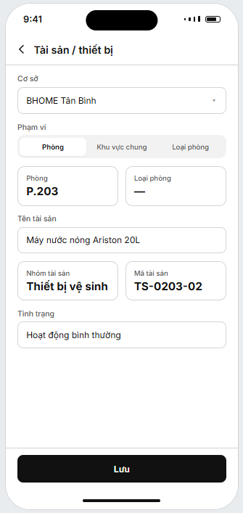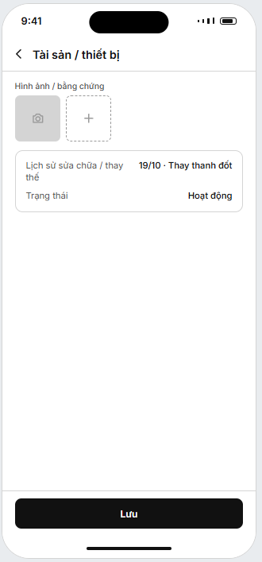

Field Name | Description
Location | Location to which the asset or facility belongs.
Scope | Room / Common Area / Room Type where applicable.
Room | Specific Room to which the asset is assigned where applicable.
Room Type | Room Type used when the asset configuration applies to multiple Rooms of the same type.
Asset Name | Name of the asset or facility.
Asset Category | Asset/equipment classification such as TV, refrigerator, washing machine, bed or sanitary equipment.
Asset Code | Operator-visible asset identifier where applicable.
Condition | Current recorded condition of the asset.
Photos/ Evidence | Supporting photos or asset information where applicable.
Repair/  Replacement History | Historical repair, maintenance or replacement records related to the asset.
Status | Active / Needs Repair / Under Repair / Retired
Save | Validates and saves the asset configuration or update.
Only Owner may create, assign, update or retire managed asset/facility records.

1.1.3 Rental Rate and Fee Management
Related Use Case: UC-06 – Manage Rental Rates and Fees
Purpose: Allows Owner to configure rental prices, electricity/water rates and supported service fees for the applicable Location, Room Type or Room, with effective dates retained for billing.
UI Layout:
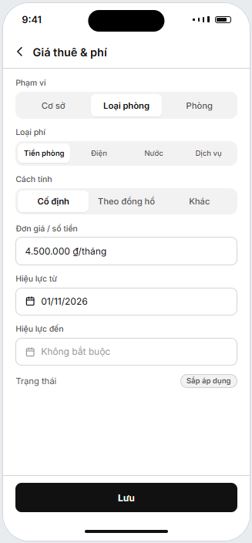
Field Name | Description
Scope | Location / Room Type / Room where the rate or fee applies.
Charge Type | Rent / Electricity / Water / Service Fee.
Charging Method | Fixed / Metered / other supported charging method.
Rate / Amount | Applicable rental price, utility rate or service-fee amount.
Effective From | Date from which the configured rate or fee becomes applicable.
Effective To | Optional end date of the applicable rate or fee.
Status | Current / Future / Retired.
Save | Validates and saves the rate/fee configuration.
Owner has chain-wide access. Staff is limited to assigned Locations.

1.1.4 Occupancy / Room History
Related Use Case: UC-07 – View Occupancy and Room History
Purpose: Displays current Room occupancy, operational status and historical tenancy information.
UI Layout:
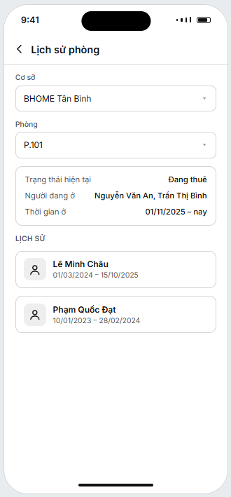
Field Name | Description
Location | Filters Rooms by Location.
Room | Selected Room.
Current Status | Current occupancy and operational status.
Current Occupants | Current Tenant and co-occupants where authorized.
Occupancy Period | Move-in and move-out dates.
History | Previous occupancy records for the selected Room.
Owner has chain-wide access. Staff may view occupancy and Room history only within assigned Locations. This function is read-only and does not directly modify Room, Tenant or Contract information.

1.2 Staff Administration

1.2.1 Staff Management
Related Use Case: UC-08 – Manage Staff Accounts, Employment and Location Assignments
Purpose: Allows Owner to manage Staff accounts, employment information and assigned Locations.
UI Layout:
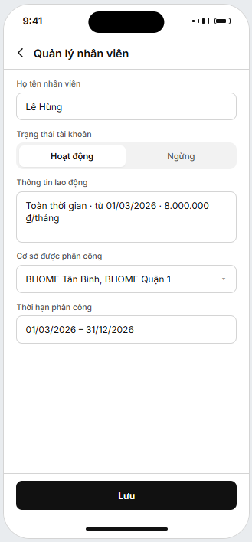
Field Name | Description
Staff Name | Staff full name.
Account Status | Active / Inactive.
Employment Information | Employment type, employment period and supported salary information.
Assigned Locations | One or more Locations assigned to the Staff member.
Effective Period | Start/end date of the Staff-to-Location assignment.
Save | Validates and saves Staff, employment and Location-assignment changes.
Only Owner may create, activate, deactivate or update Staff accounts, employment information and Location assignments. A Staff member may be assigned to one or more Locations

1.3 Staff Shift and Operational Tasks

1.3.1 Staff Shift Management
Related Use Case: UC-09 – Manage Staff Shifts
Purpose: Allows Owner to create and adjust Staff schedules and allows Staff to view their assigned shifts and related schedule changes.
UI Layout:
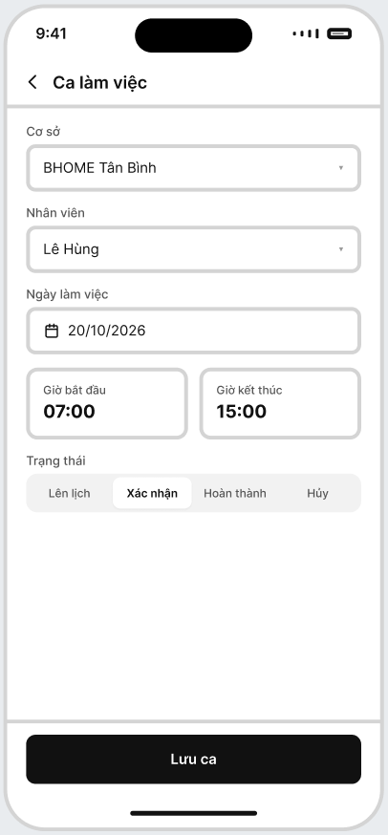
Field Name | Description
Location | Location where the shift is scheduled.
Staff | Staff member assigned to the shift.
Shift Date | Planned working date.
Start Time | Planned shift start time.
End Time | Planned shift end time.
Status | Planned / Confirmed / Ongoing / Ended / Cancelled.
Save/ Publish | Validates and saves the Staff schedule.

Owner creates and adjusts Staff schedules. Before a shift is saved, BHOME validates that the selected Staff member has an active assignment to the relevant Location for the applicable work period. Staff may view only their own assigned shifts and related schedule changes.

1.3.2 Operational Task Management
Related Use Cases: UC-10, UC-12
Purpose: Allows Owner to create or confirm recurring and ad-hoc operational tasks, monitor execution, coordinate unresolved work and verify submitted task results.
UI Layout:
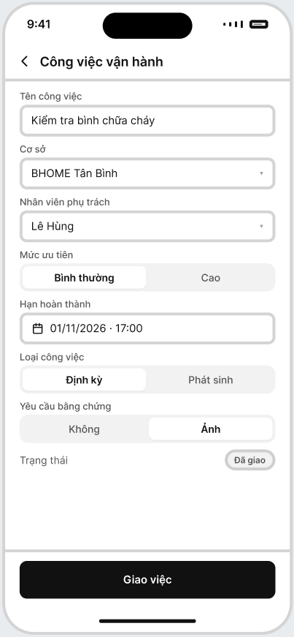
Field Name | Description
Task Name | Short task title or operational work description.
Location | Location where the task must be performed.
Responsible Staff | Staff member responsible for the selected Location according to the active Staff-to-Location assignment.
Priority | Normal / High or another configured priority.
Target Completion Time | Required target completion date/time.
Task Type | Recurring / Ad-hoc.
Status | Assigned / In Progress / Pending Verification / Completed / Overdue / Cancelled.
Evidence Requirement | Required completion evidence where applicable.
Progress / Blocker | Current Staff progress and any recorded blocker.
Completion Evidence | Result, photos, notes or other evidence submitted by Staff.
Owner Verification | Allows Owner to accept the submitted result or request rework.
Rework Reason | Reason recorded by Owner when the result is returned for additional work.

Operational tasks are Location-based. After the Location is selected, BHOME determines the responsible Staff from the active Staff-to-Location assignment instead of routing the task to an unrelated Staff member.

1.3.3 My Tasks – Staff Mobile Application
Related Use Case: UC-11 – Execute and Update Operational Tasks
Purpose: Allows Staff to view assigned operational tasks, perform the required work, update progress, report blockers, attach evidence and submit task results for Owner verification.
UI Layout:
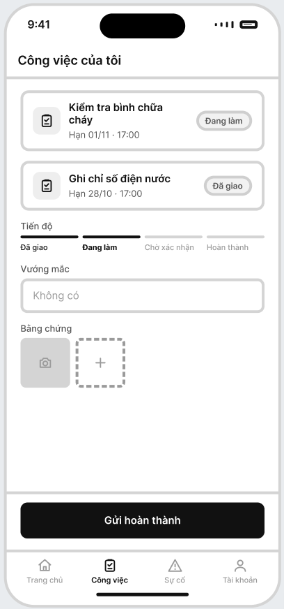
Field Name | Description
Assigned Tasks | Operational tasks assigned to the authenticated Staff member.
Location | Location where the assigned work must be performed.
Priority | Current task priority.
Target Completion Time | Required target completion date/time.
Status | Current task status.
Task Requirement | Work requirement and expected result of the assigned task.
Progress | Current work progress recorded by Staff.
Blocker | Problem preventing or delaying task completion.
Evidence Requirement | Required completion evidence where applicable.
Evidence | Photos, notes or other supported evidence of work performed.
Result | Result recorded by Staff after performing the task.
Submit for Verification | Submits the result and required evidence for Owner verification.

Staff may access and execute only tasks assigned to them within their active Location responsibility. When Staff begins performing an assigned task, BHOME changes the task to In Progress. During execution, Staff may update progress, record operational blockers and attach supporting evidence.

2. FE-02 – Identity, Fixed-Role Access Control & Audit

2.1 Authentication

2.1.1 Sign In
Related Use Cases: UC-01, UC-02
Purpose: Authenticates Owner, Staff and Tenant and provides access according to their role.
UI Layout:
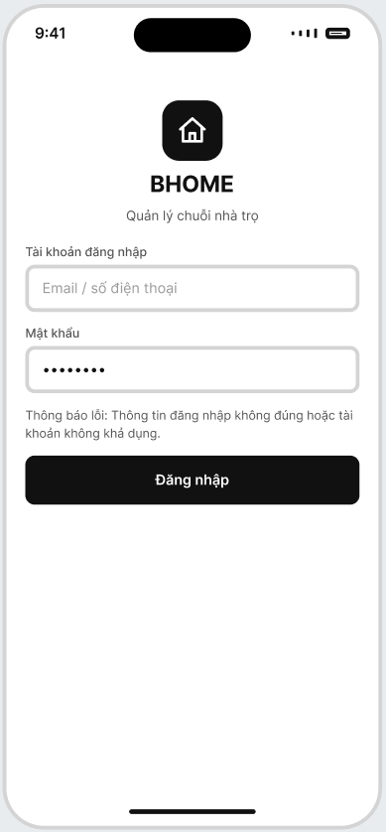

Field Name | Description
Login Identifier | Registered email address or phone number used to sign in.
Password | Password associated with the registered account.
Error Message | Displays a generic message when the login information is incorrect or the account is unavailable.
Sign In | Submits the entered credentials and authenticates the account.
After authentication, users are directed to their role-appropriate Home screen.
Sign Out securely terminates the current authenticated session.

2.2 Personal Profile

2.2.1 Profile
Related Use Case: UC-03 – View / Update Personal Profile
Purpose: Allows users to view and update permitted personal information.
UI Layout:
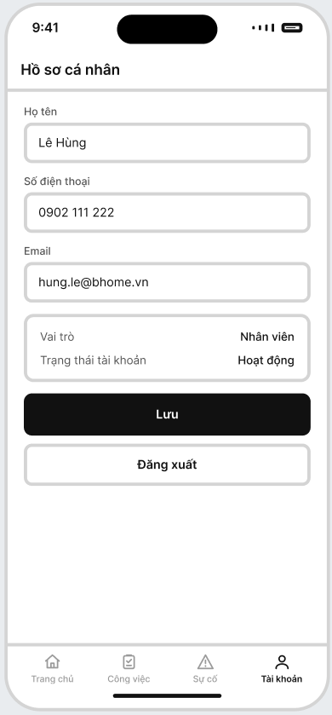

Field Name | Description
Full Name | User display name.
Phone | User contact number.
Email | User contact email.
Role | Read-only system role.
Account Status | Read-only account status.
Save | Updates permitted profile fields.
Users cannot change their own role, employment information or Location assignments.

2.3 Access Control and Audit
This is a cross-cutting system function and does not require a dedicated operational screen.
- Owner has chain-wide management authority.
- Staff access is restricted to assigned Locations.
- Tenant accesses only their own tenancy-related data.
- Important authorization, financial and operational changes retain actor and timestamp information.
- Audit records are append-only under normal business operations.

3. FE-03 – Tenant Onboarding, Contract, Room Handover & Residence Tracking

3.1 Tenant and Occupant Management

3.1.1 Tenant / Occupant Management
Related Use Case: UC-13 – Manage Tenant and Occupant Information
Purpose: Allows Owner and Staff to maintain Tenant and co-occupant information.
UI Layout:
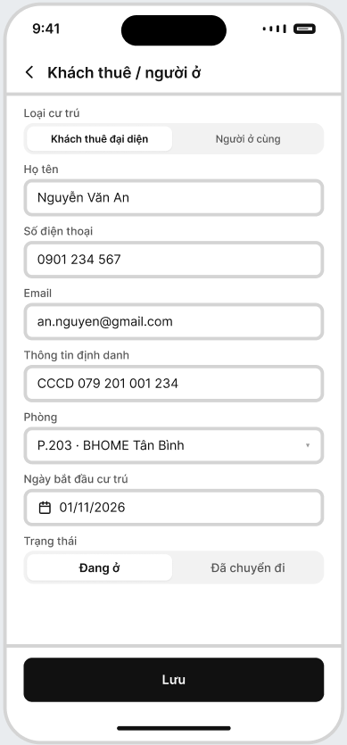
Field Name | Description
Resident Type | Representative Tenant / Co-occupant.
Full Name | Resident full name.
Phone | Contact number.
Email | Contact email where available.
Identity Information | Confirmed identity information.
Room | Assigned Room.
Residence Start Date | Date the person actually begins residing.
Status | Active / Moved Out.
Staff may manage information only within assigned Locations.

3.2 Contract Management

3.2.1 Contract Management
Related Use Cases: UC-14, UC-15, UC-16, UC-19
Purpose: Supports Holding Contract, Main Tenancy Contract, Addendum, renewal and termination.
UI Layout:
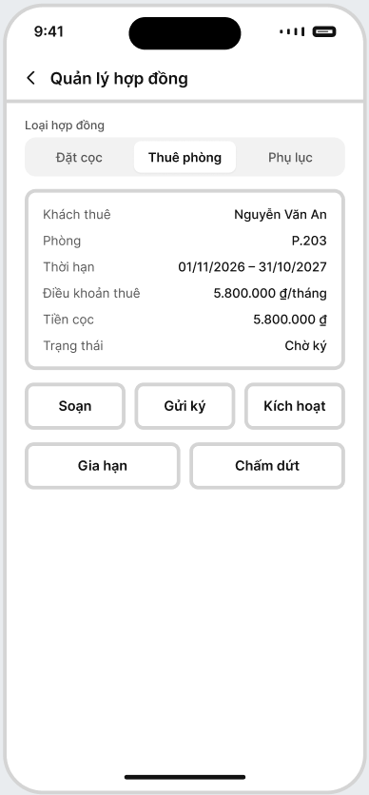
Field Name | Description
Contract Type | Holding / Main Tenancy / Addendum.
Tenant | Representative Tenant.
Room | Related Room.
Contract Period | Start and end/expiry dates.
Rental Terms | Applicable rental and recurring terms.
Deposit | Holding/Security Deposit information where applicable.
Contract Status | Draft / Pending Signing / Pending Activation / Active / Converted / Expired / Terminated / Settled / Cancelled, according to Contract type.
Action | Prepare / Send for Signing / Activate / Renew / Terminate.
Owner retains final authority for Contract activation, renewal and termination.

3.2.2 Contract Signing Status
Related Use Cases: UC-14, UC-15, UC-16
Purpose: Displays electronic signing status returned by the Electronic Contract Provider.
UI Layout:
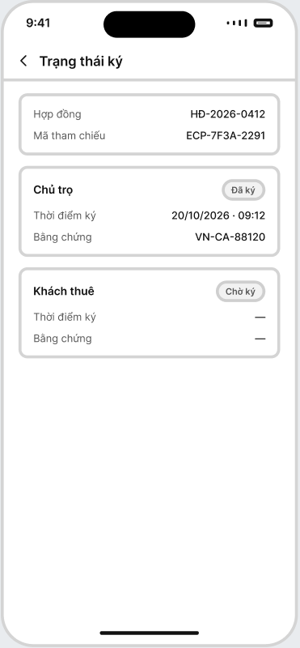
Field Name | Description
Contract | Related Contract.
Provider Reference | External signing workflow reference.
Signer | Owner or Tenant.
Signing Status | Pending / Signed / Failed / Cancelled.
Signed Time | Successful signing timestamp.
Evidence | Returned signing evidence/reference.
BHOME does not issue digital certificates or store private signing keys.

3.3 Room Handover and Residence

3.3.1 Room Handover
Related Use Case: UC-17 – Perform Move-in Room Handover
Purpose: Records Room condition when the Tenant begins occupancy.
UI Layout:
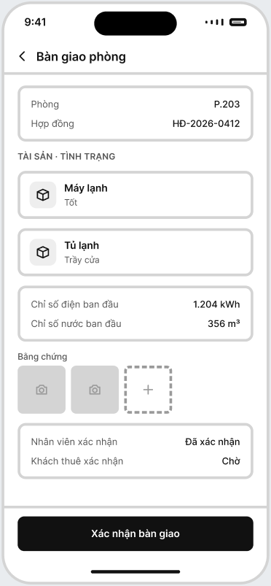
Field Name | Description
Room | Handover Room.
Contract | Active tenancy context.
Assets | Assets/facilities being handed over.
Asset Condition | Condition at handover.
Initial Meter Readings | Electricity/water baseline values.
Evidence | Handover photos/notes.
Staff Confirmation | Staff confirmation.
Tenant Confirmation | Tenant confirmation.

3.3.2 Temporary Residence Tasks
Related Use Case: UC-18 – Track Temporary Residence Registration
Purpose: Tracks temporary-residence registration tasks without submitting government records.
UI Layout:
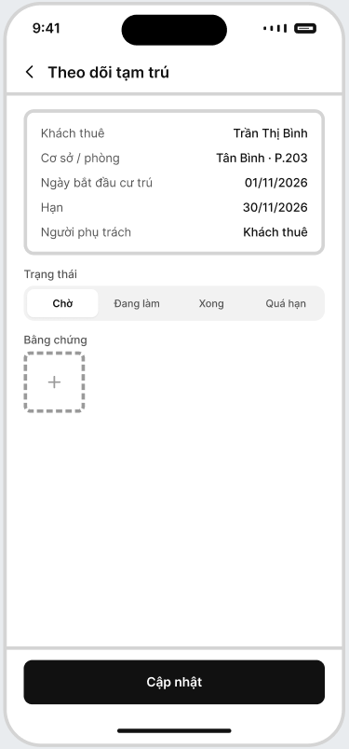
Field Name | Description
Tenant | Applicable resident.
Location / Room | Residence context.
Residence Start Date | Actual move-in/residence date.
Deadline | Required tracking deadline.
Responsible Person | Tenant / Staff as applicable.
Status | Pending / In Progress / Completed / Overdue.
Evidence | Completion evidence where available.

4. FE-04 – Utility, Fee, Invoice & Controlled Adjustment

4.1 Rental, Utility and Fee Policy

4.1.1 Billing Policy
Related Use Case: UC-06 – Manage Rental Rates and Fees
Purpose: Allows Owner to configure rental, utility and recurring service charges.
UI Layout:
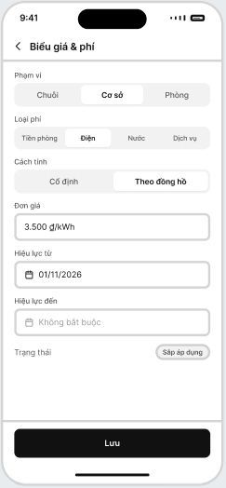
Field Name | Description
Scope | Chain / Location / Room where applicable.
Charge Type | Rent / Electricity / Water / Service Fee.
Charging Method | Fixed / Metered / supported method.
Rate | Applicable rate or amount.
Effective From | Start date of the policy.
Effective To | Optional end date.
Status | Current / Future / Retired.
Historical policy versions must remain available for billing traceability.

4.2 Meter Reading

4.2.1 Meter Reading – Staff Mobile Application
Related Use Case: UC-20 – Capture and Confirm Meter Readings
Purpose: Allows Staff to record electricity/water readings with evidence.
UI Layout:
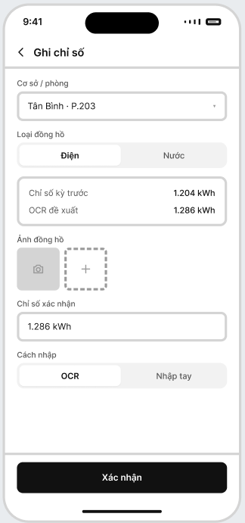
Field Name | Description
Location / Room | Selects the assigned Location and Room for the meter reading.
Meter Type | Selects the utility meter type: Electricity or Water.
Previous Reading | Displays the previously confirmed meter reading for reference.
Meter Image | Allows Staff to capture or upload an image of the meter as supporting evidence.
OCR Proposal | Displays the meter reading detected from the uploaded or captured meter image.
Confirmed Reading | Allows Staff to review and enter the final confirmed meter reading used for billing.
Entry Method | OCR-assisted / Manual.
Confirm | Validates and saves the confirmed meter reading and supporting evidence.
OCR values cannot be used for billing until Staff confirms them.

4.3 Invoice

4.3.1 Invoice Management
Related Use Case: UC-21 – Generate, Finalize and View Invoice
Purpose: Allows authorized users to view draft and finalized Invoices.
UI Layout:
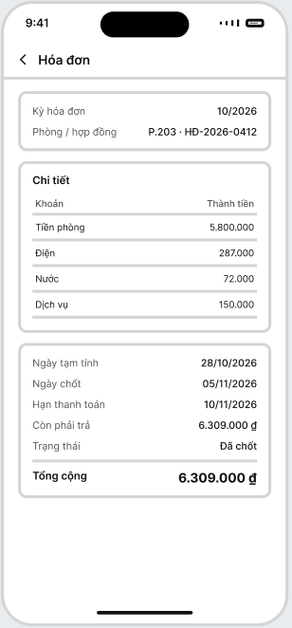
Field Name | Description
Billing Period | Displays the billing period of the invoice.
Room / Contract | Displays the Room and related Contract of the invoice.
Charge Item | Displays each charge included in the invoice, such as rent, electricity, water, and service fees.
Amount | Displays the amount of each charge item.
Draft Date | Displays the date when the draft invoice was generated.
Finalization Date | Displays the date when the invoice was finalized.
Due Date | Displays the payment due date.
Outstanding Balance | Displays the remaining amount that must be paid.
Status | Draft / Finalized / Partially Paid / Paid / Overdue.
Total Amount | Displays the total amount of the invoice.
A finalized Invoice cannot be directly edited.

4.4 Invoice Adjustment

4.4.1 Invoice Adjustment
Related Use Case: UC-24 – Request and Approve Invoice Adjustment
Purpose: Allows Tenant to request correction and Owner to approve or reject it.
UI Layout:
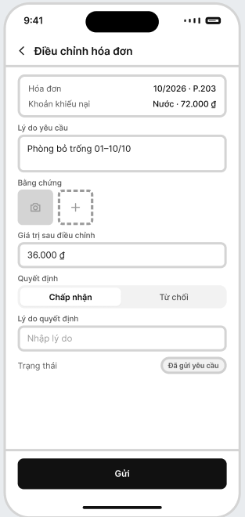
Field Name | Description
Invoice | Displays the billing period and Room related to the invoice adjustment request.
Disputed Charge | Displays the charge item being disputed and its current amount.
Request Reason | Allows the user to enter the reason for requesting the invoice adjustment.
Evidence | Allows the user to capture or upload supporting evidence for the adjustment request.
Adjusted Value | Displays or allows entry of the proposed value after adjustment.
Decision | Allows the Owner to Approve or Reject the adjustment request.
Decision Reason | Allows the Owner to enter the reason for the approval or rejection decision.
Status | Displays the current status of the invoice adjustment request.
Submit Button | Submits the invoice adjustment request or decision.
Original finalized Invoice values remain traceable.

5. FE-05 – Bank Payment, Outstanding Debt & Financial Exceptions

5.1 Payment Reconciliation

5.1.1 Payment Reconciliation
Related Use Case: UC-22 – Reconcile Bank Payment
Purpose: Displays bank transactions and allows Owner manual verification when automatic matching fails.
UI Layout:
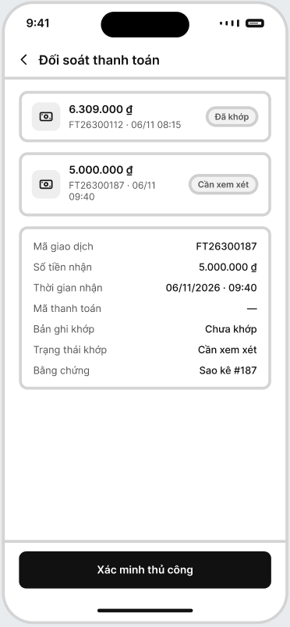
Field Name | Description
Transaction List | Displays received bank transactions with amount, transaction reference, received time, and reconciliation status.
Received Amount | Displays the amount received from the bank transaction.
Transaction ID | Displays the unique reference of the selected bank transaction.
Received Time | Displays the date and time when the transaction was received.
Payment Code | Displays the payment code used to identify the related payment obligation, if available.
Matched Record | Displays the Invoice or payment obligation matched with the bank transaction.
Reconciliation Status | Displays the matching result: Matched / Underpayment / Overpayment / Manual Review.
Evidence | Displays the supporting bank transaction or statement evidence.
Manual Verification Button | Allows the Owner to manually verify an unresolved bank transaction.
Repeated reconciliation events must not create duplicate payment effects.

5.2 Outstanding Debt

5.2.1 Debt Management
Related Use Case: UC-23 – Track Outstanding Debt and Send Reminders
Purpose: Displays outstanding and overdue payment obligations.
UI Layout:
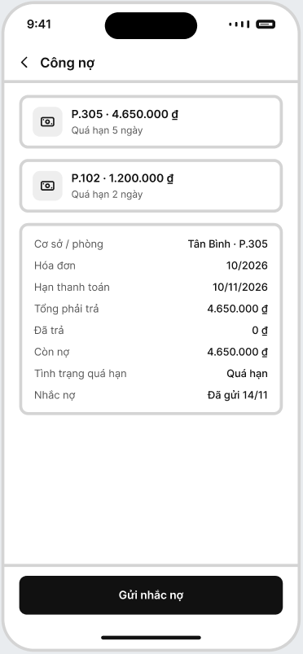
Field Name | Description
Location / Room | Displays the Location and Room associated with the selected debt record.
Invoice | Displays the billing period of the related Invoice.
Due Date | Displays the payment due date of the Invoice.
Send Reminder Button | Sends a payment reminder for the selected overdue debt.
Total Amount | Displays the total amount payable for the Invoice.
Paid Amount | Displays the amount already paid by the Tenant.
Outstanding Amount | Displays the remaining unpaid amount.
Overdue Status | Displays whether the Invoice is overdue.
Reminder Status | Displays the latest debt reminder status or sent date.
Staff receives only information required for operational debt follow-up within assigned Locations.

5.3 Payment History

5.3.1 Payment History
Related Use Case: UC-25 – View Payment History
Purpose: Displays verified payment history.
UI Layout:
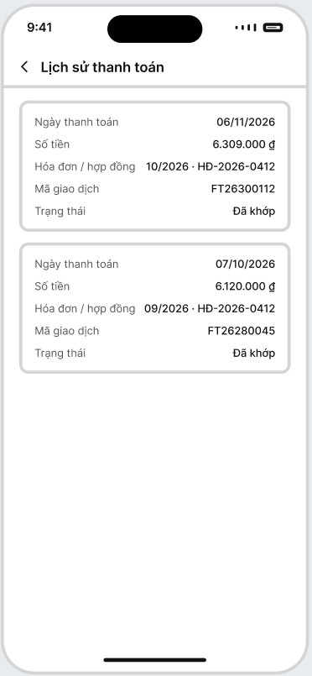
Field Name | Description
Payment Date | Displays the date when the payment was received.
Amount | Displays the amount paid in the transaction.
Invoice / Contract | Displays the related billing period and Contract reference.
Transaction Reference | Displays the bank transaction reference of the payment.
Status | Displays the reconciliation status of the payment, such as Matched.
Tenant sees only their own payments. Owner may view records by Room or Location.

6. FE-06 – Incident & Maintenance Management

6.1 Incident Management

6.1.1 Submit Incident
Related Use Case: UC-26 – Submit Incident or Maintenance Report
Purpose: Allows Tenant or Staff to submit an incident, maintenance, or living-environment report within their authorized scope.
UI Layout:
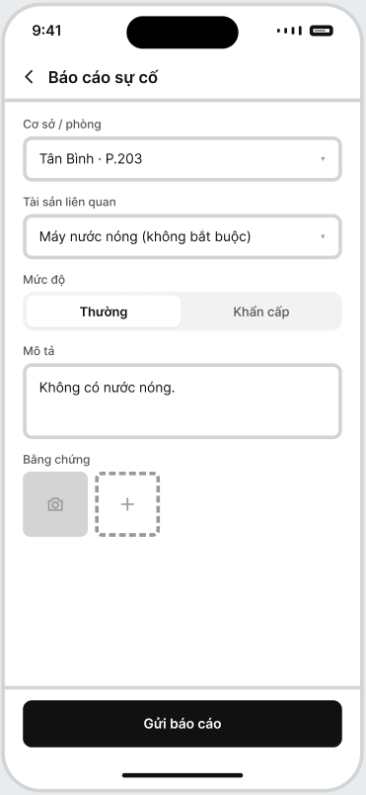
Field Name | Description
Location / Room | Selects the Location and Room where the incident occurred.
Related Asset | Selects the related asset or equipment, if applicable.
Severity | Selects the incident severity: Normal or Operational Emergency.
Description | Allows the user to describe the incident or problem.
Evidence | Allows the user to capture or upload images as supporting evidence.
Submit | Submits the incident or maintenance report to the system.
Emergency Hotline | Displays one-tap calls to 114, 115, 113 and the Location manager for life-safety emergencies; shown before the report form

6.1.2 Emergency Incident Handling
Related Use Case: UC-27 – Respond to Emergency Incident
Purpose: Allows responsible Staff to acknowledge an Emergency incident and record immediate safety, containment, or damage-prevention actions while the Owner retains authority over the official repair decision.
UI Layout:
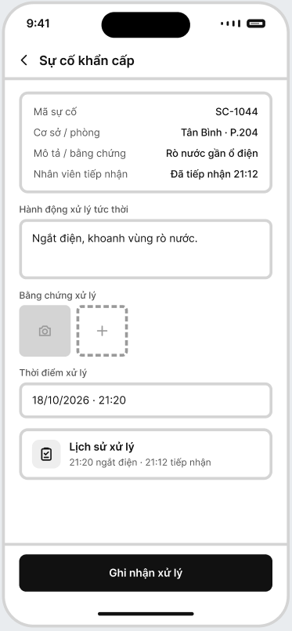
Field Name | Description
Field Name | Description
Incident Code | Displays the unique code of the emergency incident report.
Location / Room | Displays the Location and Room where the emergency incident occurred.
Description / Evidence | Displays the submitted incident description and supporting evidence.
Staff Acknowledgement | Displays the responsible Staff member’s acknowledgement and receipt time.
Immediate Action | Allows Staff to record the immediate safety, containment, or damage-prevention action taken.
Action Evidence | Allows Staff to capture or upload supporting images of the immediate handling action.
Action Time | Records the time when the immediate handling action was performed.
Action History | Displays the chronological history of acknowledgement and immediate handling actions.

6.1.3 Incident Review and Assignment
Related Use Case: UC-28 - Review and Assign Incident Handling
Purpose: Allows Owner to review submitted incidents, validate and classify them, determine the handling approach, and assign work to eligible Staff.
UI Layout:
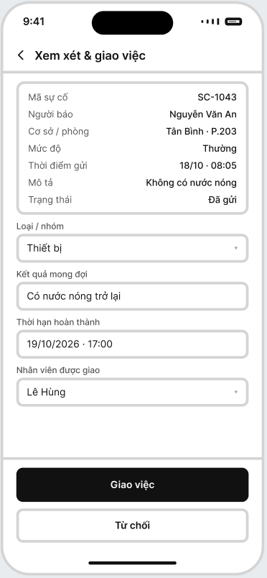
Field Name | Description
Incident ID | Displays the unique identifier of the incident report.
Reporter | Displays the Tenant or Staff member who submitted the report.
Location / Room | Displays the Location, Room, or common area related to the incident.
Severity | Displays the reporter-selected severity: Normal or Emergency.
Submitted Time | Displays the date and time when the report was submitted.
Description / Evidence | Displays the incident description and supporting photos or evidence.
Emergency Action History | Displays immediate Staff actions recorded under UC-27, where applicable.
Category | Allows the Owner to confirm the official incident type or category.
Expected Outcome | Allows the Owner to specify the required handling result.
Target Completion Time | Allows the Owner to set the target completion deadline for the Work Order.
Assigned Staff | Allows the Owner to select eligible Staff responsible for the affected Location.
Status | Displays the current report status: Submitted / In Progress / Resolved / Rejected / Duplicate / Cancelled.
Rejection / Duplicate Reason | Required when the Owner rejects the report or marks it as Duplicate.
Assign / Close Report | Creates a Work Order in Assigned status for valid reports, or closes the report with the recorded reason when rejected or marked as Duplicate.

6.2 Maintenance Execution

6.2.1 Inspection and Repair Proposal
Related Use Case: UC-29 - Inspect, Propose and Execute Repair
Purpose: Allows assigned Staff to inspect the actual condition and submit a proposed handling or repair plan for Owner approval before formal repair work begins.
UI Layout:
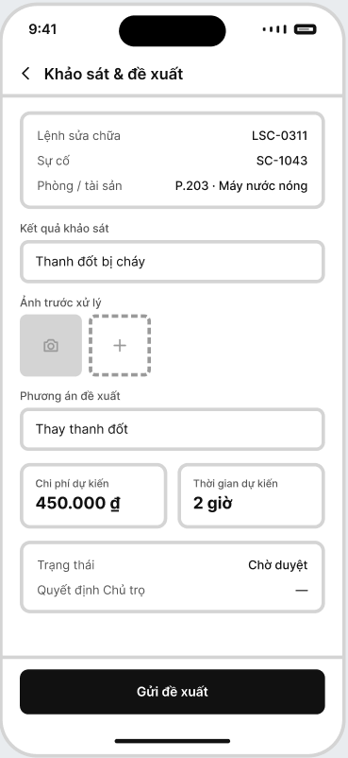
Field Name | Description
Work Order ID | Displays the unique identifier of the maintenance work order.
Incident | Displays the related incident report identifier.
Location / Room / Asset | Displays the Room and related Asset that require inspection or repair.
Inspection Result | Allows Staff to record the actual inspection result.
Before Evidence | Allows Staff to capture or upload evidence before repair.
Proposed Solution | Allows Staff to enter the proposed repair solution.
Estimated Cost | Allows Staff to enter the estimated repair cost.
Estimated Time | Allows Staff to enter the estimated time required for the repair.
Proposal Status | Displays the Work Order approval state: Assigned (draft) / Pending Approval; a rejected proposal returns the Work Order to Assigned.
Owner Decision | Displays the Owner’s decision on the repair proposal.
Decision Reason | Displays the Owner's reason when the proposal is rejected.
Submit Proposal | Submits the inspection result and proposal; BHOME changes the Work Order to Pending Approval and notifies the Owner.

6.2.2 Repair Task Execution
Related Use Case: UC-29 - Inspect, Propose and Execute Repair
Purpose: Allows Staff to perform the approved handling work and record progress and completion evidence.
UI Layout:
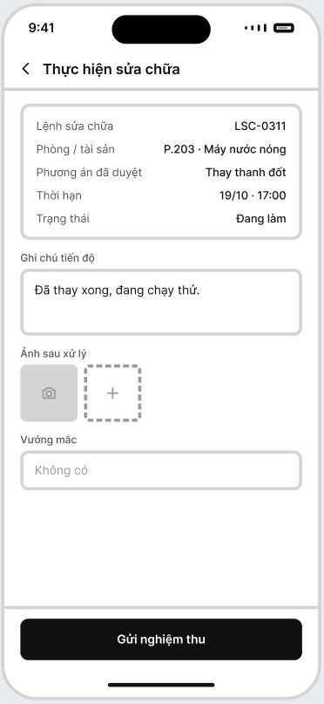
Field Name | Description
Work Order ID | Displays the unique identifier of the repair work order.
Incident ID | Displays the related incident report identifier.
Location / Room / Asset | Displays the Location, Room and Asset under repair.
Inspection Result | Displays the inspection result recorded in 6.2.1.
Approved Solution | Displays the repair solution approved by the Owner.
Completion Deadline | Displays the deadline for completing the repair work.
Progress Note | Allows Staff to record the current repair progress and work performed.
Post-Repair Evidence | Allows Staff to capture or upload evidence after performing the repair.
Blocker / Issue | Allows Staff to record any problem or obstacle encountered during the repair.
Submit for Verification Button | Submits the repair result and supporting evidence for Owner verification.

6.3 Maintenance Verification

6.3.1 Maintenance Verification
Related Use Case: UC-30 - Verify Completion and Update Maintenance History
Purpose: Allows Owner to verify completed maintenance work, request rework where necessary, and confirm completion before the related incident is resolved.
UI Layout:
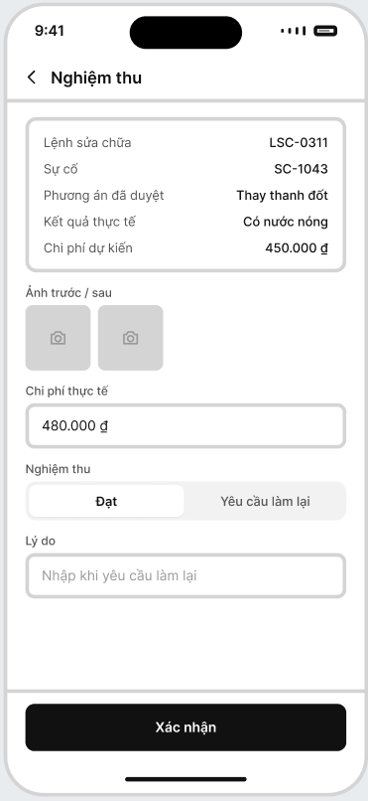
Field Name | Description
Work Order ID | Displays the unique identifier of the repair work order.
Incident ID | Displays the related incident report identifier.
Approved Solution | Displays the repair solution approved by the Owner.
Estimated Cost | Displays the estimated repair cost from the approved proposal.
Progress History | Staff progress records.
Before / After Evidence | Displays evidence before and after the repair work.
Actual Result | Displays the actual result after the repair work is completed.
Actual Cost | Allows the actual repair cost to be recorded.
Verification | Allows the Owner to select Accepted or Rework Required.
Reason | Allows the Owner to enter a reason when rework is required.
Completion Time | Displays the time when Staff submitted the completed work.
Confirm | Saves the verification result; BHOME sets the Work Order to Verified or returns it to In Progress.

6.4 Maintenance & Operational History

6.4.1 Maintenance History
Related Use Case: UC-30 - Verify Completion and Update Maintenance History
Purpose: Maintains a traceable history of incidents, repair work, costs, evidence, and before/after conditions for operational monitoring and reporting.
UI Layout:
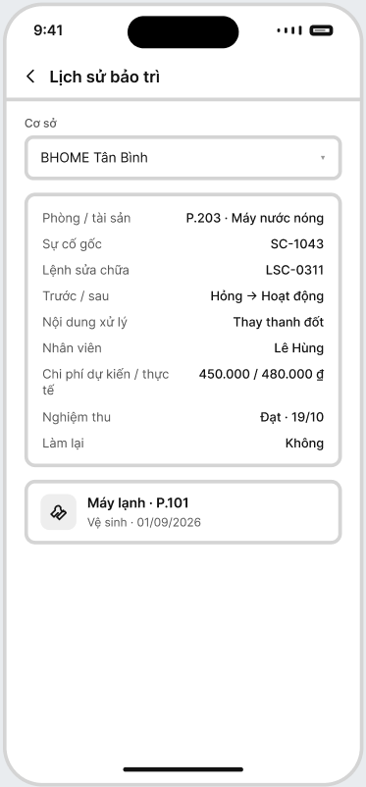
Field Name | Description
Location | Selects the Location whose maintenance history is displayed.
Room/Asset | Displays the related Room and Asset involved in the maintenance record.
Source Incident | Displays the original incident report that triggered the maintenance work.
Work Order ID | Displays the related maintenance work order identifier.
Condition Before / After | Displays the condition of the Asset before and after maintenance.
Maintenance Action | Displays the repair or maintenance action performed.
Assigned Staff | Displays the Staff member who performed the maintenance work.
Estimated / Actual Cost | Displays the estimated cost and the actual maintenance cost.
Verification Result | Displays the maintenance verification result and completion date.
Rework Status | Displays whether rework was required.
Maintenance History List | Displays previous maintenance records for other Rooms or Assets.

7.FE-07–TenantSelf-Service, Living Environment & Notifications

7.1 Tenant Home

7.1.1 Tenant Home
Related Use Cases: UC-21, UC-23–26, UC-36
Purpose: Provides Tenant with an overview of their tenancy and relevant services.
UI Layout:
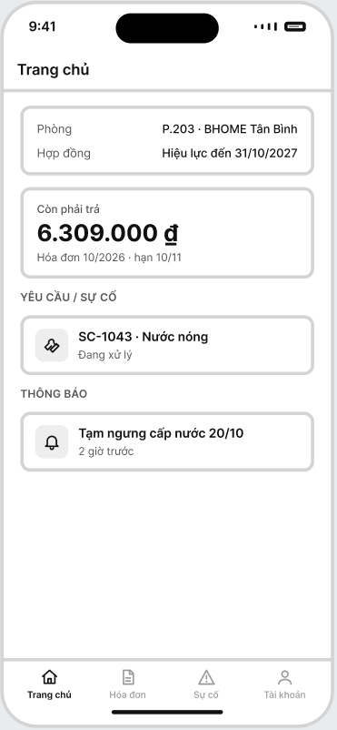
Field Name | Description
Room | Displays the Tenant’s current Room and Location.
Contract Status | Displays the current status and expiry date of the Tenant’s Contract.
Outstanding Amount | Displays the total unpaid amount currently owed by the Tenant.
Invoice Information | Displays the related billing period and payment due date.
Requests / Incidents | Displays the Tenant’s recent request or incident report and its current status.
Notifications | Displays recent operational or system notifications relevant to the Tenant.

7.2 My Contract

7.2.1 My Contract
Related Use Cases: UC-14–19
Purpose: Allows Tenant to view their own Contract and related tenancy information.
UI Layout:
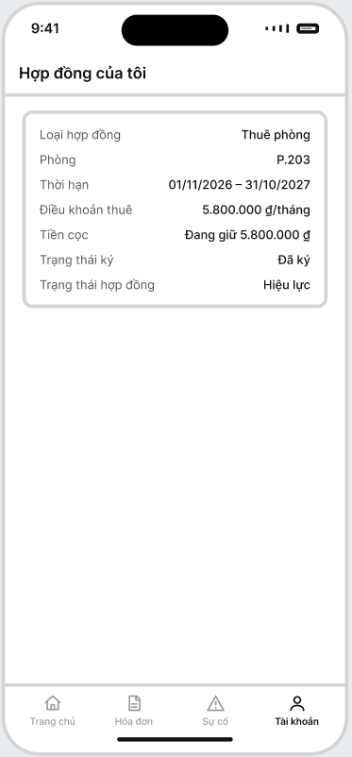
Field Name | Description
Contract Type | Displays the type of contract associated with the Tenant.
Room | Displays the Room covered by the current contract.
Contract Period | Displays the contract start date and end date.
Rental Terms | Displays the agreed rental price and recurring rental terms.
Deposit | Displays the current Security Deposit amount and deposit status.
Signing Status | Displays the current contract signing status.
Contract Status | Displays the current lifecycle status of the contract, such as Active, Expired, or Terminated.

7.3 My Billing & Payment

7.3.1 My Billing & Payment
Related Use Cases: UC-21, UC-23, UC-24, UC-25
Purpose: Allows Tenant to view their own billing, debt, payment history and adjustment requests.
UI Layout:
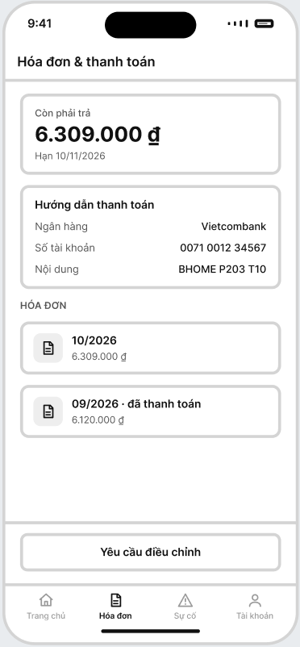
Field Name | Description
Outstanding Balance | Displays the total amount the Tenant still needs to pay.
Due Date | Displays the payment deadline for the current outstanding amount.
Bank | Displays the bank used for receiving the payment.
Account Number | Displays the bank account number used for payment.
Payment Reference | Displays the required transfer content/reference used to identify the payment.
Invoice List | Displays the Tenant’s invoices by billing period.
Invoice Period | Displays the billing month or period of the invoice.
Invoice Amount | Displays the total amount of the invoice.
Invoice Status | Displays the invoice status, such as Finalized, Partially Paid, Overdue or Paid.
Request Adjustment | Opens the invoice adjustment request workflow for the selected invoice.

7.4 Notifications

7.4.1 Notifications
Related Use Cases: UC-35, UC-36
Purpose: Allows authenticated users to receive and view operational notifications.
UI Layout:
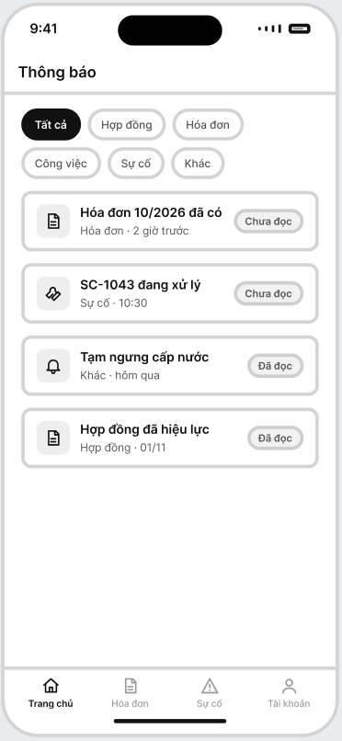

Field Name | Description
Notification Filter | Allows the user to filter notifications by category such as All, Contract, Invoice, Task, Incident, or Other.
Notification Title | Displays the title or main content of the notification.
Notification Type | Displays the category of the notification, such as Contract, Invoice, Task, Incident, or Other.
Created Time | Displays the time or date when the notification was created.
Read Status | Displays whether the notification is Unread or Read.
Related Object | Opens the related authorized record, such as a Contract, Invoice, Task, or Incident, when the notification is selected.
Owner may send chain-wide or targeted notices. Staff may send notices only within assigned Locations.

8. FE-08 – Owner Finance, Business Dashboard & Decision Support

8.1 Investment and Operating Expenses

8.1.1 Investment & Expense Management
Related Use Case: UC-31 – Manage Initial Investment and Operating Expenses
Purpose: Allows Owner to maintain investment and actual operating-cost information.
UI Layout:
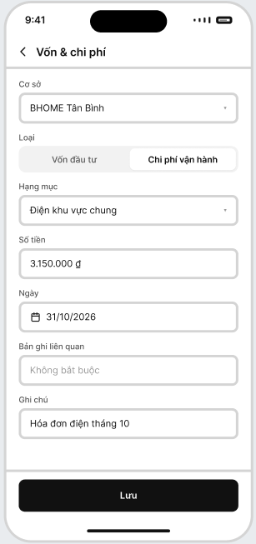
Field Name | Description
Location | Selects the Location where the investment or operating expense is recorded.
Record Type | Selects whether the record is Initial Investment or Operating Expense.
Category | Selects the category of the investment or expense, such as electricity, water, maintenance, staff cost, or other operating costs.
Amount | Records the amount of the investment or expense in VND.
Date | Records the date when the investment or expense occurred.
Related Record | Optionally links the expense to a related record, such as an Asset, Maintenance Work Order, or other operational item.
Note | Allows the Owner to enter additional information or supporting details about the record.
Save | Saves the investment or operating expense record to BHOME.

8.2 Business Reporting

8.2.1 Owner Dashboard / Business Reports
Related Use Cases: UC-32, UC-33
Purpose: Provides Owner with consolidated operational and financial indicators.
UI Layout:
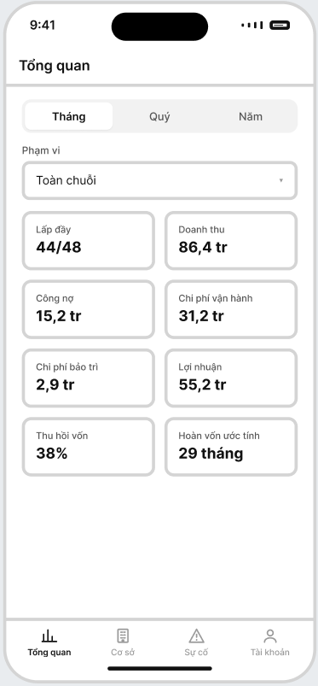
Field Name | Description
Reporting Period | Allows the Owner to select the reporting period: Month, Quarter, or Year.
Scope | Allows the Owner to select the reporting scope, such as the entire chain or a specific Location.
Occupancy | Displays the number of occupied Rooms compared with the total number of Rooms in the selected scope.
Revenue | Displays the total recorded revenue for the selected reporting period and scope.
Outstanding Debt | Displays the total outstanding amount that has not yet been collected from Tenants.
Operating Expenses | Displays the total operating expenses recorded for the selected period and scope.
Maintenance Cost | Displays the total maintenance and repair costs recorded for the selected period.
Operating Profit | Displays the estimated operating profit calculated from recorded revenue and operating expenses.
Capital Recovery | Displays the percentage of the initial investment that has been recovered.
Estimated Payback | Displays the estimated remaining time required to recover the initial investment.
These values are management indicators and are not statutory accounting or tax reports.

8.3 What-if Analysis

8.3.1 Financial What-if
Related Use Case: UC-34 – Analyze Financial What-if Scenario
Purpose: Allows Owner to test hypothetical financial assumptions without modifying actual data.
UI Layout:
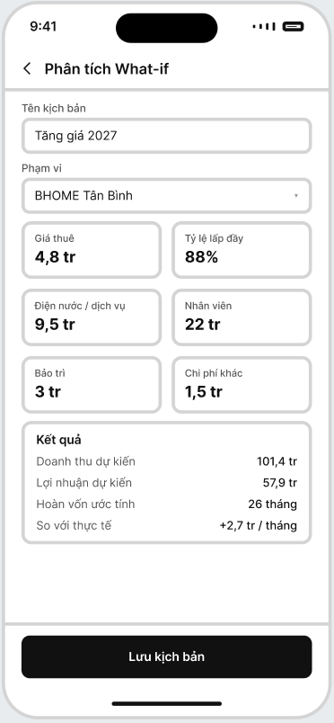
Field Name | Description
Scenario Name | Allows the Owner to enter a name for the financial What-if scenario.
Scope | Selects the Chain or specific Location to which the scenario applies.
Rental Price | Allows the Owner to enter a hypothetical rental price assumption.
Occupancy Rate | Allows the Owner to set the hypothetical occupancy rate for the scenario.
Utility / Service Cost | Allows the Owner to enter hypothetical electricity, water, and service cost assumptions.
Staff Cost | Allows the Owner to enter the estimated Staff cost used in the scenario.
Maintenance Cost | Allows the Owner to enter the estimated maintenance and repair cost.
Other Expenses | Allows the Owner to enter additional hypothetical operating expenses.
Projected Revenue | Displays the estimated revenue calculated from the scenario assumptions.
Projected Profit | Displays the estimated operating profit under the scenario.
Estimated Payback | Displays the estimated payback period based on the scenario results.
Baseline Comparison | Displays the difference between the scenario result and the actual baseline data.
Save Scenario | Saves the What-if scenario and its assumptions without changing actual operational data.
Scenario values must remain separate from actual Contract, Invoice, Payment and expense records.

9. FE-09 – Public Website

9.1 Public Content Management

9.1.1 Public Content Management
Related Use Case: UC-37 – Publish Public Location and Room Information
Purpose: Allows Owner to select approved information for publication.
UI Layout:
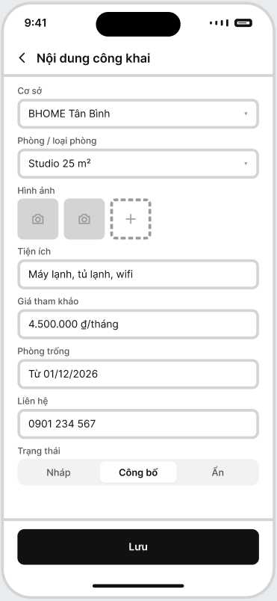
Field Name | Description
Location | Selects the Location whose information will be published.
Room / Room Type | Selects the Room or Room Type to be displayed publicly.
Photos | Allows the Owner to upload and manage approved public images.
Amenities | Allows the Owner to enter the facilities and amenities available for the selected Room or Location.
Indicative Price | Records the rental price shown publicly for reference.
Vacancy | Displays or configures the current room availability information shown to Guest users.
Contact Information | Records the approved contact information displayed on the Public Website.
Publication Status | Sets the public content status as Draft, Published, or Hidden.
Save | Saves the public content configuration to BHOME.
Sensitive Tenant, Contract, Invoice, payment or internal operational information cannot be published.

9.2 Public Website

9.2.1 Public Home / Location / Room
Related Use Case: UC-38 – View Public Location and Room Information
Purpose: Allows Guest to browse approved BHOME information without authentication.
UI Layout:
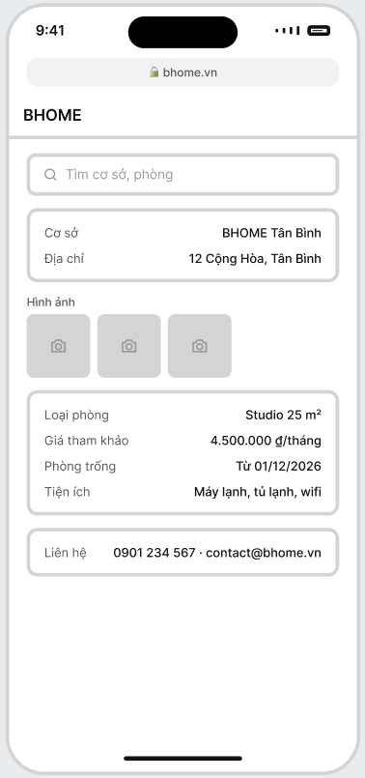
Field Name | Description
Search | Allows Guest users to search for published Locations or Rooms.
Location | Displays the published Location name.
Address | Displays the public address of the selected Location.
Photos | Displays approved public images of the Location or Room.
Room Type | Displays the published Room Type or Room information.
Indicative Price | Displays the reference rental price of the Room.
Vacancy | Displays the current Room availability information.
Amenities | Displays the available facilities and amenities of the Room or Location.
Contact Information | Displays the approved phone number or email for Guest users to contact BHOME.
The Public Website is information-only. It does not support enquiry submission, reservation, payment, Tenant onboarding or Contract processing.

10. Background Job Inventory

10.1 Overdue Invoice Reminder (JOB-01)

Item | Specification
Trigger | Daily or configured reminder schedule.
Purpose | Detect overdue Invoices and notify applicable users.
Required Processing | Find finalized Invoices past the due date with outstanding balance. Recheck payment status and send reminders to Tenant and applicable Owner/Staff.
Failure / Idempotency | Do not send duplicate reminders for the same Invoice and reminder window. Failed external delivery follows JOB-04.

10.2 Contract Expiry Reminder (JOB-02)

Item | Specification
Trigger | Daily.
Purpose | Detect active Main Tenancy Contracts approaching expiry and initiate expiry or renewal notification
Required Processing | Find active Main Tenancy Contracts expiring within 30 days and notify Owner, responsible Staff and Tenant.
Failure / Idempotency | Do not duplicate the same reminder within one reminder window. Delivery failure does not change Contract status.

10.3 Payment Reconciliation Retry (JOB-03)

Item | Specification
Trigger | Scheduled retry after a temporary reconciliation failure.
Purpose | Retry failed automatic bank-payment reconciliation.
Required Processing | Load eligible transactions, recheck current reconciliation status and retry unfinished technical failures.
Failure / Idempotency | Completed transactions are skipped. Retries must not create duplicate Payments or balance updates. After retry limit, Owner performs manual verification.

10.4 Notification Delivery Retry (JOB-04)

Item | Specification
Trigger | Scheduled retry.
Purpose | Retry failed push/email notification delivery.
Required Processing | Retry failed external delivery according to the configured retry policy.
Failure / Idempotency | Persistent in-app notification remains available. Business transactions are not rolled back and duplicate notifications are prevented.

10.5 Holding Contract Expiry (JOB-05)
Item | Specification
Trigger | Scheduled expiry check.
Purpose | Expire eligible Holding Contracts and release Room holds when applicable.
Required Processing | Recheck Contract status and expiry time, mark eligible Contract as Expired and update Room status.
Failure / Idempotency | Repeated execution must not expire or release the same Contract/Room more than once. Existing payment history is preserved.

10.6 Recurring Operational Task Generation (JOB-06)
Item | Specification
Trigger | According to configured task recurrence.
Purpose | Automatically create recurring operational tasks.
Required Processing | Generate the task for the configured Location, deadline and responsible Staff where applicable.
Failure / Idempotency | Do not create duplicate tasks for the same recurrence period. Unresolved assignment remains visible to Owner.

10.7 Operational Task Deadline Reminder (JOB-07)
Item | Specification
Trigger | Scheduled deadline check.
Purpose | Detect approaching or overdue operational tasks.
Required Processing | Recheck incomplete tasks, mark overdue tasks where applicable and notify responsible Staff and Owner.
Failure / Idempotency | Preserve original assignee, deadline and task history. Do not create duplicate reminders for the same reminder window.

10.8 Temporary Residence Reminder (JOB-08)
Item | Specification
Trigger | Daily.
Purpose | Remind responsible users about incomplete temporary-residence tasks.
Required Processing | Find Pending or In Progress tasks approaching or past their deadline and notify applicable Owner or Tenant.
Failure / Idempotency | Completed tasks are excluded. Duplicate reminders for the same task and reminder window are prevented.

10.9 Periodic Meter-Reading Task Generation (JOB-09)
Item | Specification
Trigger | Configured meter-reading date.
Purpose | Create periodic meter-reading tasks for eligible Rooms.
Required Processing | Identify eligible occupied Rooms and active meters and create electricity/water reading tasks for the billing period.
Failure / Idempotency | Only one task for the same Room, meter type and billing period may be created. Missing meter configuration is reported for Owner review.

10.10Draft and Final Invoice Generation (JOB-10)
Item | Specification
Trigger | Configured draft-invoice or finalization date.
Purpose | Generate draft Invoices and finalize eligible Invoices automatically.
Required Processing | On draft date, calculate rent, utilities and fees and create a Draft Invoice. On finalization date, revalidate required data and create the official finalized Invoice.
Failure / Idempotency | Missing required billing data keeps the Invoice in Draft/Pending state and prevents finalization. BHOME identifies the missing billing inputs for follow-up. Once the required data is confirmed, the Invoice becomes eligible for finalization. Only one finalized Invoice may exist for the same Contract and billing period. Retries must not duplicate charges or Invoices.

11. External API Specifications
External interfaces are requirement-level contracts. Exact vendor endpoint URLs, schemas, credentials and implementation libraries belong to Report 4 – Software Design Specification after provider selection.

11.1 Payment Gateway Integration (API-01)
Item | Description
Interface / Direction | Payment Gateway ↔ BHOME
Purpose | Provide bank-transfer transaction data for payment/deposit reconciliation.
Required Behavior | BHOME validates transaction references, matches eligible obligations and prevents duplicate payment effects.
Security | Provider authenticity and transaction integrity must be validated.
Fallback | Owner manually verifies unmatched or unavailable transactions.

11.2 Notification Service Integration (API-02)
Item | Description
Interface / Direction | BHOME → Notification Service
Purpose | Deliver supported push/email notifications.
Required Behavior | External delivery failure must not roll back the related business transaction.
Security | Notification payloads must not contain sensitive identity or unnecessary financial information.
Fallback | Persistent in-app notification remains available and failed delivery follows JOB-04.

11.3 Electronic Contract Provider Integration (API-03)
Item | Description
Interface / Direction | BHOME ↔ Electronic Contract Provider
Purpose | Support electronic signing for Holding Contracts, Main Tenancy Contracts and supported Addendums.
Required Behavior | BHOME sends Contract and signer information and receives signing status, provider reference, signed time and signing evidence.
Security | Communication must be authenticated and protected. BHOME does not issue digital certificates or store users' private signing keys.
Fallback | If signing is incomplete or the provider is unavailable, the Contract remains Pending Signing and cannot be activated until required signing is completed.

IV. Non-Functional Requirements

1. External Interfaces
Interface | Requirement
Owner Web Portal | Primary administration interface for Owner. Supports configuration, management, finance, reporting and business analysis.
Mobile Application | Primary operational interface for Staff and Tenant; provides Owner monitoring, notifications and quick-response functions.
Public Website | Displays approved public Location/Room information. It does not support enquiry, reservation, payment or Contract processing.
REST API | Central interface shared by Owner Web Portal, Mobile Application and Public Website.
Payment Gateway | Provides bank-transfer information for reconciliation. Owner manual verification remains available.
Notification Service | Supports external push/email delivery. Failure does not change committed business data.
Electronic Contract Provider | Supports external electronic signing and returns signing status and evidence to BHOME.

2. Quality Attributes

2.1 Usability

Requirement | Target / Description
Mobile-first | Staff and Tenant core workflows shall be optimized for smartphones. Owner monitoring, notifications and quick-response actions shall be usable on smartphones, while complex Owner administration, configuration, reporting and financial workflows shall be optimized for desktop web usage. .
Clear confirmation | OCR-assisted values must be clearly distinguishable from Staff-confirmed values.
Clear errors | Validation and permission errors shall clearly describe the required corrective action without exposing sensitive information.
Manual fallback | Meter/CCCD data may be entered manually when OCR is unavailable. Owner manual payment verification remains available when automatic reconciliation fails.
Consistent terminology | The system shall consistently use Owner, Staff, Tenant and Guest as business roles.
UI Language | Vietnamese for MVP user-facing interfaces.
Currency | VND.
Time Zone | Asia/Ho_Chi_Minh (UTC+7).

2.2 Performance
The following are the current v1.3 acceptance targets for Test Plan validation. They may be refined without expanding the committed MVP scope.

Requirement | Target / Condition
Standard API Response | 95% of normal list/detail/create/update requests complete within 2 seconds, excluding external-provider latency.
Dashboard Response | Owner dashboard initial summary completes within 5 seconds for the planned MVP scale.
Concurrent Use | System remains usable for at least 100 concurrent authenticated/public sessions in the evaluation environment.
Internal OCR Processing | Produces an OCR proposal or manual-fallback state within 10 seconds under the evaluation workload.
Background Processing | Scheduled jobs shall not block normal interactive requests.
Idempotency | Retry/background processing shall not create duplicate Invoice, Payment, Contract or Notification effects.

2.3 Security
Requirement | Description
Authentication | All Mobile Application operations require authenticated accounts except approved public information.
Authorization | Server-side authorization shall enforce Owner/Staff/Tenant roles and Staff Location assignments.
Tenant Isolation | Tenant shall access only their own identity, Contract, Invoice, payment and request data.
Sensitive Identity Data | Identity information shall be access-controlled and masked where appropriate. Temporary CCCD OCR images shall not be retained after processing.
Password Protection | Passwords shall never be stored or logged in readable plaintext.
Transport Security | Sensitive network traffic shall use HTTPS/TLS in deployed environments.
Audit | Important authorization, financial, Contract and maintenance actions shall retain actor and timestamp history.
Payment Integrity | Duplicate provider/reconciliation events shall not create duplicate financial effects.
Contract Signing Security | BHOME shall protect contract-signing references and integration credentials and shall not store private signing keys.
Public Data Protection | Public APIs shall expose only Owner-approved non-sensitive information.

2.4 Reliability and Recoverability

Requirement | Description
Integration Failure | OCR, Payment Gateway, Notification Service or Electronic Contract Provider failure shall use retry, pending-review or manual fallback without corrupting business state.
Financial Consistency | Invoice, adjustment, payment, debt and deposit changes shall remain consistent and traceable.
No Silent Data Loss | Failed external calls and background jobs shall be logged and retried or moved to an explicit review state.
Notification Reliability | Every applicable event shall retain an in-app notification even when external delivery fails.
Report Upload | Support up to 5 images, maximum 5 MB each, for applicable incident evidence.
Availability | No contractual 24/7 SLA is required for the capstone MVP.
Backup / Recovery | Daily database backup; target RPO 24 hours and RTO 8 hours.

2.5 Privacy and Test Data
- Development and testing shall use synthetic, mock or anonymized identity data; real Tenant identity records are not required for demonstrations.
- CCCD images are temporary OCR inputs and shall not be retained after processing. Only Staff-confirmed identity fields and required verification metadata are stored.
- Public and role-scoped responses shall expose only the information required by the actor and workflow.
- Sensitive identity and financial data shall be access-controlled, masked where appropriate and excluded from unrestricted logs and notifications.

V. Requirement Appendix

1. Business Rules

GBR-ID | Rule Statement | Applies To | Enforced By
GBR-01 | BHOME uses fixed business roles: Owner, Staff and Tenant. Guest is a public non-RBAC user. | Authorization | Server authorization
GBR-02 | Owner has chain-wide authority. Staff may perform operational actions only within assigned Locations. Tenant may access only their own tenancy data. | All protected functions | Server authorization
GBR-03 | Owner makes final decisions on Contract activation/termination, deposit settlement, important repair decisions and management financial matters. | Contract / Maintenance / Finance | Business workflow
GBR-04 | Supported electronic Contract signing is performed through the Electronic Contract Provider. BHOME stores signing status/evidence but does not store private signing keys or issue digital certificates. | Contract signing | Contract service
GBR-05 | A Room may contain multiple occupants. Each occupant is stored separately and one Tenant may be identified as the representative Tenant. | Tenant onboarding | Resident service
GBR-06 | Temporary-residence registration is performed by the Tenant outside BHOME. BHOME tracks deadline, status, reminders, evidence and applicable Owner confirmation. Staff does not perform the registration process. | Temporary residence | Residence task service
GBR-07 | OCR output is a proposal only. Meter and identity data becomes authoritative only after required human confirmation. Manual entry remains available. | OCR / Meter / Onboarding | UI + validation
GBR-08 | Rental, utility and service-fee policies are effective-dated. Historical versions used for billing must remain traceable. | Billing policy | Billing service
GBR-09 | Confirmed electricity and water readings required for billing must be available before Invoice finalization. A Draft Invoice may exist with incomplete billing inputs, but it shall remain Draft/Pending and shall not be finalized until all required billing data is confirmed. Finalized Invoices cannot be edited directly; corrections must use InvoiceAdjustment. | Invoice | Invoice service
GBR-10 | Bank reconciliation must not create duplicate Payment or balance effects. Owner manual verification remains available for unmatched transactions. | Payment | Payment service
GBR-11 | Normal incidents require Owner review before Staff assignment. Operational Emergency incidents immediately notify Owner and responsible Staff for safe containment. Life-safety emergencies must use public emergency services first. | Incident / Maintenance | Incident workflow
GBR-12 | Maintenance result, evidence and actual cost must remain linked to the related Location, Room, Asset or work item. Owner verifies completion before closure.When the Owner handles an incident directly, the Owner's completion confirmation serves as the verification. | Maintenance | Work-order service
GBR-13 | Sensitive security actions and important Contract, financial and approval decisions shall retain actor, timestamp, reason and relevant before/after references in append-only AuditLog records. Routine operational progress remains in task/work history. | Audit | Audit service
GBR-14 | Notifications may be sent only within the sender's permitted scope. External delivery failure does not roll back the related business transaction. | Notifications | Notification service
GBR-15 | Actual investment, revenue and expenses must remain separate from What-if Scenario data. Scenario changes never modify Contracts, prices, Invoices, Payments or actual expenses. | Financial analysis | Scenario service
GBR-16 | Profit, capital recovery, payback and What-if results are internal management indicators, not official accounting, tax or legal outputs. | Financial analysis | Reporting
GBR-17 | Public Website content must be explicitly approved and non-sensitive. It does not support enquiry, reservation, payment, Tenant onboarding or Contract processing. | Public Website | Public API
GBR-18 | Background jobs and integration retries must be idempotent and must not create duplicate Invoices, Payments, tasks, Contract state changes or notifications. | Jobs / integrations | Services + database

2. System Messages

# | Message Code | Type | Context | Content
1 | MSG01 | Inline | Empty result | No results found.
2 | MSG02 | Inline error | Required field | This field is required.
3 | MSG03 | Inline error | Unauthorized action | You do not have permission to perform this action.
4 | MSG04 | Inline error | Staff Location scope | This Location is outside your assigned scope.
5 | MSG05 | Toast | OCR completed | OCR result is ready. Please confirm or correct it before saving.
6 | MSG06 | Toast | OCR unavailable | OCR assistance is unavailable. Please continue with manual entry.
7 | MSG07 | Inline | Contract activation | Required signing or payment conditions are incomplete.
8 | MSG08 | Toast | Contract signing | Contract signing status has been updated.
9 | MSG09 | Inline | Invoice incomplete | Required billing information is incomplete.
10 | MSG10 | Inline | Finalized Invoice | This Invoice has been finalized. Use an adjustment request for corrections.
11 | MSG11 | Toast | Adjustment request | Invoice adjustment request submitted successfully.
12 | MSG12 | Inline | Unmatched payment | Transaction could not be matched automatically. Owner review is required.
13 | MSG13 | Toast / Push | Emergency incident | Emergency report submitted. Owner and responsible Staff have been notified.
14 | MSG14 | Toast | Repair completion | Repair result submitted for Owner verification.
15 | MSG15 | Toast | Rework | Owner requested rework. Please review the reason.
16 | MSG16 | Toast | Task completion | Task completion submitted successfully.
17 | MSG17 | Generic error | Sign in | Incorrect login information or account unavailable. Please try again.
18 | MSG18 | Inline error | Public content | Restricted information cannot be published.
19 | MSG19 | Push / in-app | Report rejected or duplicate | Your report was closed: reason.
20 | MSG20 | Push / in-app | Work Order assigned | New Work Order at Location / Room. Target: time.
21 | MSG21 | Push / in-app | Rework requested | Work Order returned for rework: reason.
22 | MSG22 | Push / in-app | Report resolved | Your report has been resolved.

3. Other Requirements

3.1 Open Questions Register
The following items remain Open Questions in v1.3 and must be validated before the affected implementation is frozen. If evidence is insufficient, the high-risk variant is deferred rather than silently becoming a requirement.

ID | Question | Status | ID | Question
OQ-01 | What exact Security Deposit deduction and final move-out settlement rules apply when damage, debt or other obligations remain? | Open | OQ-01 | What exact Security Deposit deduction and final move-out settlement rules apply when damage, debt or other obligations remain?
OQ-02 | Which Invoice Adjustment categories require Owner approval and are any approval thresholds required? | Open | OQ-02 | Which Invoice Adjustment categories require Owner approval and are any approval thresholds required?
OQ-03 | What exact Holding Contract validity period and Holding Deposit payment deadline apply? | Open | OQ-03 | What exact Holding Contract validity period and Holding Deposit payment deadline apply?
OQ-04 | What acknowledgement and response-time targets apply to Normal and Emergency incidents? | Open | OQ-04 | What acknowledgement and response-time targets apply to Normal and Emergency incidents?
OQ-05 | How should Tenant-caused damage be charged: through an Invoice Adjustment/new charge or Security Deposit deduction? | Open | OQ-05 | How should Tenant-caused damage be charged: through an Invoice Adjustment/new charge or Security Deposit deduction?
OQ-06 | Which Staff cost/salary inputs are required for Owner internal financial analysis? | Open | OQ-06 | Which Staff cost/salary inputs are required for Owner internal financial analysis?
OQ-07 | What retention, deletion or anonymization period applies to Tenant identity information after tenancy ends? | Open | OQ-07 | What retention, deletion or anonymization period applies to Tenant identity information after tenancy ends?
OQ-08 | Is email mandatory for every co-occupant, and which occupants receive billing notifications? | Open | OQ-08 | Is email mandatory for every co-occupant, and which occupants receive billing notifications?

3.2 Traceability Summary

Feature | Use Cases | Key Business Rules | Planned Delivery
FE-01 | UC-04, UC-07 -> 12 | GBR-02, GBR-13, GBR-18 | Sprint 1–2
FE-02 | UC-01, UC-02, UC-03, UC-08 | GBR-01, GBR-02, GBR-13 | Sprint 1 + cross-cutting
FE-03 | UC-13–19 | GBR-03–07, GBR-13 | Sprint 1–2
FE-04 | UC-06, UC-20, UC-21, UC-24 | GBR-07–09, GBR-13 | Sprint 2
FE-05 | UC-22, UC-23, UC-25 | GBR-10, GBR-13, GBR-18 | Sprint 2
FE-06 | UC-05, UC-26 -> 30 | GBR-11–13 | Sprint 3
FE-07 | UC-26, UC-35, UC-36 | GBR-02, GBR-11, GBR-14 | Sprint 3
FE-08 | UC-31 -> 34 | GBR-12, GBR-15, GBR-16 | Sprint 2–3
FE-09 | UC-37 -> 38 | GBR-17 | Sprint 3

Detailed requirement traceability is maintained in the Project Tracking workbook and links GAP/Supporting scope → FE → UC → Screen → Functional Requirement → Business Rule → Test Case → Sprint/Status.

3.3 Explicit MVP Exclusions
The following capabilities are outside the current BHOME MVP:
- Cross-provider marketplace, OTA-style booking, brokerage, property sales and property valuation.
- Guest enquiry submission, online Room reservation, payment or Contract processing through the Public Website.
- Cash-payment recording.
- Full IoT, smart-lock and direct electronic-meter integration.
- Full accounting, statutory payroll, official tax filing and statutory e-invoice compliance.
- Direct government temporary-residence submission or integration.
- BHOME-issued digital certificates, certification-authority services or storage of users' private signing keys.
- Advanced cross-Location Contract-holder or Tenant transfer workflows.
- Autonomous AI pricing, demand forecasting, AI report classification, chatbot operation or biometric camera recognition.
The following capabilities remain in scope:
- Electronic Contract signing through an external Electronic Contract Provider.
- Basic temporary-residence task tracking, reminders, status and evidence.
- Contract Addendum and renewal.
- Emergency incident notification and immediate Staff response.
- Owner investment/expense tracking, capital recovery, payback and What-if analysis.
- Information-only Public Website.

